### **July 4th, 2022 - Web Portal**

July 4th, 2022 Release Notes for Calimatic EdTech Web Portal



Written By Ivan Karmer

Created one year ago

A) **New Reports are released -**

1. Reports > Billing > Transaction Summary (Provides the Transaction Summary for a specified range)
2. Reports > Class. We added few reports here -
   1. Class List Report (Provides the list of classes for the selected criteria)
   2. Class Students List (Provides the list of Students for the selected classes list criteria)
   3. Makeups Report (Provides the information for any makeups)
   4. Class Retention Report (Provides the retention information for the classes)
   5. Drop List Report (Provides the Drops or Transfers for the selected criteria)
   6. Unexcused/Excused Report (Provides the absence information if that absence is excused or unexcused)
3. Reports > Families/Students Report. We added couple of reports here -
   1. Student Retention Report (Provides the retention information of the Students
   2. Roll Sheet Report (Provides the attendance information and also provides the ability to take manual attendance on paper)

B) New Options are provided for Attendance marking - Casual, Trial, Makeup, Cancelled Class, Tady/Left Early, Expected Absent, First Day Ever, First Day at Location, First Day in Class, First Day in Course, First Day in Level, Excuse Absent, Unexcuse Absent. Along with the new options, Notes column is also added to enter any Attendance notes.

C) Changes in Enrollment Pages for existing customers -

When an existing parent login in the Enrollment page (in the website), the students of the corresponding family are displayed. The system provides the ability to enroll to the classes within the enrollment pages without the need to login to the portal.

D) Few bug fixes have been made

### **April 12th, 2022 - Web Portal**

April 12th, 2022 Release Notes for Calimatic EdTech Web Portal



Written By Ivan Karmer

Created one year ago

**The following items have been addressed -**

1. Calendar View for Enrollment Pages -
   1. View - Enrollment Pages now have a new view that shows the list of Courses in a Calendar view.
   2. Embedded Scripts or Pages - You can obtain the embedded scripts or page links from the Courses > Class > Class Setup page for the corresponding Types or Categories.
   3. Age Filters - The calendar view displays the Age Filters. The list of courses display for the selected Age based on the age defined in the Classes.
   4. The weeks and schedule buttons will be displayed based on the classes you define for the selected From and To dates of a Class.
   5. When you click on the Schedule button, it will open a popup with the list of Classes available for that week for the corresponding course.
   6. The user will then have the ability to select the Class and continue with Enrollment.
   7. The Next & Previous buttons above the Calendar view will provide the ability to navigate across the weeks.
2. Export to CSV option is enabled for the grids to export the data in CSV format.
3. "Already a Customer" in Enrollment Form now has a change -
   1. In the Enrollment page form, a popup will appear for the user to say Yes or No if they are already a customer or not. If they Yes then a login option will appear for the user to log in.
   2. When they login then it will display the list of Students for the logged-in account. The user has the ability to add additional classes to enroll and continue with the enrollment.
4. Archived Classes - Provided the ability to Copy the archived class to create a new class with archived class details.
5. Class Popup - When the user clicks on Create Class, now the Class Name is by default filled with the Course Name. Going forward, the user has the ability to create Classes with duplicate Class Names.
6. Family and Student Info Popups - Added Notes Tab with "General Notes" and "Payment Notes" fields.
7. NMI and RazorPay Payment Gateways - Included Fee Details & Check details in the Receipt.
8. Increased the View file size limit to 250MB in the Curriculum.
9. Resolved Time zones issues for Dates on the Classes Overview page.

### **March 22nd, 2022 - Web Portal**

March 22nd, 2022 Release Notes for Calimatic EdTech Web Portal



Written By Ivan Karmer

Updated one year ago

**Following Items have been addressed -**

1. Additional Configurations have been implemented -
   1. Auto assign newly created Challenges to Students on a daily schedule.
   2. Ability to configure if the Lessons/Steps have to be auto-assigned when Challenge is assigned.
2. UI Responsive issues across the application have been addressed.
3. Enrollment Pages - Calendar view -
   1. In Portal Class Popup - Class Bundling (Anytime Program Feature) - Allows the user to enroll to anytime program along with the future class.
   2. In Portal Class Popup - Class Bundling (Anytime Program Feature) - Provides the ability to specify Price per day and Price based on the number of days.
   3. In Enrollment Pages for Calendar - Added UI & Backend Changes to support Class Bundling.
4. Resolved assessment question issue on edit if it has special characters with images.
5. Resolved paying fee through invoice error.
6. Implemented the Ability to order the Types & Categories (in Courses > Class > Type Setup, Courses > Class > Category Setup) for Franchise Admins.
7. RazorPay and NMI Payment Gateways - Implemented to display Fee Details in the invoice.
8. Resolved Whiteboard tools position.
9. Resolved Timezone issue in Classes Overview page where the Class End Date is displaying one day off for certain cases.
10. Resolved the Assessments questions opening issue in some cases.

[Next](https://help-lcm.calimatic.com/article?categoryId=48&solutionId=213)

### **Feb 23rd, 2022 - Web Portal**

Feb 23rd, 2022 Release Notes for Calimatic EdTech Web Portal



Written By Ivan Karmer

Updated one year ago

**Following Items have been addressed -**

1. Resolved - When the user is creating curriculum via Course Player, we are getting exception and the curriculum items are not displaying.
2. Resolved - Class Notes popup (in Class board & Student board), increase the width of the popup (to avoid scroll bar).
3. Resolved - Courses > Class > Create Class popup > The filters are not working in the popup.
4. Resolved - If a Student is assigned to a Course/Class, based on the settings (Board Settings - auto assign), all the challenges are assigned to the Student. Now, if new Challenges are created for the Course, they are not auto-assigned.
5. Resolved - Some responsiveness issues across the application

[Next](https://help-lcm.calimatic.com/article?categoryId=48&solutionId=212)

### **Feb 10th, 2022 - Web Portal**

Feb 10th, 2022 Release Notes for Calimatic EdTech Web Portal



Written By Ivan Karmer

Updated one year ago

**Following Items have been addressed -**

1. In Course Player, for the courses sections/boxes, displaying the State & Stage info.
2. Provided the ability to set Template for Level in the Level popup for Business so that it gets sync to franchises.
3. New calendar design for Enrollment Pages.
4. While copying/syncing content, the SCORM file is not copying.
5. Resolved - Course > Steps/Challenges count on course card, it excludes level steps so overall steps count is invalid.

### **Jan 31st, 2022 - Web Portal**

Jan 31st, 2022 Release Notes for Calimatic EdTech Web Portal



Written By Ivan Karmer

Updated one year ago

**Following Items have been addressed -**

1. Resolved - HTML step for images - Open in a separate window.
2. Resolved - Assessments > Add Question > When choosing a question type from the dropdown menu, the loader does not appear on the screen Fixed.
3. Resolved - Assessment > Question numbers are not displayed appropriately while editing an assessment Fixed.
4. Resolved - Course Player > An HTML file is included in the challenge step, shows broken images. Also SCORM files do not open in a new tab Fixed.

### **Jan 19th, 2022 - Web Portal**

Jan 19th, 2022 Release Notes for Calimatic EdTech Web Portal



Written By Ivan Karmer

Updated one year ago

**Following Items have been addressed -**

1. Assessments > Question Bank Feature - Implemented Question bank (repository) that contains all the questions created in a single place, that can be reused in the assessment module.
2. In the Central Page grid, display the Steps/Lessons count for the Challenges
3. Resolved - For NMI/RazorPay generate refundreceipt.pdf to show refund details
4. Resolved - Class Setup > Open secure through Type/Category URL, showing blank screen if the type/category name contains special characters also an error in console appears.
5. Resolved - NMI Franchise > Enrollment Form Setup > The Payment section for the default Enrollment form is hidden.
6. Resolved - Course Player > Add Assessment in Step > As I am unable to calculate the actual number of questions, the Question Bank popup should display the total number of entries found.
7. Resolved - Assessment > When assessment copy to franchise, Question image name is not showing in edit Assessment popup
8. Resolved - Assessment > Add Questions from Question bank, Question image name is not showing in edit Assessment popup.

### **Dec 31st, 2021 - Web Portal**

Dec 31st, 2021 Release Notes for Calimatic EdTech Web Portal



Written By Ivan Karmer

Created one year ago

**Following Items have been addressed -**

1. NMI Merchant Payment Gateway implementation For Secure one-time payment with Banks (as payment method)
2. NMI Merchant Payment Gateway implementation For Portal one-time payment with Banks (as payment method)
3. NMI Merchant Payment Gateway implementation For recurring payments with Banks.
4. Reply email logic changed and each franchise can set their own Sendgrid configuration.
5. Resolved - Classes Secure > Enrollment page, it is showing Auto deduction tag in manual recurring classes.
6. Resolved - Enrollment Info Email for classes with don't charge and coupon applied not showing the correct total amount.
7. Resolved - The Enrollment info email is not received from Franchise secure.
8. Resolved - MP4 Video upload issue, if extension is in upper case (.mp4 => .MP4)
9. Resolved - Unable to create a recurring class for a franchise that has switched to RazorPay as its payment method.

### **Dec 27th, 2021 - Web Portal**

Dec 27th, 2021 Release Notes for Calimatic EdTech Web Portal



Written By Ivan Karmer

Created one year ago

**Following Items have been addressed -**

1. Administration > Email - Provided the ability specify your own SendGrid Account API key.
2. NMI Merchant Payment Gateway implementation For Secure recurring payments with credit card for class/event.
3. NMI Merchant Payment Gateway implementation For Portal recurring payments with credit card for class/event.
4. NMI Merchant Payment Gateway implementation For Discount/Coupons from both sides portal/secure.
5. NMI Merchant Payment Gateway implementation For Drop-off class/event in portal.
6. NMI Merchant Payment Gateway implementation For Transfer class/event in portal.
7. NMI Merchant Payment Gateway implementation For Student Fee-- One-time Fee > Recurring Fee > Post Fee.
8. NMI Merchant Payment gateway along with razor pay changes at franchise level.
9. Resolved - In Enrollment Info Email Total amount is not showing correctly.
10. Resolved - Some responsiveness issues across the application.

### **Dec 10th, 2021 - Web Portal**

Dec 10th, 2021 Release Notes for Calimatic EdTech Web Portal



Written By Ivan Karmer

Created one year ago

**Following Items have been addressed -**

1. Assessment - Provided support for mathematical symbols for options with a Symbol button.
2. Assessment - Disabling/Hiding Auto-Evaluation option for question types like Short/Long Answer etc., where it is not possible in order to avoid confusion among users.
3. Resolved - Login Page - The resolution of the monitor that users were facing an issue with 3440x1440 (21:9 Ultrawide aspect ratio)
4. Merchant Payment Gateway implementation For Secure one-time payment for class/event with credit card
5. Merchant Payment Gateway implementation For Portal one-time payment for class/event with credit card
6. Merchant Payment Gateway implementation For Refund for one-time payment credit card
7. Resolved - Show error message instead of success msg if the transaction fails due to any reason
8. Resolved - Franchises > Setup > Attachments/Inventory, Save & Close buttons are not showing in popup.
9. Resolved - Events > Event sOverview, buttons are misplaced, add some space between buttons.
10. Resolved - Courses > central > Links > Add Links > Pagination is inappropriate for Mobile view.
11. Resolved - Courses > Class > Class Setup, Courses Types and Categories are not visible in mobile view.
12. Resolved - Course > calendar > event popup > Calendar event detail pagination issue.
13. Resolved - Course Player, Buttons placement is inaccurate for mobile view.
14. Resolved - Franchises > Setup > Contact Form Setup > Preview> Phone#, Select Country code dropdown overlaps on other fields.
15. Resolved - Course Player > Ordering > Challenge tab is not visible in mobile view.
16. Resolved - Reports > Billing > Revenue Generated > All Enrollment Dropdown lists are not working in Tab or Mobile view.
17. Resolved - Franchises > Setup > Contact Form Setup > Add new Field > Add Radio Button, Options pagination is inappropriate.

### **Nov 23rd, 2021 - Web Portal**

Nov 23rd, 2021 Release Notes for Calimatic EdTech Web Portal



Written By Ivan Karmer

Created one year ago

**Following Items have been addressed -**

1. Resolved - Whiteboard icon is not showing against the student.
2. In the Class Board, provided Attendance Button. Clicking on it opens the Attendance page with the ability to take/view attendance for that Class.
3. Provided the ***Waiting List Feature*** for Classes
4. Resolved - Student unable to join class from Dashboard link (containing special characters).
5. Resolved - Unable to create class containing `(backtick) and specific characters.
6. Resolved - Changed decoding scheme while saving level (containing special + Spanish characters).
7. Resolved - Students filter "Select All" checkbox not selecting new assigned students.

### **Nov 9th, 2021 - Web Portal**

Nov 9th, 2021 Release Notes for Calimatic EdTech Web Portal



Written By Ivan Karmer

Created one year ago

**Following Items have been addressed -**

1. Events Copy Feature -
   1. Provided the ability to copy Event that will make a copy of the event including its timing & pricing.
   2. Bulk copy button that provides the ability to select multiple events and make copies of them.
2. Blackout Dates - Prorate Monthly Tuition based on holidays - Provided the ability to define the Blackout Dates. Based on the number of blackout dates, the recurring payment will reduce the payment amount.
3. Provided the ability to create a class only if the instructor has access to the Course.
4. Additional RazorPay Features (India Clients) -
   1. Classes - Coupons/Offers for RazorPay.
   2. Events - Coupons/Offers for RazorPay
   3. Students Fees - RazorPay
5. Resolved - Course > Class Overview, Buttons size are inappropriate.
6. Resolved - Course > Enrollment form setup > Generate Embedded Script > Select types, It's Not Responsive for Tab or Mobile View.
7. Resolved - Course Player > Course Type popup, Pagination is misplaced.
8. Resolved - Courses > Enrollment form setup, Check box field is not aligned with other fields.
9. Resolved - Courses > Enrollment form setup, Divider in Enrollment page is quite lighter than the divider in preview
10. Resolved - Course > Class Overview > column Setting popup, UI is not appropriate in Tab & mobile View.
11. Resolved - Events > Manage Event > Embedded script, Scroll is Stuck.
12. Resolved - Events > Manage Events > For Event Type Secure Url is not opening in mobile view.
13. Resolved - Events > Manage Events > For Event Types Left & Right scroll is not working in Tablet view.
14. Resolved - Events > In Enrollment Form Setup Preview UI is showing correctly for field in Message section but in the enrollment form, it is not showing correctly.
15. Resolved - Events > In Enrollment Form Setup Preview UI checkbox not showing properly.
16. Resolved - Event > Events overview > Action > send Email popup, Email Template Dropdown placement is not aligned.
17. Resolved - Events > Manage Events > Add Event to Franchise Popup pagination is misplaced.
18. Resolved - Events > In Enrollment Form Setup, Copy Item to Franchise popup pagination is misplaced. NOT DONE For Mobile View.
19. Resolved - Events > Manage Events > Event Types are not showing in mobile view.
20. Resolved - Boards > Class board > Challenges > Homework step, Pagination is misplaced. Responsiveness Issue.
21. Resolved - Events > Events Overview > in event popup Category & Staff dropdown is misplaced in mobile/Tab & M Laptop view.
22. Resolved - Student Info > Class > Transfer popup, pagination is misplaced.

**Following Items have been addressed -**

1. Additional RazorPay features -
   1. Events - DropOff & Transfer with RazorPay
   2. Recurring Invoices for RazorPay
2. Updated the course player link from dashboard.
3. Resolved amount issues in enrollment emails when enrolled in Enrollment pages
4. Resolved amount issues in enrollment email when enrolled in Portal
5. Resolved amount issues in enrollment email handled via Billing App
6. Implemented - Restrict sending invoice option for recurring payments for stripe

### **Oct 25th, 2021 - Web Portal**

Oct 25th, 2021 Release Notes for Calimatic EdTech Web Portal



Written By Ivan Karmer

Created one year ago

**Following Items have been addressed -**

1. Sibling Discount Functionality - In Admin > System Config > Manage Coupons, a new "Mark as Sibling Coupon" option is provided. Define Sibling discount for a Type and how much % the sibling discount can be applied if more than 1 student signs up for a class for a Family.
2. Additional RazorPay features (for India Clients) -
   1. Enabled Classes Fee for RazorPay
   2. Enabled Events Fee for RazorPay
3. Resolved Video Title overlap issue for Challenges in Course Player.
4. Resolved - Franchises > Franchise Enrollment > Add new Franchise, scroll is stuck.
5. Resolved - Events > In create event popup scroll is stuck.
6. Resolved - CRM > Leads > Update Lead popup scroll is stuck.

### **Oct 15th, 2021 - Web Portal**

Oct 15th, 2021 Release Notes for Calimatic EdTech Web Portal



Written By Ivan Karmer

Created one year ago

**Following Items have been addressed -**

1. Provided Ability for Instructors to view course material automatically based on assigned class. Example - Class 1 for Course 1 is created and Instructor 1 is assigned to Class 1, then Instructor 1 should be able to see the Course 1 & its content in Course Player.
2. RazorPay items (for India Clients) -
   1. RazorPay Invoicing (without Discount & with Discount)
   2. Enable RazorPay payment for one-time/recurring event enrollments from secure.
   3. Enable RazorPay payment for one-time/recurring event enrollments.
   4. Enable the refund functionality for RazorPay for both recurring & non-recurring.
   5. Enable transfer for razorPay including both recurring & non-recurring.
   6. Hide the payment information section for course/event enrollment form for RazorPay.
3. In Reports > Student Progress > Provided the ability to upload Excel documents for each student
   1. Ability to upload Excel sheets for each Student.
   2. Ability for Students, Parents & Staff to see those sheets for each student
   3. Ability for Staff to download the sheet, fill (with info, charts, etc) & upload it for the student
   4. Ability to send email of these sheets to the Parents & Students.

### **Oct 8th, 2021 - Web Portal**

Oct 8th, 2021 Release Notes for Calimatic EdTech Web Portal



Written By Ivan Karmer

Created one year ago

**Following Items have been addressed -**

1. For the Enrollment Pages Classes Popup, provided the filter for Kids Age (if the Kids Age setting is enabled). Based on the filter, the classes sections will be displayed.
2. Login Page, Logo > Provided the recommended image resolution/size info.
3. Fixed the Logo size in Enrollment Pages.
4. Enrollment Pages > Categories Tabs > Increased the Tabs size.
5. Provided Instructors ability to view course material (overview, instructions, Instructor Notes, etc) without the need for full edit access
6. Provided "Add Student to the Class" without payment setting
7. Provided "Add Student to the Class" with payment (Admin, Staff & Parents) setting.
8. Resolved Central Popups scroll issue.
9. Attachments PPT full screen issue for different screens resolved.
10. Event types and categories tab selection and hover issue resolved.

### **Sept 27th, 2021 - Web Portal**

Sept 27th, 2021 Release Notes for Calimatic EdTech Web Portal



Written By Ivan Karmer

Created one year ago

**Following Items have been addressed -**

1. Provided following Settings in Admin > System Config > Class Configuration -
   1. Level dropdown hide/show in Class Add/Update Popup.
   2. Show/hide the age in Enrollment pages for Courses and Classes.
2. Enrollment Pages > Display age on Course section and Class popup.
3. Provided the ability to upload .XCF and .RBLX files in Curriculum
4. Provided Age restriction in Class add/update Popup.

### **Sept 13th, 2021 - Web Portal**

Sept 13th, 2021 Release Notes for Calimatic EdTech Web Portal



Written By Ivan Karmer

Created one year ago

**Following Items have been addressed -**

1. Enrollment Forms > Provided the ability to disabled Families and Contacts sections to handle Student only Enrollments.
2. Events Related Issues/Changes -
   1. Resolved Grid Filter issues in Events Overview page.
   2. Resolved Event Price recurring and Auto Deduct values display in event grid
   3. Open Student Info popup when the user clicks on Student Name In Enrolled Event
3. Class Detail report > Changed the Class Type Text and disabled Actions column sorting.
4. Resolved Homework submission error in some cases.
5. Edit Courses > Manage classes > Add label for total amount field
6. Administration > System Config > Manage Coupon > Resolved Fixed Amount Filter that is not working
7. Administration > Users > Franchises > Resolved Franchise Name sorting that is not working for desc.

### **Sept 2nd, 2021 - Web Portal**

Sept 2nd, 2021 Release Notes for Calimatic EdTech Web Portal



Written By Ivan Karmer

Created one year ago

**Following Items have been addressed -**

1. Resolved the Paid Date/Time display in the Payment grids.
2. Resolved ordering for Courses & Levels in the Enrollment pages based on the order in Central Repository.
3. Resolved "Phone Number" field to handle country code properly for Enquiry Forms.
4. Performance Optimizations on Enrollment Pages.

### **Aug 25th, 2021 - Web Portal**

Aug 25th, 2021 Release Notes for Calimatic EdTech Web Portal



Written By Ivan Karmer

Created one year ago

**Following Items have been addressed -**

1. When we copy embedded script for a specific class and if that class have more than one type/category, Then first type's enrollment is picked up. Provide sub-menu options with links for each type-category in these cases - Resolved.
2. Reports > Student Progress > Online & Offline Assessments > Provide Active/In-Active column in the grid & show the reports for in-active students as well. By default, filter only the Active Students. - Resolved
3. Courses > Class > Classes Overview > Create a Class popup > Type & Category filters are not working. - Resolved
4. When there is Due Date specified for Homework and Assessments, send an email & mobile notification if they haven't completed it. - Resolved
5. Send 1 day before and also the same day. Provide email setting (by default send to Student & Parent). Notification something like this <https://nimb.ws/OT8RDi> - Resolved
6. Provide Grade field as standard field in Family & Student info Overview tab. - Resolved
7. Class notes tab is in the class white board page currently. It will be easy to access if it is in the whiteboard page. - Resolved
8. Close Add to class modal when click on "items in cart" - Resolved
9. In the Transaction Statement, under Account Summary section, for Fees, instead of calculating and displaying from Enrollments, we can calculate and display from the Transactions grid that is displayed in the statement. If we do this, the Balance will always be 0 as we are calculating from the transactions made & displayed in the grid. - Resolved
10. Currently the Total Amount column in the Transactions grid is showing Original Amount + Fee. But we would be changing it to include Discount as well. Example – Total Amount (150) = Original Amount (100) + Fee (100) – Discount (50). - Resolved
11. Reports > enrollments > class details, the class that is marked as deleted is not being displayed in the class dropdown for that particular category - Resolved
12. Reports > enrollments > class details, inactive classes are not visible in class selector. - Resolved
13. Student > Assessment > Column Setting, Text of Dropdown option is not showing. - Resolved
14. Admin > System Config> Email> Email settings Popup, apply space between text. - Resolved
15. CRM > Contact Form > Contact List > Update Contact Popup, Update button is not working and also error in Console appears. - Resolved
16. Family Info > Payment > Column Setting, Dropdown Option text is invisible. - Resolved
17. Boards > Whiteboard > Code board, Console Error Occurs. - Resolved
18. Student Board > Whiteboard > submit to Homework, console error Occurs if Challenge & Homework is not assign to Student. Should Show Toaster. - Resolved
19. Admin > System Config, SMS Setting popup, apply space between text. - Resolved
20. Course > course player > edit course > curriculum > challenge, exception. - Resolved
21. Courses > course player > edit course > curriculum > challenge details > instructions > add step > assessment, displaying exception and also the assessment pop-up is not closing. - Resolved
22. Flat Coupon Issue one-time payment shown in payment grid with Status Partially pay. - Resolved
23. Reports > Student Progress > Online & Offline Assessments > Provide Active/In-Active column in the grid & show the reports for in-active students as well. By default, filter only the Active Students. - Resolved
24. Courses > Class > Classes Overview > Create a Class popup > Type & Category filters are not working. - Resolved
25. Assessment > Add Online Assessment, unable to add Assessment for a present date with time which is greater than present date. validation should be changed. - Resolved
26. Hide filters & column settings when there is no data available - Resolved
27. CRM > Announcements > add announcement> Select 1 Franchise> The announcements is visible to other Franchises too - Resolved
28. Event related issues > Cannot delete event. - Resolved
29. Transaction Statement Flat Amount are not showing in case of Refund amount - Resolved
30. Class > Category Setup, Filter a Category & move to other tabs filter is not getting reset - Resolved
31. Class Overview, showing wrong categories/type of a Class - Resolved

### **Aug 10th, 2021 - Web Portal**

Aug 10th, 2021 Release Notes for Calimatic EdTech Web Portal



Written By Scott Smith

Updated one year ago

**Following Items have been addressed -**

1. Add a validation to check for pending payment when dropping a student from the class. - Resolved.
2. Class detail report changes - Resolved issues.
3. Usernames throughout the application (make sure proper validation message is there and allow non-sql injection characters) - Resolved.
4. Students -> assessments -> assignments -> Provide the Reports for the Assessments here as well. - Resolved
5. Calimatic online classes recordings - Provide the ability to download based on the permissions - Resolved
6. Families > Payments> Student Fee - Provide sorting for Student Name - Resolved
7. Show alert for events when dropping student from the event - Resolved
8. Exception occurs when trying to transfer or drop from classes overview - Resolved
9. Enrollment form for Classes > unable to add a student with contact has hidden email field but it shows validation toaster for enter email first when user clicks on the continue button - Resolved.
10. Admin > User > Add new User > unable to create Parent/Student if user puts just Required fields. Error in Toaster appears - Resolved.
11. Admin > User > Franchise, when I update franchise Admin detail & save a Console error Occurs - Resolved
12. Admin > Import students > Error description is inappropriate - Resolved
13. Courses > class > class overview > add new class > type selector & category selector, both type selector and category selectors are not working - Resolved
14. Course > Calendar > Class Detail Popup, Pagination is misplaced. Showing Event Timings & Color in Class Detail Popup but show Correct Title for Event/class - Resolved
15. Course > Transactions > Add/remove column Setting dropdown, am unable to View text of option - Resolved
16. Online Class > am unable to conduct/take online class if the class name has Apostrophe(') - Resolved
17. Course > Class > Archived Class, it's not showing number of enrolled students in Class - Resolved
18. Course > Class Overview > When I enter special characters/tags in Class name & Save, an Exception Occurs - Resolved
19. Add to Class popup > Error in Toaster Occurs if Class name have special characters in the name - Resolved
20. Events > Events Overview > In Events Overview popup, filters are not able to display data - Resolved
21. Provide searching and pagination in "Add to class" section for mobile (web view) - Resolved
22. Show view result button only in completed case For Assessment - Resolved

### **Aug 10th, 2021 - Web Portal**

Aug 10th, 2021 Release Notes for Calimatic EdTech Web Portal



Written By Scott Smith

Updated one year ago

**Following Items have been addressed -**

1. Add a validation to check for pending payment when dropping a student from the class. - Resolved.
2. Class detail report changes - Resolved issues.
3. Usernames throughout the application (make sure proper validation message is there and allow non-sql injection characters) - Resolved.
4. Students -> assessments -> assignments -> Provide the Reports for the Assessments here as well. - Resolved
5. Calimatic online classes recordings - Provide the ability to download based on the permissions - Resolved
6. Families > Payments> Student Fee - Provide sorting for Student Name - Resolved
7. Show alert for events when dropping student from the event - Resolved
8. Exception occurs when trying to transfer or drop from classes overview - Resolved
9. Enrollment form for Classes > unable to add a student with contact has hidden email field but it shows validation toaster for enter email first when user clicks on the continue button - Resolved.
10. Admin > User > Add new User > unable to create Parent/Student if user puts just Required fields. Error in Toaster appears - Resolved.
11. Admin > User > Franchise, when I update franchise Admin detail & save a Console error Occurs - Resolved
12. Admin > Import students > Error description is inappropriate - Resolved
13. Courses > class > class overview > add new class > type selector & category selector, both type selector and category selectors are not working - Resolved
14. Course > Calendar > Class Detail Popup, Pagination is misplaced. Showing Event Timings & Color in Class Detail Popup but show Correct Title for Event/class - Resolved
15. Course > Transactions > Add/remove column Setting dropdown, am unable to View text of option - Resolved
16. Online Class > am unable to conduct/take online class if the class name has Apostrophe(') - Resolved
17. Course > Class > Archived Class, it's not showing number of enrolled students in Class - Resolved
18. Course > Class Overview > When I enter special characters/tags in Class name & Save, an Exception Occurs - Resolved
19. Add to Class popup > Error in Toaster Occurs if Class name have special characters in the name - Resolved
20. Events > Events Overview > In Events Overview popup, filters are not able to display data - Resolved
21. Provide searching and pagination in "Add to class" section for mobile (web view) - Resolved
22. Show view result button only in completed case For Assessment - Resolved

### **July 1st, 2021 - Web Portal**

July 1st, 2021 Release Notes for Calimatic EdTech Web Portal



Written By Ivan Karmer

Created 2 years ago

**Following Items have been addressed -**

1. Password creation fields, don't allow the user to input characters that are part of html or sql injection - Resolved
2. Student & Parent Login > Dashboard > Links > Exams is misspelled - Resolved
3. Death Screen implementation in portal & franchise secure - When any system error occurs display the death screen and send error to the Appteam.
4. When user clicks on the Back in the enrollment form, instead of making the cart empty, display the message to use the button to add more classes or courses - Resolved
5. CRM - emails -> send emails - > choose list of leads -> added state field in the grid to filter upon.
6. Student & Parent Login > Dashboard > Links > When the user clicks on the "View Profile Information" link, the system will take them to the Student Info Popup.
7. Gender field under family & student info overview tab has only male/female option even though enrollment form has more options. Field need to match with enrollment form - Resolved
8. Student & Parent Dashboard > Student Engagement counter is not working (correct % is not displaying) - Resolved
9. Phone filed on enrollment page (secure) - Enabled Validation
10. Make "Set is Paid" for the Challenge and Lessons as checked by default if it is a create/add case - Resolved
11. Fee Receipt set default logo when company logo is not exist - Resolved
12. Change the text for duplicate email pop up - Resolved
13. Course Player> Assign Course popup> In Gender dropdown the 'Other' option is not available - Resolved
14. Course> Class Overview> Action> Manage Student popup, In Gender dropdown the 'Other' option is not available - Resolved
15. Class/Event Secure > Add multiple students/contacts have HTML tags in password, it should focus on that specific Student or contact which has a problem in a password. same as Portal - Resolved
16. Change Message in Enrollment form for already exists email id case - "You already have an Account created with provided email address. Please Login to make any additional enrollments or add any new Students. Forgot your password? Use ‘Forgot Password’ button and reset. Don’t remember username? Contact Center representative." - Resolved

### **June 21st, 2021 - Web Portal**

June 21st, 2021 Release Notes for Calimatic EdTech Web Portal



Written By Ivan Karmer

Created 2 years ago

**Following Items have been addressed -**

1. Enrollment Page - Going forward the Student Email id will not be a required if you don't make it required in the enrollment form page. Student account will be automatically activated. The Student needs to contact the center if they need username or password.
2. When a Payment is made by Check and the Payment is marked as by Check, provide the Receipt capability for the Check payment.
3. Provide the ability to perform bulk action in Courses > Class > Classes Overview > Assign Instructor(s) to multiple classes at once.
4. Class - class overview - start date and end date is off by a day (time zone issue) has been addressed.
5. When the Student is set to active from in-active, we are giving a popup are you sure you want to Active/In-Active?" but we have to give that popup only when we are setting from Active to In-active and not the other way round. - This case has been resolved.
6. Even though 'Automatically Assign All Course to All Staff' set to true and synced to all franchises, and even though it is true in franchises, when we add new coach, courses are not assigned automatically. Also when new course is published, no instructor is getting assigned. This has been resolved for the cases of old courses when the setting is made.
7. In the Enrollment page (Classes & Events) -
   1. For the Email field (both Contacts & Students section), a check is provided to see if that email already exists in the system for the same franchise. If it exists then the system displays a text "You already have an Account. Please Login to make any additional enrollments or add any new Students." The Login text should be a company specific URL where they login & redirects to the Family info popup & classes tab.
   2. In the Contacts section, the default meta will display Contacts for the title. In the Students section, the default meta will display as Students for the title. Removed the Student, Contact label headings.
   3. In the Contacts section, the + button icon label is changed to "Add more Contacts". In the Students section, the + button icon label is changed to "Add more Students".
8. Event > In Type / Category Setup , added some space between text.
9. CRM > Emails > Lead Emails, added space between text.
10. Event > Enrollment Form Setup > Note, text is inappropriate - resolved.
11. Staff> Update Staff > Skill Set, pagination text should be appropriate - resolved.
12. Staff > Update Staff info > Video, Label is inappropriate - resolved.
13. Course > Class Overview > Create Class, On creation its showing wrong toaster message - resolved.
14. Student > Student Info popup > add an email for contact, its showing wrong toaster - resolved.
15. When i click on cancel filter, Left panel is not going to default state - resolved.
16. Course > Class Overview > Action> Manage > Drop off, an exception Occurs if that student is created from Action > Add new student - resolved.
17. Student info > Events > when we drop event and it is user last enrollment user status not updated - resolved.
18. Archived Class > On column setting change > Class Overview page load instead show same page - resolved.

### **June 11th, 2021 - Web Portal**

June 11th, 2021 Release Notes for Calimatic EdTech web portal



Written By Ivan Karmer

Created 2 years ago

#### **Complete Class Feature**

The Complete Class feature is introduced to reduce the manual effort of completing a class in a more efficient way.

1. In Admin > System Config > Class Configuration, this setting needs to be enable for Complete Class to work -



1. System will Auto-Complete Class when the Class passes the End Date if there are no pending Payments or Fees and it will make the Class as In-Active.
   1. If Student is not assigned to any other Class then the Student is set to In-Active.
   2. Email will be sent to the Franchise Admin & CCs (specified in system admin > Emails) once the process is successful.

1. When there are Payments or Fees pending and the Class passes the End date then the system will send an email to the Franchise Admin & CCs (specified in system admin > Emails) with list of Students whose payments or Fees are pending. In this case, you will need to manually mark the Class as complete.

1. In order mark the Class as Complete, Navigate to Courses > Class > Classes Overview. Click on Actions button and Click on "Mark Class as Complete" option. When you Mark the Class as complete manually and if there are pending payments or Fees then the system displays a message.
   1. You can cancel and collect the payments or fees OR click on each student name and collect any Payments or Fees.
   2. If you Continue anyway and if the Student is not assigned to any other Class then the Student is set to In-Active.
   3. The pending payments for the associated Class will be deleted. If the Student is In-Active and if you want the associated Fees to be deleted, ensure this option is selected (Admin > System Config > Class Configuration) - 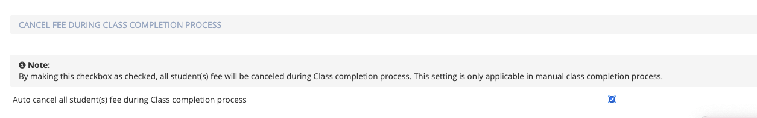
2. The Completed Classes are displayed in Courses > Class > Archived Class.

#### **Following Items have been addressed -**

1. Admin Dashboard - For Enrollment Counter, counter is not increasing when student is enrolled in event from the portal and secure.
2. Admin Dashboard - For Payments Received Counter on dashboard, its not getting increasing when student is enrolled in event form portal and secure and pays due payments
3. Admin Dashboard - For de-enrollment counter on dashboard it is showing number of all in active student *Expected Results*: it should show the number of in active student which are enrolled in class/ event
4. Franchise secure Instructor page and modal UI settings have been optimized
5. Added Confirmation popup while clearing the white board
6. Slots selection UI (secure page) issues are fixed
7. Restrict only numeric input in redeem points
8. Add default meta for class type field
9. Staff > Time Tracker > Timesheet > Export to Excel, It's having an issue that file is downloaded in (.xls) format.
10. Student Info > Export to Excel > In Excel Sheet, Checkbox Column is Showing for Mark Active/Inactive and also if I Checked it'll shows Empty in Sheet.
11. Duplicate Class Size issue is resolved
12. Payment grids permission issues are resolved
13. Task board setting issue is resolved
14. Added staff video validation
15. Staff Record group by issue is resolved
16. Attachment resize issue is resolved
17. Attachment Count issues are resolved
18. Transaction grid export issue is fixed
19. Instructor page responsive settings are resolved
20. Class Popup grid UI Issue is fixed and Header text are updated
21. Course Player detail page Responsive settings are updated
22. Challenge Popup Left panel Issue on mobile screen are updated
23. Classes Overview > Actions > Class Students > Manage -
    1. Student Name is not sorting properly if any student's have profile pic.
    2. Also, the Age column sorting is also not working properly.
    3. Class column is not working properly
24. CRM > Emails > Templates page > # & Template name are not sorting properly
25. CRM > Articles page > Type column are not sorting properly
26. Course/ Event > Enrollment Form Setup > Add Enrollment Form, I can Add an enrollment form without its name even though name is a mandatory field.
27. Course Player Buttons are misplace. Responsiveness Issue is resolved
28. Course Player > Ordering is not working for Tab & Mobile View. Responsiveness Issue is resolved
29. Course > Central > Ordering is not working for Tab & Mobile View. Responsiveness Issue is resolved
30. Course > Central > Row Display dropdown placement is not appropriate for Mobile view. Responsiveness Issue is resolved
31. Course > Class > Class setup> Ordering is not working for Tab & Mobile View. Responsiveness Issue is resolved
32. Course > Enrollment Form Setup Buttons are not working for Tab & Mobile View. Responsiveness Issue is resolved
33. Course Player > Search Bar> Remove text button is overlap on text. Responsiveness Issue is resolved
34. Course Player > Search Button UI is not appropriate for Mobile View.
35. Issues for students count in class grid is resolved
36. Class Overview > Confirmation popup, console error occurs
37. Make student name as link in Complete Class (Payments pending popup)
38. Re-implement Manage Students from classes overview

### **June 4th, 2021 - Web Portal**

June 4th, 2021 Release Notes for Calimatic EdTech web portal



Written By Ivan Karmer

Created 2 years ago

#### **Following Items have been addressed -**

1. Stage/Status field not getting synced for courses to franchises.
2. For all grids, export to excel -- need to support xlsx and should export all pages instead of 1st page.
3. Slots selection UI (secure page) - Need to create an embedded script UI that the admin will use in client's website popup. In that UI, we need following information Ability to select an instructor (from the list of instructor of a course). Each instructor info (Profile pic, Instructor Name, Instructor Overview, Skillset, Certificates, Video) should display the list. We need to add Instructor Overview, Upload Video fields in the Staff info popup that we can leverage here. Once the instructor is selected, the user should be able to select the Type of the Class (One-on-One or Group). Add Class Size Type field in the Class popup in our portal which will be leveraged here. The type info should be displayed based on the which classes & class type the selected instructor is assigned to.
4. Homework board implementation > Ability for the Students to move items in the Done State (based on the setting)
5. Payment grids permission issue in Family and Student Payments.
6. In Course/ Event Enrollment form grid, type filter not working if i change text of type in System Config
7. Board Navigation issue from System Config.
8. Reports> Enrollments > Class Details, Select Type/Category, an Exception Occurs.
9. Course Player/ Boards> Edit Challenge Popup, Whiteboard Attachment> when I Add new Attachments they'll be copied to Homework step Attachments, also the Remaining Whiteboard Attachment hasn't been showing.
10. Board button responsive UI issue
11. Board > Staff board Height responsive UI issue
12. Board > Class board top button responsive UI issue
13. Board > Class board height responsive UI issue
14. Board > Student board height responsive UI issue
15. Provide a question icon by the side of the Fee amount for the corresponding Class/Event to show the fee details.
16. Custom popover added in franchise secure.
17. (Arabic English) Text implementation.
18. Toaster text changes to Arabic.
19. Courses, student -> (student info & student point) , family , user crud.
20. System Config space issue in filter solve.
21. Class overview grid action button sub dropdown issue on mobile screen
22. LMS Portal UI Bugs and responsive settings.
23. Add company check in Add-to-events popup
24. Student Board , Class board and Staff board are not responsive in Mobile and tab view i am unable to move tickets to other states.
25. Class Overview->Edit Courses> Edit Challenge Popup, Whiteboard Attachment> when I Add new Attachments they'll be copied to Homework step Attachments, also the Remaining Whiteboard Attachment hasn't been showing.
26. Franchise secure Instructor page and modal UI settings.
27. Add Conformation popup while clearing the white board.
28. Restrict only numeric input in Redeem points.
29. Add default meta for class type field.
30. Staff> Time Tracker> Timesheet> Export to Excel, It's having an issue that file is download in (.xls) format.
31. Student Info> Export to Excel> In Excel Sheet, Checkbox Column is Showing for Mark Active/Inactive also if I Checked it'll show Empty in Sheet.
32. In enrollment form, some fields are not showing validation messages.
33. Assessment > Assignments> Select student popup, am unable to view/search student that accesses specific Assessment.
34. For Enrollment Counter on dashboard, it's not getting increase when student is enrolled in event form portal and secure.
35. For Payments Revived Counter on dashboard, it's not getting increased when student is enrolled in event form portal and secure and pays due payments.
36. For de-enrollment counter on dashboard it is showing number of all in active student *Expected Results*: it should show the number

### **May 24th, 2021 - Web Portal**

May 24th, 2021 Release Notes for Calimatic EdTech web portal



Written By Ivan Karmer

Created 2 years ago

#### **Following Items have been addressed -**

1. New Staff info popup - Don't Select All by default for the Department field.
2. Provide a setting and make it work - System Config > Class Configuration > Provide a new setting (Auto In-Active Class if Class end date reached). When the class reaches its end date should make the Class inactive so that it is not available in secure, Class boards menu & for Parents & Students.
3. Implement Filter searching on System Config Sidebar Menu.
4. Admin > System Config - On the left side section, provide search bar to search for the menu.
5. System should not Allow me to delete a family where there is a student active and registered in a class
6. Class Boards > Make the "Class Notes" as a separate button instead of option under Online Classes button (we need have same like how we have in Student Board)
7. White Board (code board) >> https://nimb.ws/0PhqMG
8. Admin > System Config - URL - Looks like the url is constant for all the tabs of the System config page. Can we have the urls updated for the tabs like - /UserManagement/SystemConfig/ManageCoupons.
9. Course Popup > In Caliber academy, Age To field label is displaying for Age From field and Price field. It is happening for the new accounts also.
10. Challenge Popup -- Instead of displaying like this - https://nimb.ws/CFf3pY, display like this https://nimb.ws/mFbHLI (where the 1st step should be selected by default and the editor & the steps section should cover the screen instead of having the space.
11. CRM > Leads --- If there are any failures in the import, currently we are just giving an error message. Instead, display all the errors in a popup and provide buttons (Ignore and Import, Cancel the Import, Cancel). When the user clicks on ignore & import then we should ignore those rows or data. If the user clicks on "Cancel the Import" then we should close all the import popups.
12. CRM > Leads --- In the import Lead popup, Don't make any field as required
13. Staff > Staff Info - Include Department column as well but don't enable it by default.
14. Issue from Stem Builders - sort by student name and some other columns in families, transactions does not work.
15. Franchises > Inventory --- when franchise purchase inventory, send an email to the Business admin base on Business Company Permissions
16. Revenue Grid Issue
17. Reports > Show Total Amt Paid for all the record
18. Reports > Show Total Amt Refunded for all the record
19. Course Player > All Type And All Category Text Changed
20. Admin Role > Student > Assessment > Create Assessment > Question > Category, Arabic Changes are Required in Assessment popup, Add Question.
21. In system config > Emails, Provider same style for switch buttons
    1. Students > info Popup > Payments > action > Set Recurring
    2. Students > info Popup > Payments > action > hold payments
    3. Students > info Popup > Payments > action >Cancel Payment
    4. Students > info Popup >Attendance> Cancel Attendance
22. CRM > Contact Form > Contact List > Edit Contact Form, a Console Error Occurs & after that Setup page is going to Blank.
23. Attendance > By Class > Select Inactive Class > Click on Attendance for Batch Classes , an Exception Occurs.
24. UI of student progress popup is not showing properly
25. UI of class notes popup is not showing properly
26. System config > Emails, Ui of inventory emails setting is not showing properly
27. CRM > Announcement > Edit Announcement Popup, Select Role/Franchise Drop-downs are Misplace. (For Arabic)
28. In assessment > Add Question, Ui of Display points check is over lapping on text
29. For Copy to franchise popups, pagination is not aligned
30. Spacing issues for email tab.
31. Unassigned Category Courses and Unassigned Courses are not Showing in Revenue Generated Grid Filters
32. Getting error when i upload select Empty leads file and click on import.
33. Family/Student> Student/Family Info popup> Convert a Student/Contact to Lead, Its Showing wrong Toaster Message.
34. Student> Attendance Tab> Start/End Date, Sorting are not Applying, also Console Error Occurs.
35. Staff > Assign Course/Class Popup, should show total number of records found.
36. Franchise > Inventory > Transaction > Click on Pending payments a Console Error Occurs.
37. In Reports > Enrollments, Following charts have count issue
    1. - Active Students Comparison
    2. - New Enrollment
    3. - De-Enrollment

### **April 22nd, 2021 - Web Portal**

April 22nd, 2021 Release Notes for Calimatic EdTech web portal



Written By Ivan Karmer

Created 2 years ago

#### **Following Items have been addressed -**

1. Billing > Revenue Generated > When Class Enrollments, Event Enrollments are selected, Type, Category, Course, and Class filters need to be multi-select autocompleted fields.
2. Print settings of the institute to support Documents along with PDFs
3. CRM > Emails > Send Emails > Users drop-down list (do the same for SMS page as well) --
   1. Provide "<Make a Selection>" default option. "Choose the list of users" will be the 2nd option
4. Make following filters as Multi-select auto-complete drop-down lists --
   1. CRM > Emails > Send Emails > Choose the list of Leads popup > Make the Lead source as a separate filter and make it as multi-select autocomplete. Do the same for the SMS page as well
   2. CRM > Emails > Lead Emails > Send To dropdown list (Lead source). Do the same for the SMS page as well
5. Unable to print pdf files from franchise documents even when the franchise print pdf files only is allowed.
6. When people are replying to the emails they received from the system, it is coming to "appteam@calimatic.com" instead of going to the email set in the system config.
7. CRM > Emails > Send Emails > Users drop down list (do the same for SMS page as well)
   1. Provide "By Event" filter
8. CRM Filters revamping
9. Show company name in the profile menu dropdown with some optimization.
10. Franchise > Document > On clicking Folder Exception Occurs.
11. CRM filtering issues.
12. Courseplayer -> Assign course > filters for in-active are not working.
13. Courses >class > Classes overview > filters are not applying on Student Enrolled and Amount column
14. CRM -> Emails > unsubscribed users, email type filter is not working.
15. CRM > Lead> Advanced Filters> when applying a filter having no data, it showing only 'No Data Image' And hide filter dropdown and buttons so am unable to undo filtering.
16. Admin> Class name having Special characters shows some piece of code instead of class name also it Cause of hiding Assessments detail from student board.
17. In internal Articles > Categories of other franchises are showing in franchise
18. in Articles > internal and external articles are other franchises are showing in franchise
19. (Terminology) is not applying to the franchise dropdown in the classes setup page
20. Password is still showing validation error when adding student or parent from admin user, even when password field is not mandatory
21. Classnotes> Attachments> Google drive Popup is opening under the popup.
22. Course player -> Assign course > filters, for gender and for in-active not working.
23. Admin> In Franchise's Documents/ CRM Articles/Course Attachment> Add Attachments, When I Add an attachment through Google Drive Which has special characters in the file name, an Exception Occur.
24. Admin > Staff > Time Tracker > Wage Details, spelling Mistakes.
25. Staff> Time Tracker> Timeoff Approvals, it shouldn't allow hours in (-ve).
26. In CRM Contact Form Setting > Heading > provide valid to toaster which shows the number of characters is allowed in Heading
27. In internal Articles > Categories of other franchises are showing in franchise
28. in Articles > internal and external articles are other franchises are showing in franchise
29. Terminology changes are not implemented in copy to franchise events
30. (Terminology) is not applying to in course player edit > manage class popup
31. In CRM > Lead > LeadSourse I am unable to create a lead source in the franchise when the same name lead source exists in the company
32. Deleted classes are showing in class filters in Attendance by class in Attendance Tab
33. From classes overview > action > manage > student info popup, and in course player > assign course student info popup, select student and select fee drop-down are disabled, for student fee > assign fee popup
34. Provide Dropdown For gender Column in Course player > Assign Course popup
35. Admin > user, when I create student and parent, Portal Accesses email is sending even When portal access setting is off
36. Class Board/ Class Overview > Send Bulk Email> Choose Recipient,
37. It's showing some Extra Students who are not enrolled in that Class/Event.
38. CRM> Leads> Converted Family Has 2 contacts 1 is Active & other is inactive, It changes lead type for Inactive contact & will convert to the student.
39. CRM > Emails: Fix this for both Email and SMS tabs.
40. CRM > Emails > Add Email Template Popup-CRM > Emails > Emails Sent > View Users/Leads: Fix this for both Email and SMS tabs -
41. CRM > Emails > Emails Sent > System Emails: Fix issues for both Email and SMS tabs -
42. Admin Role> Student> Assessment> Create Assessment, Arabic Changes are Required in Assessment Popup.
43. Admin Role> System Config > Assessment Rubrics Config > Manage Criterion> Manage Rating, Arabic Changes are Required.
44. Student> Payment> Fee Payment> Post Fee, Arabic Changes
45. Student> Payments > action Button and popups, Arabic Changes
46. Students > info popup > billing, Arabic Changes
47. Students > info popup > billing > add Billing info, Arabic Changes
48. Students > Attendance > Take Attendance > Cancel Class, Arabic Changes
49. Students > Student info > action, Arabic Changes
50. Students > info Popup > Payments > action > pay, Arabic Changes
51. Students > info Popup > Events >add to event, Arabic Changes
52. Students > info Popup > Events /class >Drop or transfer, Arabic Changes
53. Students > info Popup > Events /class > add to class/ event send invoice, Arabic Changes
54. Students > info Popup > Events /class > add to class/ event, Arabic Changes
55. Remove sorting from receipt, and provide sorting for date and time column, also provide filters for transaction grid
56. Event Overview > Send Bulk Email> Choose Recipient, It's showing some Extra Students which are not enrolled in that Event or converted to lead.
57. Admin Role> Student> Assessment> Create Assessment> Question> Category, Arabic Changes are Required in Assessment popup, Add Question, Arabic Changes
58. In system config > Emails, Provider same style for switch buttons, Arabic Changes
59. Students > info Popup > Payments > action > Set Recurring, Arabic Changes
60. Students > info Popup > Payments > action > hold payments, Arabic Changes
61. Students > info Popup > Payments > action >Cancel Payment, Arabic Changes
62. Students > info Popup >Attendance> Cancel Attendance, Arabic Changes
63. Hide top filter and load data according to relevant class from following areas
    1. Class Board
    2. Classes Overview
    3. Event Overview

### **April 2nd, 2021 - Web Portal**

April 2nd, 2021 Release Notes for Calimatic EdTech web portal



Written By Ivan Karmer

Created 2 years ago

#### **Following Items have been addressed -**

1. Keep Contact form successfully submission toaster message for some more long time.
2. For the Business Admin, don't have the Select All check box selected by default. wherever we have the Franchises dropdown list.
3. Franchises > Billing > All Transactions >
   1. Enable Grid Tools (Export to Excel)
   2. For the Transactions Date & Time column, provide from & to date filters
4. Franchise Contact Form -
   1. https://nimb.ws/f2SFI8 - Even though the fields are not touched, it is giving those validation errors.
   2. When the user submits the form, send a confirmation email to the email specified in the form and also send an email to the Copy email. --- Do this for CRM contact forms as well"
5. The system should not allow deleting a family when a student is active and registered in a class
6. Franchise > Franchise Enrollments > click on the edit icon (Franchise popup)- Provide Franchise Type drop-down list field (provide a Manage button where the business admin can add the different Franchise Types and those types will be displayed in the Type field)
7. CRM-> Leads -> include state column as well.
8. CRM -> Articles -> In grid > show external URL column and if article is external then show URL.
9. When the user submits the form, send a confirmation email to the email specified in the form and also send an email to the Copy Emails --- Do this for CRM contact forms as well.
10. Email Templates and Email popups -- alignment in the preview of email does not match with how it is really set in the editor.
11. Show company name in the profile menu dropdown
12. Allowing Office Docs files without converting to pdf for print.
13. Send Email > Choose lead >Select all issues on filtering.
14. Add Subscription Name Column in Assign Company Subscriptions.
15. The contact form is not populating with the right country for phone number.
16. Pagination of Articles Grid not working properly.
17. Articles - Currently External articles that are created by the Business are not visible for the Franchises on the Articles page.
18. Admin> CRM> Contact Forms, am unable to view the Phone No of leads that are created by contact forms.
19. Admin> Franchise> Contact Form> Preview popup, Dropdown of Phone# is showing all data in Popup.
20. Admin> CRM> Articles, When I Save a New Article it'll save on random in the grid.
21. Franchise > CRM> Articles> External Article, On View Business Articles title, shouldn't be 'update Article'.
22. Franchise> CRM> Articles> Add Internal Article popup, dropdown is empty.
23. CRM> Contact form Setting popup, am unable to save changes a Console Error Occurs also Ui is misplaced.
24. Send Email->Lead Emails->Choose Leads (Leads Count Issue).
25. CRM emails > Gmail and yahoo mail sending Issue.
26. When Send Portal Access Setting off then the login button should not show.
27. Issue while sending CRM emails to Leads.
28. Provide column for SMS Setting type which shows SMS is send using (Own SMS Setting or Calimatic SMS Setting ) and Remove Email Delivery Column.
29. SMS Recipient popup is not getting closed when the send button is clicked.
30. Admin/Franchise >Calimatic Billing, Billing History, Should show Latest on Top.
31. SuperAdmin> Calimatic subscription> Transactions, showing wrong time Also on Billing History.
32. Super admin > For Franchise, Unable to activate franchise when the franchise is activated once.
33. Deleted Franchise Transactions are not Showing in super admin > Climatic subscriptions > Transactions.
34. Floating-point issue in subscription metered Fee.
35. Example - On Send Emails page, click on the Leads button, filter the Lead Source and click on the Select all check box and click on Choose button. It is selecting all leads instead of the filtered leads.

### **March 18th, 2021 - Web Portal**

March 18th, 2021 Release Notes for Calimatic EdTech web portal



Written By Ivan Karmer

Updated 2 years ago

#### **Reports - Provided Additional Filters**

Dates, Class and/or Event Filters have been provided for the following Reports -

1. Reports > Enrollments > Enrollment Details
2. Reports > Enrollments > New Enrollments
3. Reports > Enrollments > Active Student Comparison
4. Reports > Billing > Revenue Generated

These additional filters will provide the ability for you to drill down deeper to get the information you need in the Reports.

#### **Calimatic Hosted Online Classes - Recording Visibility Setting**

Calimatic now provides a way to set for how long the Online Class recordings should be displayed to the users. A setting has been introduced where you can set the visibility for each role.

Example - If you don’t want the Students and Parents to view the online class recordings after 2 weeks of the recording time then you set the setting for 2 weeks for Parent & Student role.

**Navigation:** Admin > System Config > Recordings Configuration

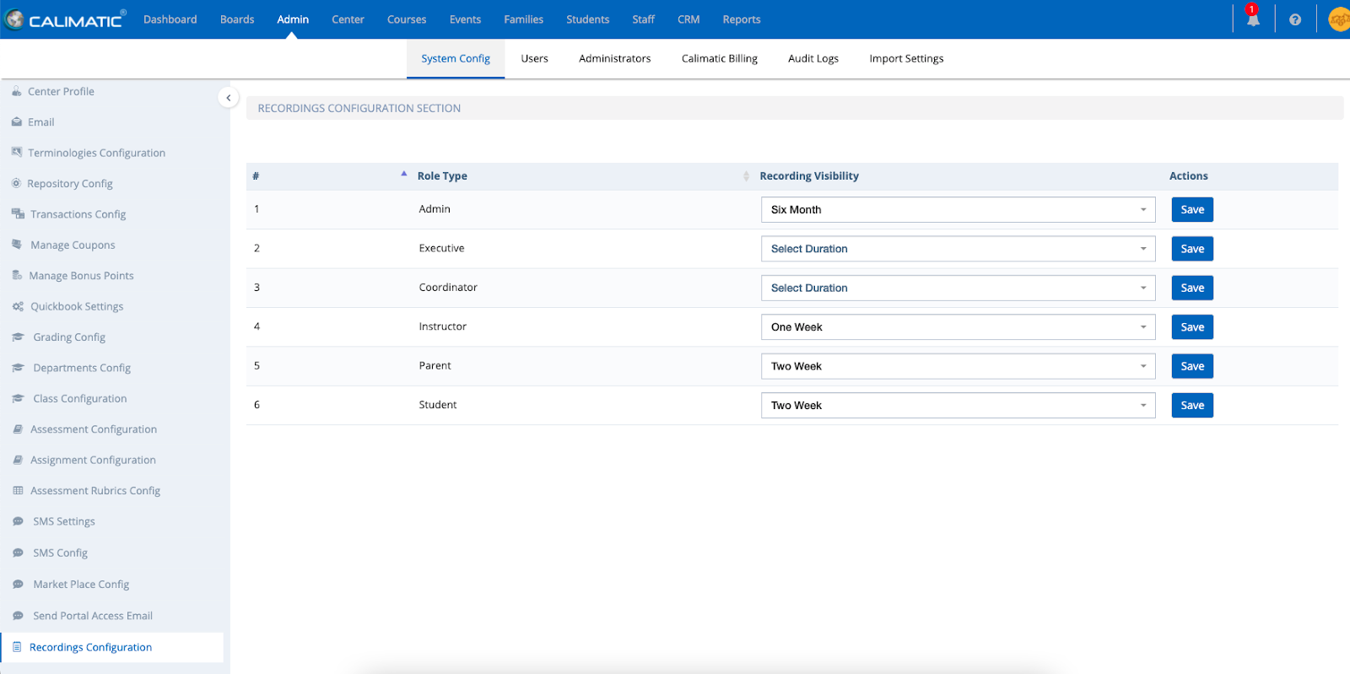

#### **Confirmation - Setting Students to In-Active if there is balance due**

A confirmation popup will display when you are setting a Student to In-Active if there is any amount due for the Student. If you don’t want to set the Student to In-Active until you collect the balance payment, this confirmation popup will help you to collect the payment. You can skip and continue with In-activation if collection is not needed.

#### **Control Sending Portal Access Email**

New settings have been introduced to set where the system has to send Portal Access email to the parents or students when enrolling to a Course/Class or Event.

**Navigation:** Admin > System Config > Send Portal Access Email

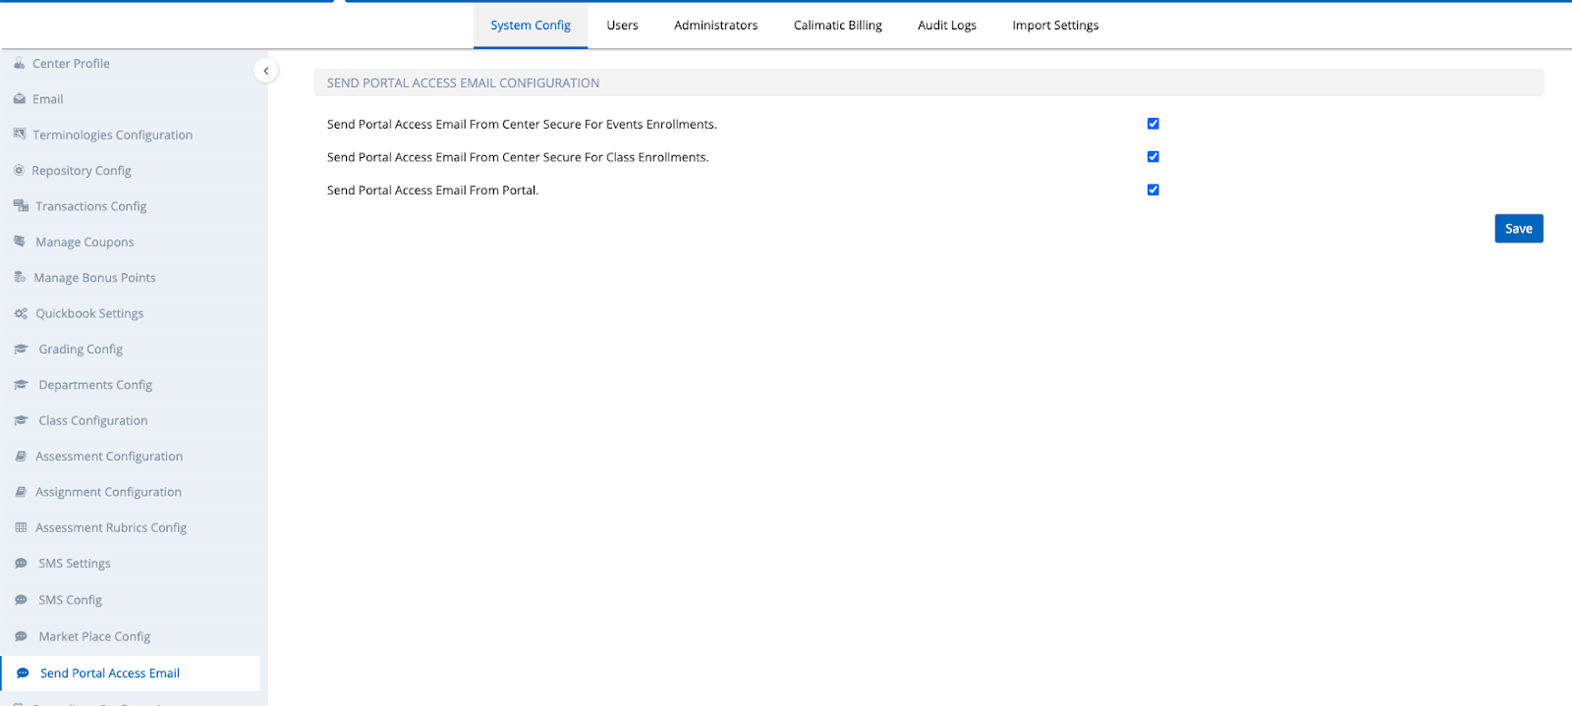

#### **Ordering your Courses Display in the Enrollment Pages**

The system provides the ability to order the Courses that are displayed in your website (embedded enrollment pages). Each Franchise can perform their own ordering.

Navigation: Courses > Class > Class Setup.

Click on the Ordering button under the Category tab for which you want to order the courses.

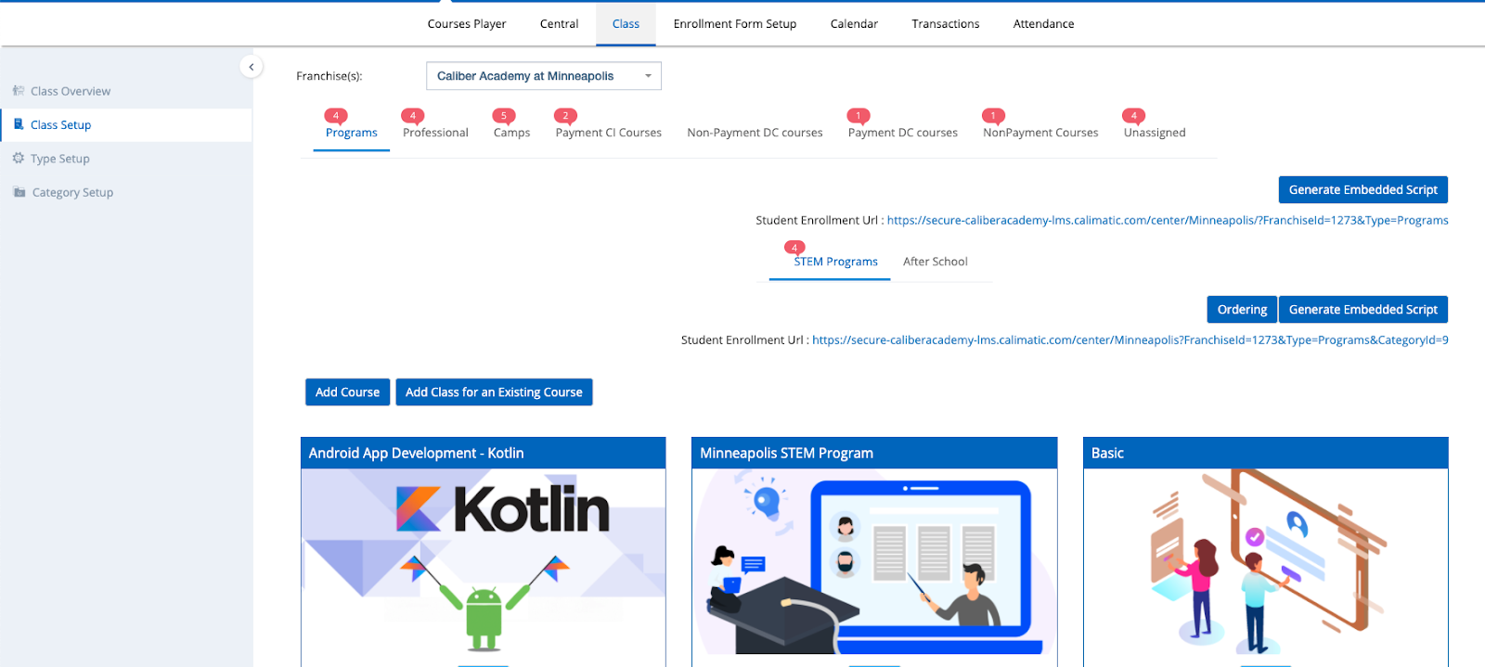

In the Ordering popup, you have the ability to order the Courses. The ordered courses will be displayed in the same order in the Enrollment pages.

#### **Send Student/Family Info from One Franchise to Another Franchise**

This implementation was done previously only for the Business/Master Account. Now it is applied for Franchises as well -

If a Student is transferred from one franchise to another, we have provided a feature where the Business admin can email the information of the Student from one franchise to the other franchise admin. You can do the same for a Family as well.

Navigation:

1. Students > Students Info > For any Student row in the grid, hover on the row and click on Actions button. Click on the “Share Student Detail” option.
2. Families > Families Info > For any Family row in the grid, hover on the row and click on Actions button. Click on the “Share Family Detail” option.

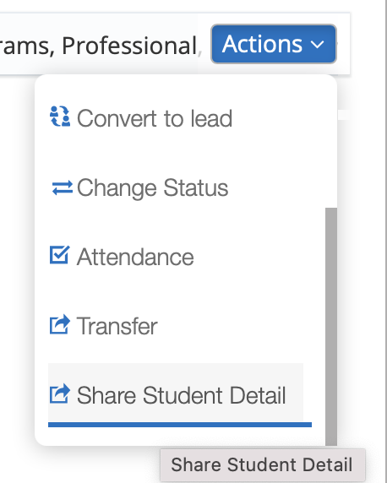

Select the Franchise to which the Student needs to be transferred. Click on the Share button.

The system will send an email to the Franchise admin with the details.

#### **Few Bugs fixes have been made**

Along with the Features, we also fixed bugs that were encountered by the customers and some previous pending bug fixes.

Some of the fixes include -

1. Add Items to Franchise' copying items that are in deleted status. It should not copy deleted ones.
2. Events > Event Overview> Add Student popup> Add new Student> enroll in an Event, unable to login to tats Student.
3. Admin > User tab > Show pending payment alert when changing Active/ In_Active status of students.
4. In enrollments > Class details, Getting Exception when i open Class details Reports.
5. Show refunded amount column in Revenue grid in Reports.
6. In Classes setup > ordering, all courses and levels are showing in unassigned category even when classes have assigned categories
7. When we make duplicate categories and assign course to one of those categories, the course shows in both categories
8. Lead Contact form creation issue fixed
9. CRM > Leads> Lead Source, search for a contact form and its Shows no data in some cases.
10. CRM> Leads > Advanced Filters, when select 2 contact forms, Dropdown Text is displaying wrong
11. Show Pending Payments Confirmation Alert while updating Student Status. Areas Covered (Course Player,Classes Overview,Events Overview)
12. Show Pending Payments Confirmation Alert is showing when there is no pending payment exists against the student.
13. Show refund row in transaction statement
14. Add filters in CRM -> Emails->Emails sent ->View Leads
15. Date filter feature for lead emails
16. Issue in the advanced filter for any custom date fields in Leads page
17. Events > Add new Student > payment, Payment of that specific Event shows Hold status in Payment grid.
18. Status is not showing for course and level in Ordering Modal.
19. Business account > lead page > filters are not working
20. In the Student board & course player, in join classes dropdown > student & parent should see only those classes that are directly enrolled against students.
21. In billing, the total revenue comparison is not showing the data correctly.
22. In Classes Overview > when parents add a new student then the student did not go under the existing parent's family and new student with new family created.
23. In Classes overview > add students to class, Classes are shown to instructors which are not assigned to instructors, also none of the students or instructor is enrolled in class.

### **March 1st, 2021 - Web Portal**

March 1st, 2021 Release Notes for Calimatic EdTech Web portal



Written By Ivan Karmer

Updated 2 years ago

#### **Filters (Status, Classes, Events & Billing Info) -**

Separate Filters option is provided in the Families Info & Students Info pages to

1. Filter Status of Families or Students, Set to a Status Filter by default
2. Filter by a Class, Set to a Class Filter by default
3. Filter by an Event, Set to an Event Filter by default
4. Filter by Billing Info, Set to Billing Info Filter by default

**Navigation:**

1. Students > Students Info > Click on the Filters button
2. Families > Families Info > Click on the Filters button
3. Reports > Enrollments > Enrollment Details

**Demo Videos -**

1. <https://www.screencast.com/t/EXOjPGMav>
2. <https://www.screencast.com/t/z5j4tuMH>
3. <https://www.screencast.com/t/RTjQ5rC2a>

#### **CRM > Emails Sent > Tracked Opened System generated Emails**

In the previous releases we have released the ability to track who opened CRM bulk emails. In this release, the system generated emails are also covered.

Navigation:

CRM > Emails > Emails Sent > System Emails

The “Email Status” column shows the “Opened” status in the column if the System email is opened by the user.

#### **Assessments - Code Editor Option**

Taking the Assessments to the next level, we have introduced the option to add Code in a Question and/or have the ability for the students to write code in their answer.

The code editors provide the Syntax Colors and IntelliSense functionalities while storing the code securely in the system. By default, we provided some coding languages but if you need any missing language, please email us appteam@calimaticedtech.com.

**Demo video -**<https://www.screencast.com/t/7f1q91eD>

#### **Introducing Assignment to the Steps/Lessons**

In order to accommodate individualized learning experience, the assignment structure has been enhanced.

Currently, there is ability to assign following items (note that the following terminologies can be adjusted in Admin > System Config > Terminologies Configuration) -

1. Courses
2. Levels
3. Challenges or Topics

With this release we have provided the ability to set assignments of the Steps or Lessons. The Steps or Lessons are in the “Students Instructions” tab within the Challenge or Topic.

By default, all the Steps or Lessons are assigned to all the students who are assigned to the Challenge or Topic.

In order to manually handle the assignment of the Steps or Lessons to Students, you can turn off the setting in Admin > System Config > Assignment Configuration -

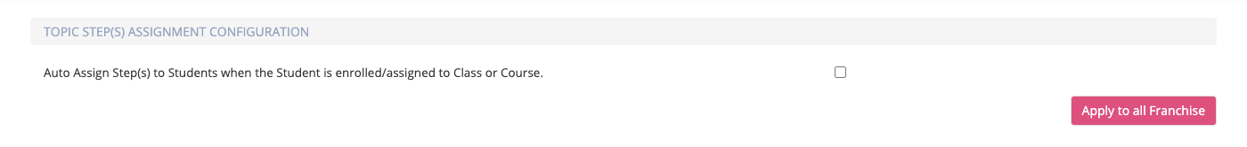

Within the Challenge or Topic, click on the Student Instructions tab. The Steps and Lessons that are within the Challenge or Topic are displayed. Click on the edit icon for any step and you will notice that the Assign button is displayed. Using the Assign button, you have the ability to assign or unassign any Step -

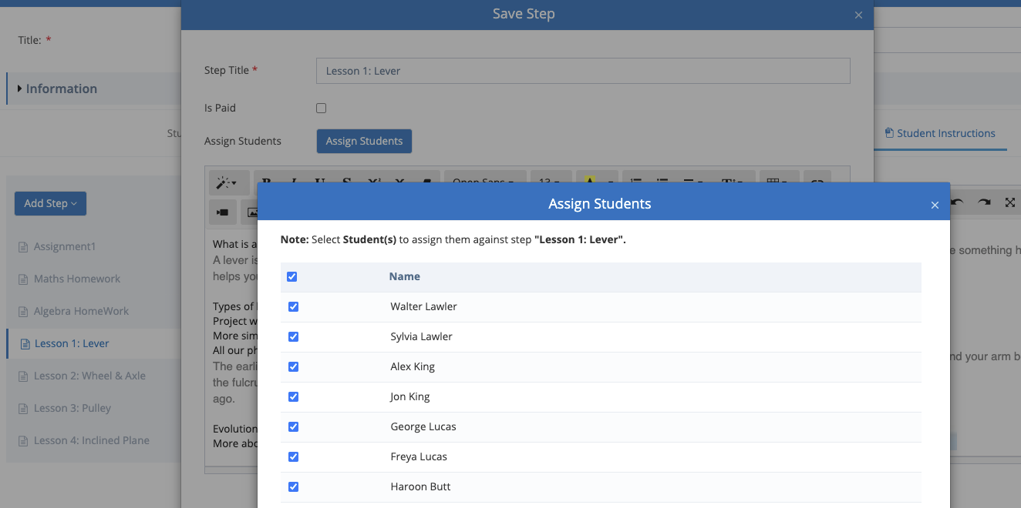

#### **Few Bugs fixes have been made**

Along with the Features, we also fixed bugs that were encountered by the customers and some previous pending bug fixes.

Some of the fixes include -

1. Default Sort By Data for Franchise Secure For Classes/Events In Portal.
2. Date Column Was Missing in Add More Classes popup. (In Franchise Secure)
3. Restrict Duplicate Emails in CC’s & To’s. (LMS Billing).
4. Send Emails to CC’s In Case Of collecting pending Franchise Fee. (Credit Card)
5. Loader is added to the first Time page load after Login. (In Portal)
6. Disable video option in the CRM Email Template editor.
7. Secure Documents changes for Attachments added by Attachment step.
8. UI Issues Fixed In Franchise Secure & Portal.
9. Student Info Grid Filtering In Portal. Model Changes
10. Email Send and Open functionality.
11. General issues fixed - Ignore Space from filters
12. All the reports, default filter start date, and end date should be the current month
13. Course player tooltip issue when video is added
14. course player detail page buttons issue incase of attachment franchise >billing ,correct spelling mistakes
15. White board button UI Issues.
16. Assessment Popup language dropdown hiding issue fixed
17. fixed email to and cc duplicate issue case sensitive In portal
18. fixed email to and cc duplicate issue case sensitive In Billing app
19. Email Opened and delivered functionality in Board and fixed some issues.

### **Feb 3rd, 2021 - Web Portal**

Feb 3rd, 2021 Release Notes for Calimatic EdTech Web portal



Written By Ivan Karmer

Updated 2 years ago

#### **Business Admin -- Send Student/Family Info to Another Franchise**

If a Student is transferred from one franchise to another, we have provided a feature where the Business admin can email the information of the Student from one franchise to the other franchise admin. You can do the same for a Family as well.

Navigation:

1. Students > Students Info > For any Student row in the grid, hover on the row and click on Actions button. Click on the “Share Student Detail” option.
2. Families > Families Info > For any Family row in the grid, hover on the row and click on Actions button. Click on the “Share Family Detail” option.



Select the Franchise to which the Student needs to be transferred. Click on the Share button.

The system will send an email to the Franchise admin with the details.

#### **Fee Payments - Post Fee - Providing both Number and % Discount options**

The system provides both Number and Percentage options for the Post Fee payments feature.

Navigation:

1. Students > Payments > Under Fee Payments > Click on the Post Fee button.
2. Families > Payments > Under Fee Payments > Click on the Post Fee button.

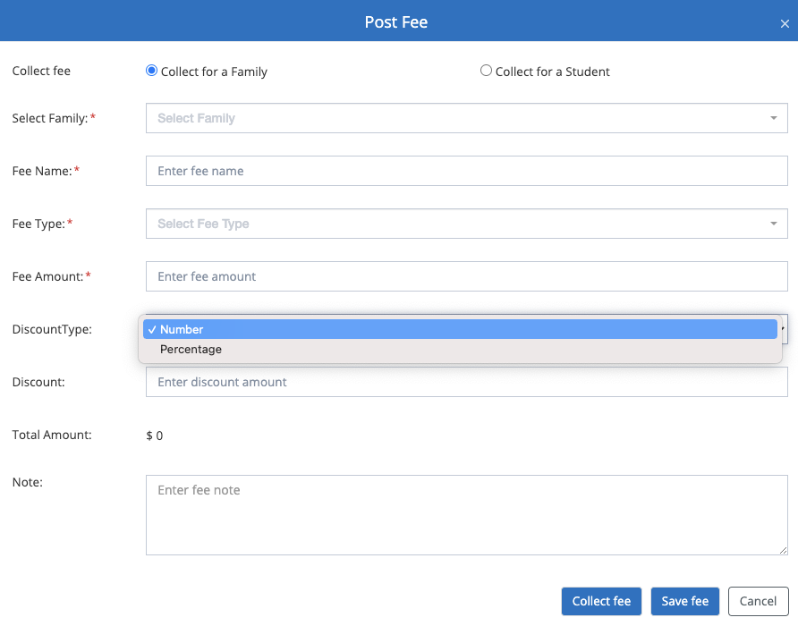

#### **Attachments option for emails sent from Students or Families Info popup**

The system provides the ability to add attachments while sending emails to the Students or Family from the Student or Family info popup.

Navigation:

1. Students > Students Info > Double click on any Student > In the popup header, click on the Email icon (top right corner of the popup).
2. Families > Families Info > Double click on any Family > In the popup header, click on the Email icon (top right corner of the popup).

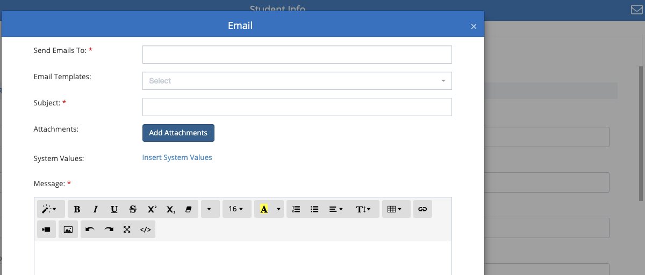

#### **CRM > Contact Forms > Provided additional fields as System Fields**

For the Contact forms, following additional fields are provided as system fields that are disabled by default. You have the ability to enable them for any forms you need.

1. Address
2. State
3. City
4. Zip

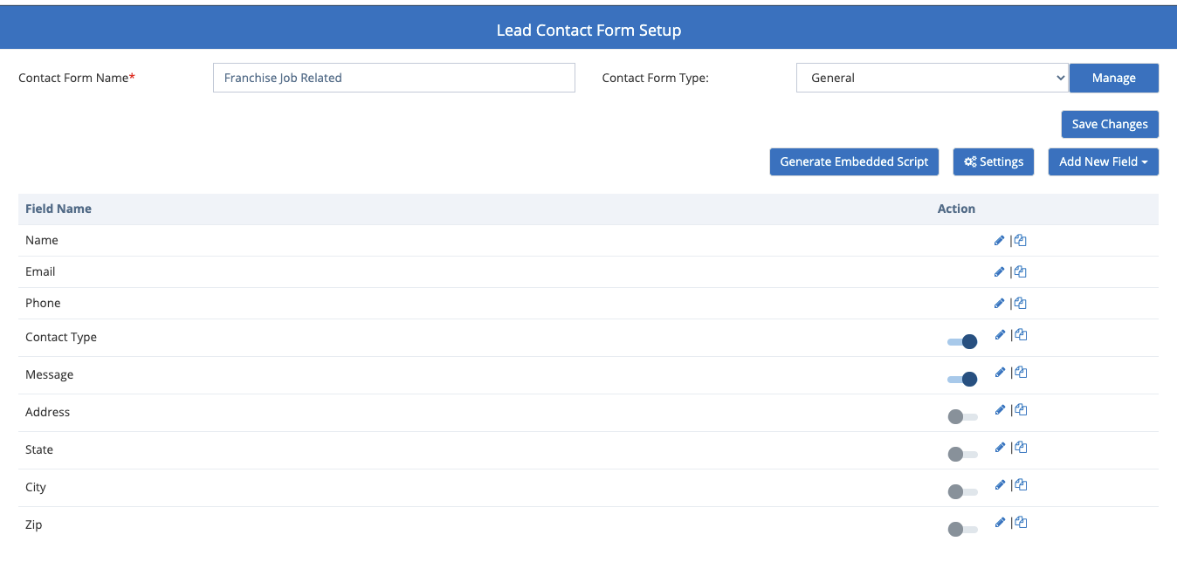

#### **CRM > Leads > Email Lead from the Lead popup**

The system provides the ability to send an email to a Lead directly from the Lead popup instead of going into the Emails module.

Navigation:

CRM > Leads > Double click on any Lead in the grid > Click on the Email icon on the top right side of the popup header.

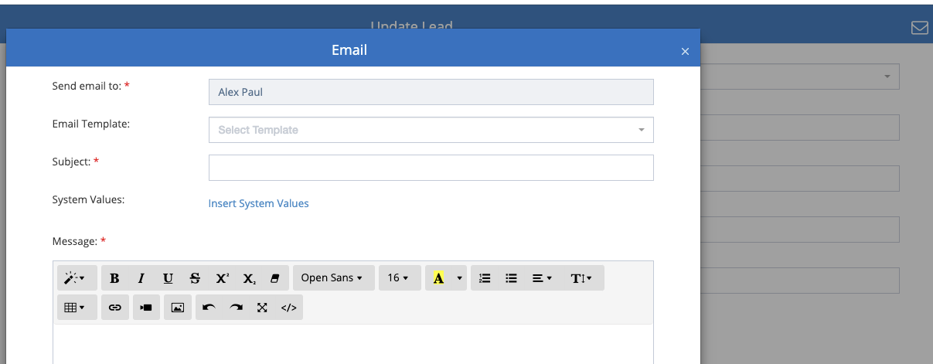

#### **Few Changes in the System**

1. Payments - When recurring payment occurs, the email sent to the users will have the email subject format as “Transactions Summary - <today’s Date>”.
2. Payments > Recurring Payments - When a Student is enrolled within the portal to a Class that has recurring payment, the next recurring scheduled date used to be the enrolled date. A change has been made to keep the recurring start date as blank if you choose not to collect the payment immediately.
3. CRM > Leads > Advanced Filters - For the Contact forms field, the Forms drop down list has been changed to multi-select. This will allow the user to select multiple forms to filter.

#### **Few Bugs fixes have been made**

Along with the Features, we also fixed bugs that were encountered by the customers and some previous pending bug fixes.

### **Jan 14th, 2021 - Web Portal**

Jan 14th, 2021 Release Notes for Calimatic EdTech Web portal



Written By Ivan Karmer

Updated 2 years ago

#### **Homework/Assignment Enhancements**

Assignments/Homework functionality has been enhanced with this release. For each Challenge, you have the ability to add new Assignment/Homework to it. When the Challenge is assigned to the Student then the corresponding Assignments/Homework are assigned.

Within the Challenge popup/page, click on Add Step > Add Assignment/Homework.

In here, you have the ability to either create a new one or choose from the existing assignments/homework. You have the ability to specify the priority & due date by when the assignment/homework should be submitted. You have the ability to add instructions & attachments for the Student to follow & review.

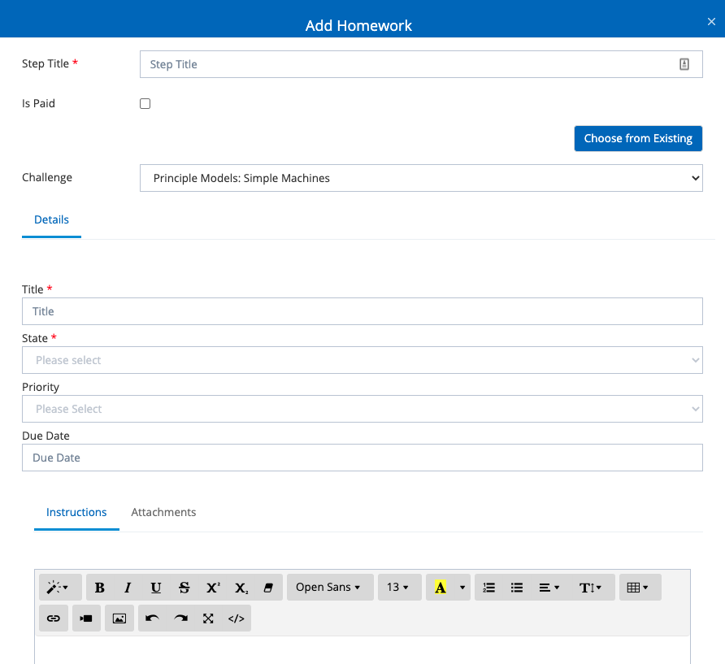

When the Student opens the Challenges & the corresponding Assignment/Homework, they have the ability to Submit their work by clicking on the Submit work tab.

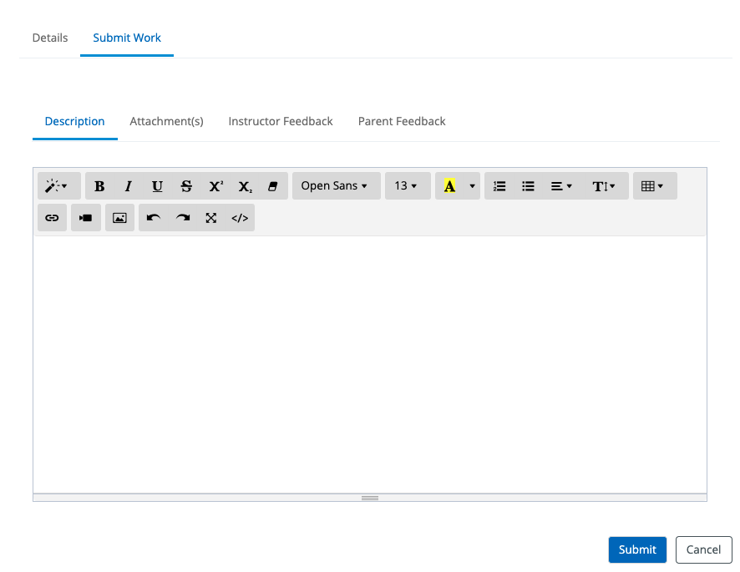

They can provide their work description in the description tab and add any attachments in the Attachments tab.

Instructions can review the homework and provide their feedback in the Instructor Feedback tab.

Parents have the ability to provide any of their feedback in the Parent feedback tab for the corresponding homework.

**Track Students Homework in the Student’s Board >**

In each Student board, click on Boards & select Homework option. All the Homework/Assignments for the Students are displayed here. Clicking on the Manage Homework button will open a popup where all the Homework/Assignments can be managed.

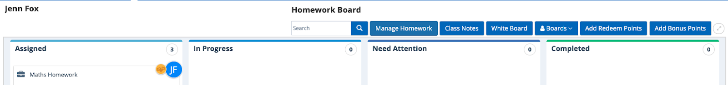

**Track Students Homework in Course Player >**

Navigate to Courses > Courses Player > Select a Course.

For any Homework/Assignments that are submitted, you will the number of submitted homework. Clicking on the button will open a popup where you can track all the submissions.

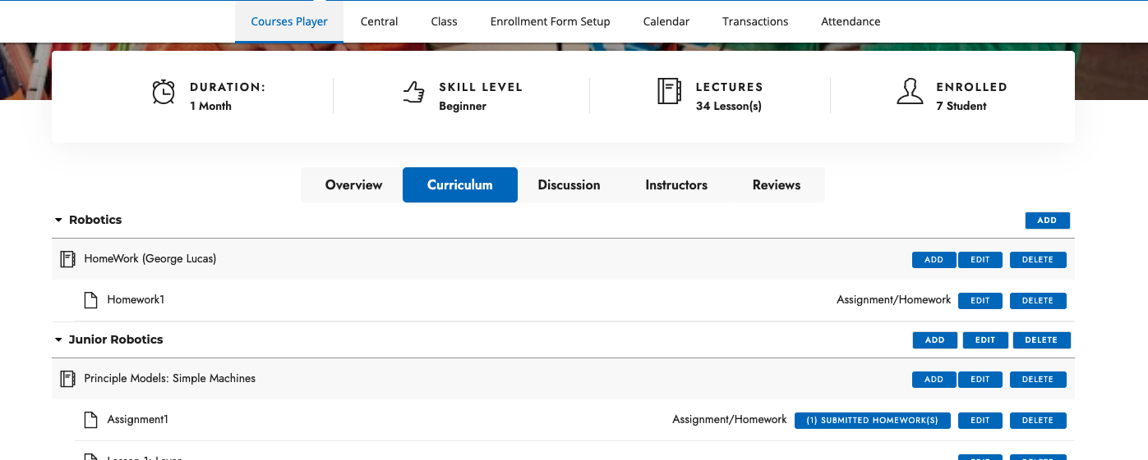

#### **Few Email related changes/issues have been taken care of**

1. In some cases, the email is not sent when you click on the Email icon in the Families Info and Student Info popup and send it from there. This is now resolved.
2. CRM > Emails > Email Templates -
   1. Resolved - When the Email Template is copied from Business account to Franchises, the Footer is not syncing properly and not getting added to the emails.
   2. Email Template Editor default font size is now set to 16.
3. CRM > Emails > Send Emails -
   1. There is no need to select the Template to start a new email. Navigating to the page & tab will open with blank fields. When you select a Template then it will fill the information with the template information.

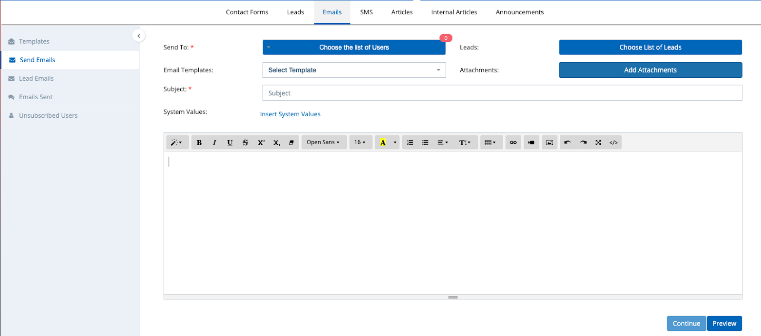

* 1. Remove Required Flag for the Attachments

#### **Student Boards > Provide Delete icon on the Challenge Card**

In the Student Board, when you right click on the Challenge Card, there is ability to delete the challenge. However, for some users this option is not working in certain machines. Now, the Delete icon is available on the Challenge card on the right bottom side to delete the challenge.

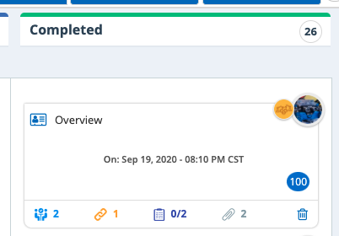

#### **Business Admin related changes**

#### **Business Admins - Franchises Billing**

Following Franchises Billing changes are rolled out -

Business Admin > Franchises > Billing > Add/Update Fee - The Recurring field is now not a required field. You have the ability to create adhoc fee and post the fee.

#### **Few Bugs fixes have been made**

Along with the Features, we also fixed bugs that were encountered by the customers and some previous pending bug fixes.

### **Jan 1st, 2021 - Web Portal**

Jan 1st, 2021 Release Notes for Calimatic EdTech web portal



Written By Ivan Karmer

Updated 2 years ago

#### **Transaction Statements - Ability to Add Notes**

The system provides the ability to add Notes for the Generated Transaction Statement PDF in order for you to include details like Tax ID, Additional Fee details and any other information.

Please note that the Notes information is not stored in the system. It is just added into the Generated PDF. Please retain the copy of the PDF if you would like to retain the Notes for future use.

Navigation:

1. Students > Students Info > Click on any Student name > Click on Transactions tab > Transactions Section. Select a Date Range and click on Generate button.
2. Families > Families Info > Click on any Family name > Click on Transactions tab > Transactions Section. Select a Date Range and click on the Generate button.

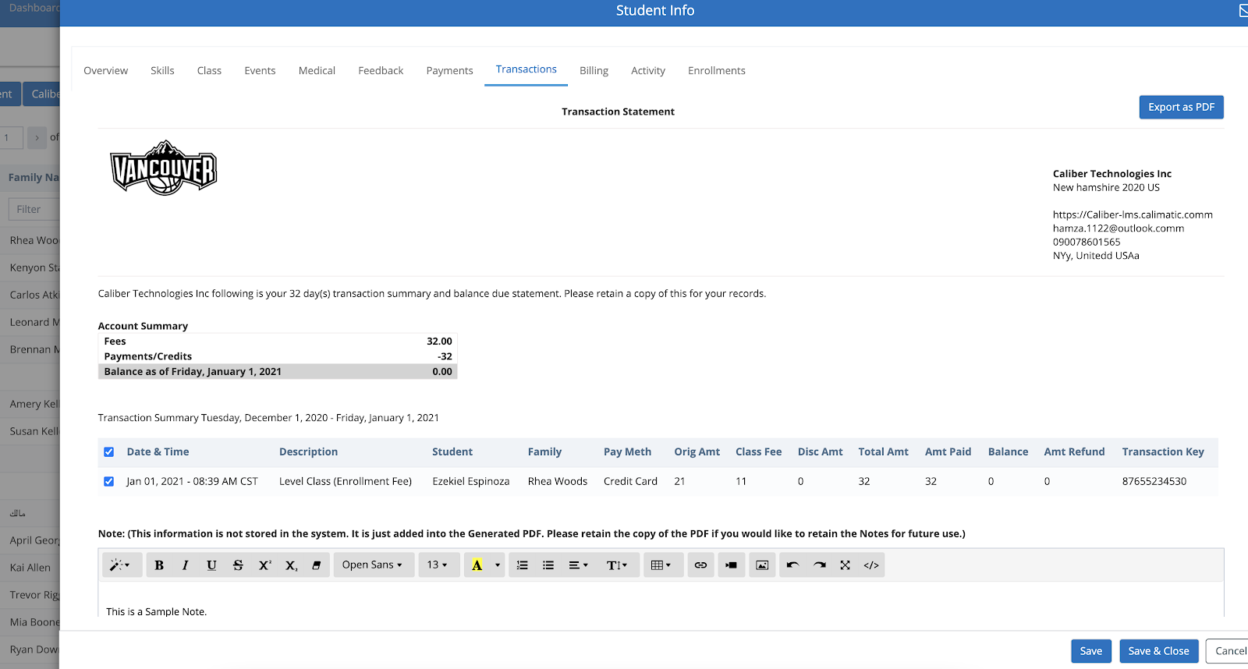

Entering the required information into the Notes Text Editor field and Clicking on “Export as PDF” button will export the statement with the Notes.

#### **Transactions Statement - Ability to Generate Statement PDF only for the selected items**

The system provides the ability to Generate the Transaction Statement (PDF) for only the selected Transactions of your choice within the selected Date Range.

Navigation:

1. Students > Students Info > Click on any Student name > Click on Transactions tab > Transactions Section. Select a Date Range and click on Generate button.
2. Families > Families Info > Click on any Family name > Click on Transactions tab > Transactions Section. Select a Date Range and click on the Generate button.



In the Transactions grid, selecting the checkboxes of the required Transactions and clicking on the “Export as PDF” will export the Transactions Statement in a PDF for the selected Transactions.

#### **Included Class Name, Event Name or Class Fee Name in Stripe Recipients**

The Stripe Recipients were showing the Description as TOTAL. With this release, for all the future Transactions, the Stripe Recipients will

1. Include the Class Name for every Class Enrollment payments
2. Include the Event Name for every Event enrollment payments
3. Include the Fee Name for every Fee Payments

The Stripe recipients are included in the Emails sent after any Transaction is processed.

Users can access the Recipients anytime from the system by navigating to -

1. Students > Transactions - In the grid, the Recipient url column will have the Recipient links.
2. Families > Transactions - In the grid, the Recipient url column will have the Recipient links.

#### **Direct Class Enrollment Link - Embedded Link - Shortened URL**

Navigation:

Courses > Class > Click on Actions button for any Class. Click on the “Copy Embedded Link” option.

The link is now a shortened URL with a GUID being displayed in the URL. Previously it was showing the complete Query string.

This shortened URL can be provided to the users for them to directly enroll to the corresponding class.

#### **Business Admin related changes**

#### **Business Admins - Franchises Billing**

Following Franchises Billing changes are rolled out -

1. Ability to collect the Fees for the Failed Payments.
2. Stripe Recipients will include the Fee Name instead of displaying just the “TOTAL” word

#### **Few Bugs fixes have been made**

Along with the Features, we also fixed bugs that were encountered by the customers and some previous pending bug fixes.

### **Dec 23rd, 2020 - Web Portal**

Dec 23rd, 2020 Release Notes for Calimatic EdTech web portal



Written By Ivan Karmer

Updated 2 years ago

#### **Provide Discounts for Recurring Enrollment Payments**

A new option (Add Additional Discount) has been added for the Scheduled or Manual Recurring Enrollment payments.

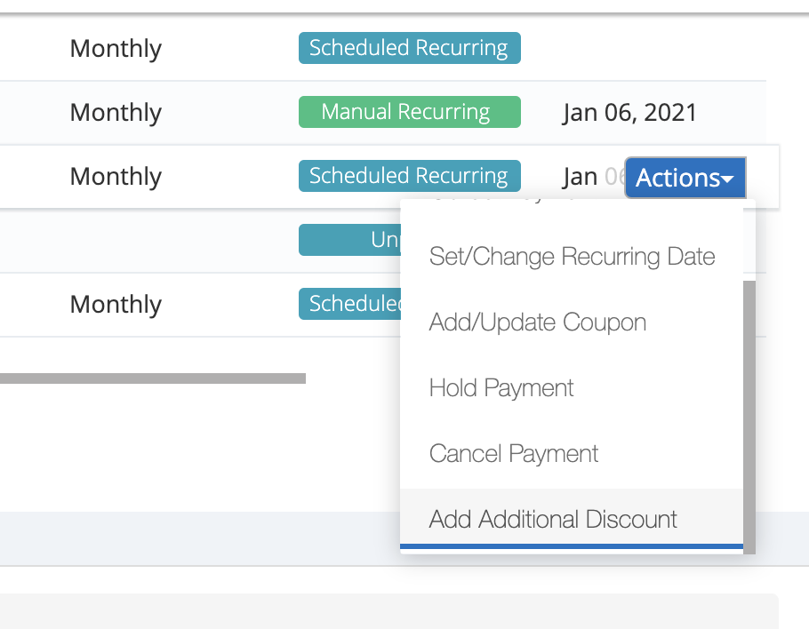

This allows you to provide discounts for any particular duration for the recurring payment.

Navigation -

1. Families > Payments > Under Enrollment Payments section, for any payment that has Status as “Scheduled Recurring” or “Manual Recurring”, hover on the row and click on Actions button. Scroll down and click on the “Add Additional Discount” option.
2. Students > Payments > Under Enrollment Payments section, for any payment that has Status as “Scheduled Recurring” or “Manual Recurring”, hover on the row and click on Actions button. Scroll down and click on the “Add Additional Discount” option.

In the popup, all the Discounts provided for the Payment are displayed here. Click on “Add Discount” button to add a new discount. In the “Add Discount” popup, you have following abilities -

1. Discount Type - You have the ability to provide discount by number or by percentage
2. Disc. - You have the ability to provide the discount (number of percentage).
3. Start Date - You have the ability to specify from which date the Discount will be applied.
4. End Date - You have the ability to specify until when the Discount will be applied.

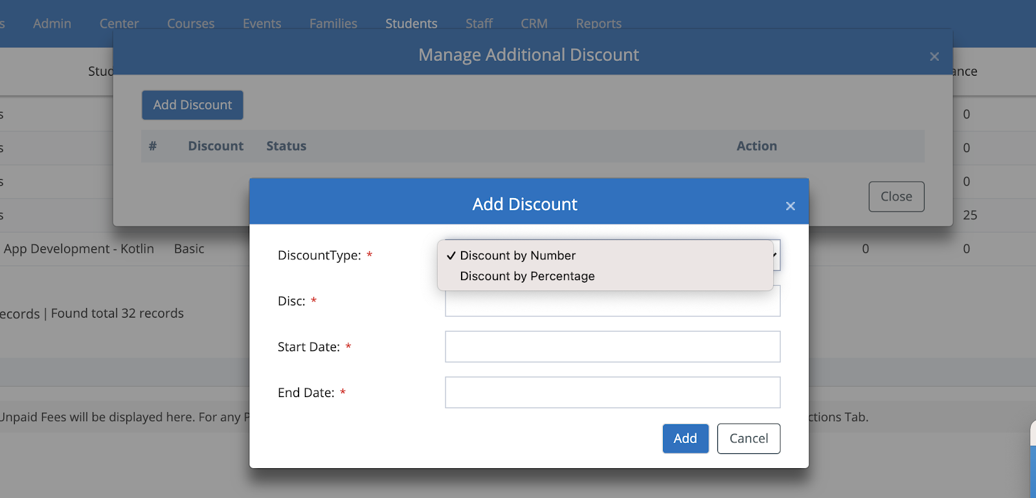

#### 

#### **Events Enrollment > Cart Message**

The Successful message pointing to the Cart has been added to the Event Enrollment pages. It works the same way that we have in the Classes.

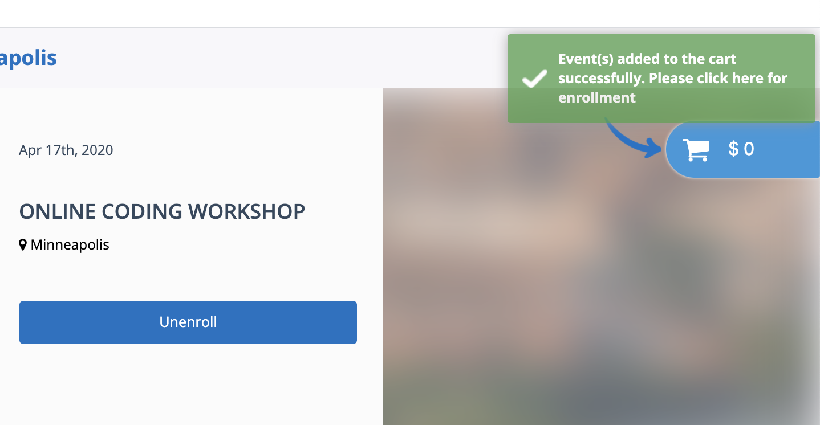

#### **Business Admin related changes**

#### **Business Admin - Ability to view all Franchises/Centers Classes & Events Setup**

The system provides the ability for the Business Admins to view all Classes and Events for the corresponding Types and Categories.

Navigation -

1. Courses > Class > Classes Setup
2. Events > Events > Manage Events

Clicking the Franchise(s) drop down list will display all the active Franchises/Centers. Selecting the option will show the appropriate Franchise/Center Classes/Events.

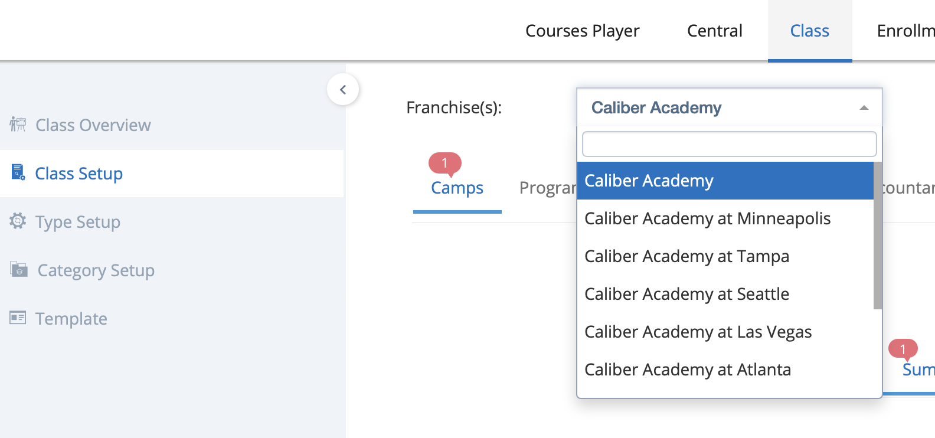

#### **Business Admins - Franchises Billing**

Following Franchises Billing changes are rolled out -

1. Send email to Business Admins when Franchise Billing info was not active and when there is a failed payment.
2. Display the Failed payments information in Franchises > Billing > Transactions section.
3. Issue Fixed - Franchises > Billing > Add Franchise Fee is not working if multiple franchises are selected and it only applies to the first franchise.
4. Send Calimatic email as well when Franchise Fee is charged along with the Stripe email. Display Fee Details in the Calimatic email.

#### **Few Bugs fixes have been made**

Along with the Features, we also fixed bugs that were encountered by the customers and some previous pending bug fixes.

### **Dec 9th, 2020 Release - Web Portal**

Dec 9th, 2020 Release Notes for Calimatic EdTech web portal



Written By Ivan Karmer

Updated 2 years ago

#### **Pending Payments/Fees (Audit Report)**

In order to ensure you are tracking pending payments or fees or failed transactions, this Audit report functionality has been introduced. In this page, you have the ability to view all the pending payments for the selected date range of Classes or Events (or) Student Fee for a selected date range.

Navigation - Reports > Billing > Pending Payments/Fees

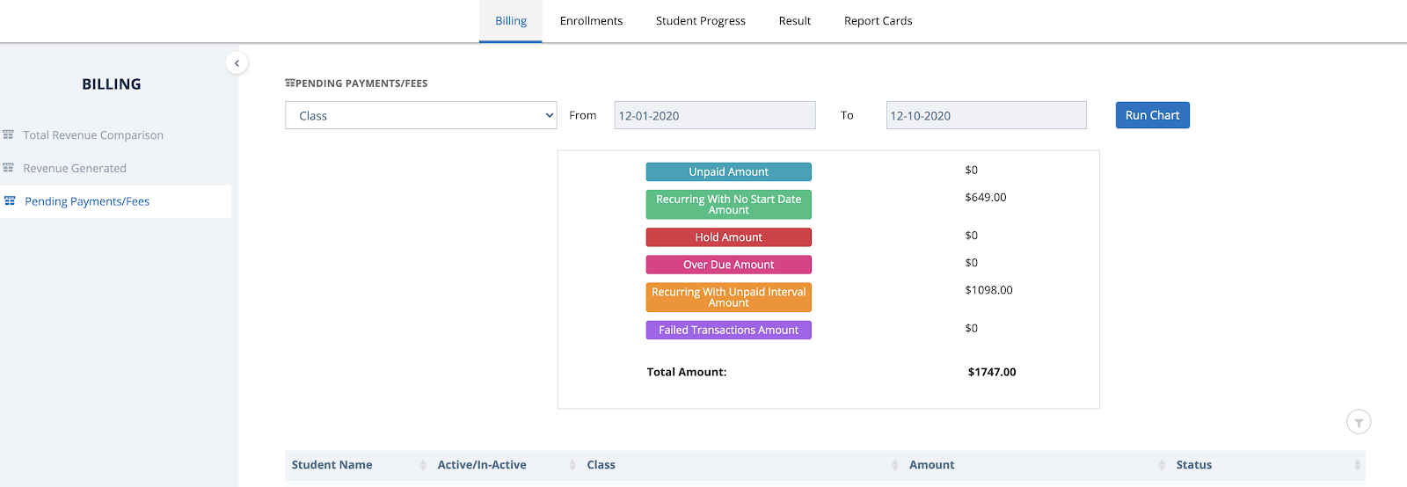

#### **CRM - Ability to attach Attachments when sending Emails**

The system provides the ability to add **attachments** while sending emails from CRM. The emails with attachments are sent to the selected Users and/or Leads.

Navigation - CRM > Emails > Send Emails.

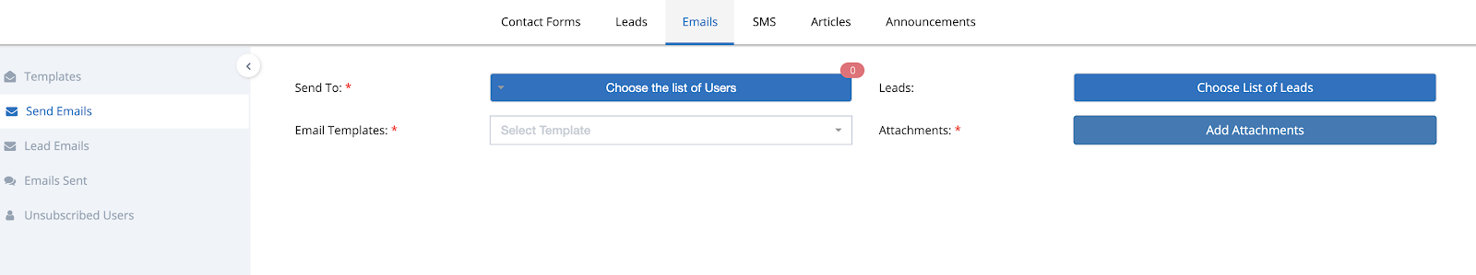

#### **CRM - More Tracking for the emails sent from CRM (including “who” opened the email)**

More tracking capabilities have been added to the Emails sent from the CRM module. You will be able to track -

1. Number of Emails Sent (in one Bulk email)
2. Number of Emails Opened by the users/leads (that are sent from CRM Emails)
3. View the list of Users to whom the emails are sent, their details and the Email delivery and opened status.
4. View the list of Leads to whom the emails are sent, their details and the Email delivery and opened status.

Navigation - CRM > Emails > Emails Sent.

**Demo -**<https://www.loom.com/share/909fc45dd1af46f8baa2bd49a0ffe5d2>

#### **Payment Pages - Column Settings**

Column settings functionality has been added to the Payments grid in the Payment Pages to reorganize the columns, set the width of the columns and enable/disable which columns to see.

Navigation -

1. Students > Payments. Click on the Column Settings icon.
2. Families > Payments. Click on the Column Settings icon.

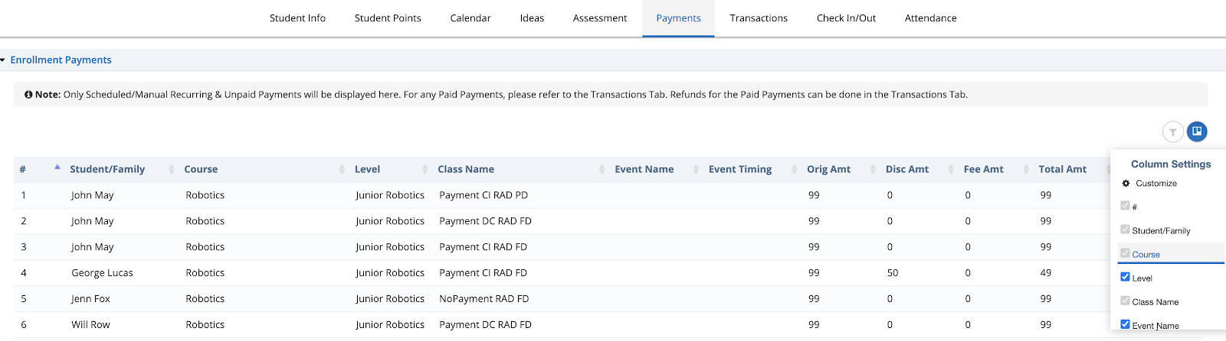

#### **Student Boards - Maintains Challenges Order based on the order set in Central**

The challenges in the Student Boards will now be automatically arranged in the order that are set in the Courses > Central page.

Even if the challenges are reordered in the Student Boards page, then will be arranged back to the order that they are set in the Central page. This also applies when new challenges are added, deleted or modified.

#### **Send Email to Master/Business Admin when a new Franchise Enrollment is submitted**

The system sends a notification to the Master/Business Admin when a new Franchise Enrollment is submitted.

#### **Few Bugs fixes have been made**

Along with the Features, we also fixed bugs that were encountered by the customers and some previous pending bug fixes.

### **Nov 21st, 2020 Release - LMS Web Portal**

Nov 21st, 2020 Release Notes for Calimatic LMS web portal



Written By Ivan Karmer

Updated 2 years ago

#### **Email Notification Setting (Portal Enrollments & Recurring Payments) -**

The system now provides 2 different settings for sending Emails to Parents & Students. Previously it was a combined setting. You have the ability to set it ON or OFF based on your need.

These settings are available in Admin > System Config > Emails > Email Frequency section.

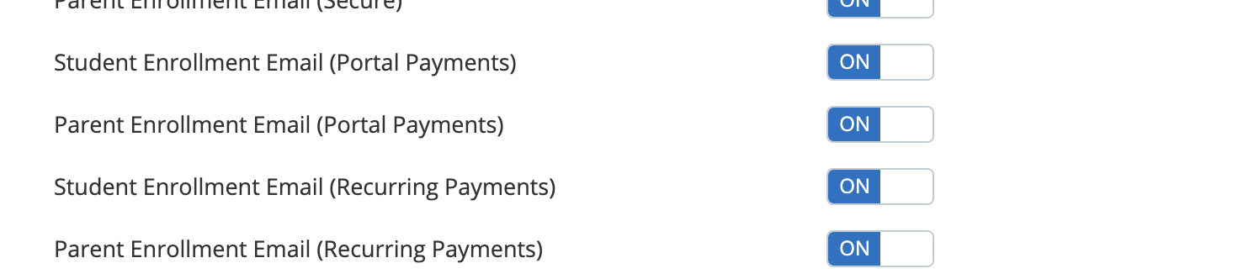

#### **Portal Enrollments - Recurring Start Date**

Within the Portal, When a Student is added to a Class that has recurring payment set and when the Payment is not made then the Recurring Start Date will not be set by default. You will have the ability to set the recurring details as per the need.

**Demo -**<https://www.screencast.com/t/SAZxF7ams>

Following scenarios provides different scenarios of the recurring payments for the enrollments that are made within the Portal. Green color highlighted text represents the change that has been released with this release.

If current Date is Nov 6th, 2020 -

| **Class Pricing Recurring that has been set for a Class** | **Add Student to the Class**  **from Portal** | **If there is Billing on File** | **Payment Action** | **Status** |
| --- | --- | --- | --- | --- |
| **Auto Deduct**  Start Date - Nov 10th, 2020 (Future Date)  End Date | When Student is added to a Class, confirmation appears (Payment Information is available on file. Would you like to collect the payment?) | Yes | If you select **Yes** option then it **will collect** the payment.  Next scheduled Recurring Date of Student - **Dec 6th, 2020**  If you select **No** option then it **will Not collect** the payment.  Recurring Start Date is NOT Set | **Status** set to  **Scheduled Recurring** |
| **Auto Deduct**  Start Date - Nov 10th, 2020 (Future Date)  End Date | When Student is added to a Class, without collecting any payment, it automatically enrolls the student to the class as there is no billing on file | No | Payment **NOT collected**.  Recurring Start Date is NOT Set  No payment is collected until Billing is added. | **Status** set to  **Scheduled Recurring** |
| **Not set to Auto Deduct**  Start Date - Nov 10th, 2020 (Future Date)  End Date | When Student is added to a Class, confirmation appears (Payment Information is available on file. Would you like to collect the payment?) | Yes | If you select **Yes** option then it **will collect** the payment.  Next scheduled Recurring Date of Student - **Dec 6th, 2020**  But Auto Deduct will not happen.  If you select **No** option then it **will Not collect** the payment.  Recurring Start Date is NOT Set. Auto Deduct will not happen. | **Status** set to  **Manual Recurring** |
| **Not set to Auto Deduct**  Start Date - Nov 10th, 2020 (Future Date)  End Date | When Student is added to a Class, without collecting any payment, it automatically enrolls the student to the class as there is no billing on file | No | Payment **NOT collected**.  Recurring Start Date is NOT Set  No payment is collected until Billing is added.  Auto Deduct will not happen. | **Status** set to  **Manual Recurring** |

#### **Recurring Payments - Ability to Disable past recurring Payments with Reason**

The system provides the ability to disable Past recurring Payments if you don’t want to collect them. You have the ability to specify the reason on why you don’t want to collect the past payment.

**Demo -**<https://www.screencast.com/t/X2YC4m3KFXv>

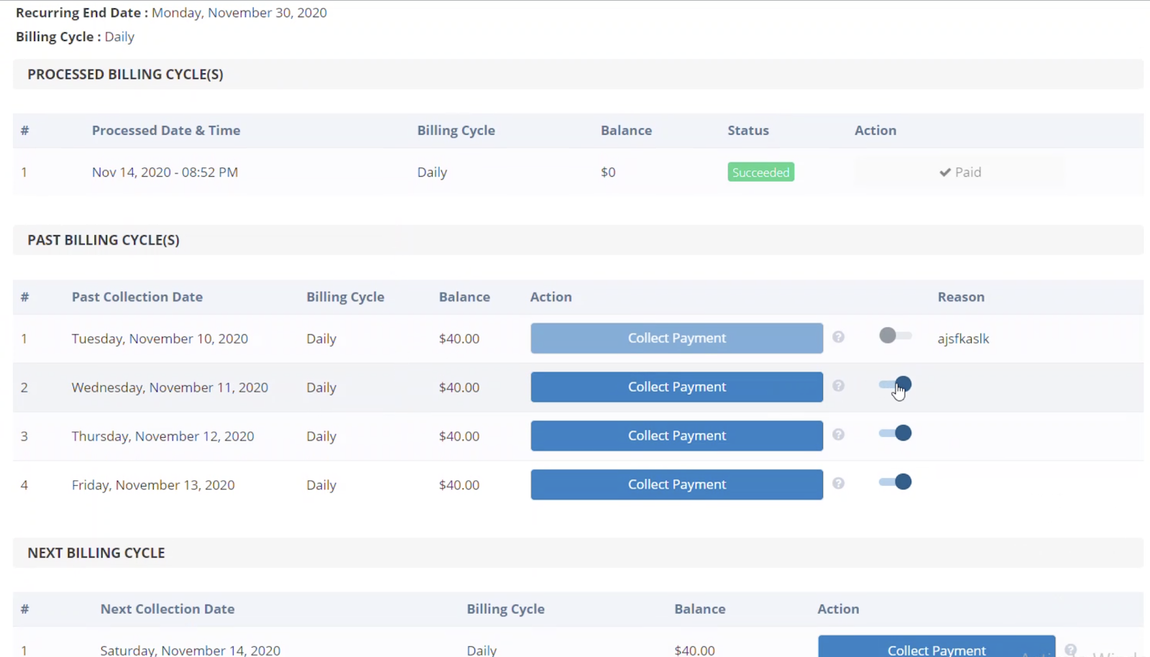

#### **Students Points - Export to Excel, PDF & ability to sort Points**

The system provides the ability to sort any of the Points columns. It also provides the ability to Export the Student Points into Excel or PDF or Print.

Navigation: Students > Student Points.

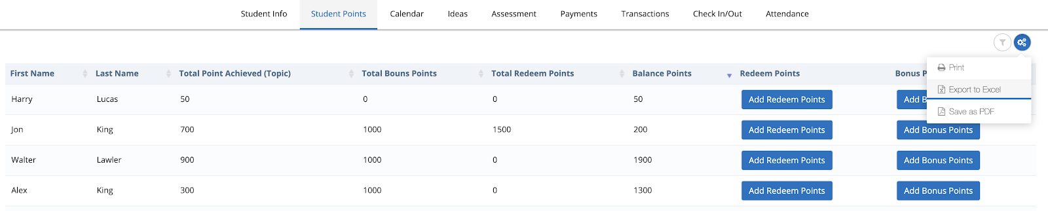

#### **Business or Master Accounts - Franchise Filters for Leads**

The system provides the ability to display all the Leads from all the Franchises in the Leads page and in Emails & SMS pages.

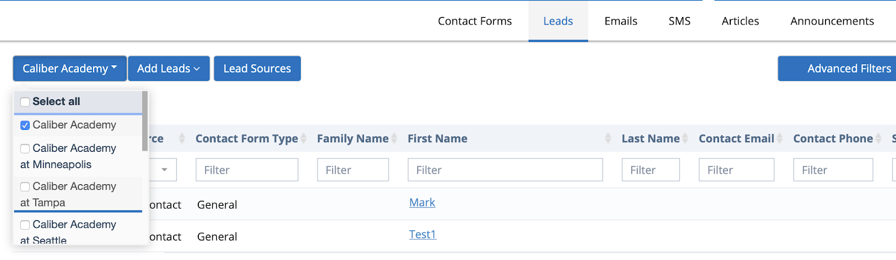

#### **Events - Display events in the Events Overview even without Event timings**

The system was not showing Events in the Events Overview page when there are no Event timings set. Going forwards, the page will display all the Events with or without event timings.

Navigation - Events > Events Overview.

#### **Few Bugs fixes have been made**

Along with the Features, we also fixed bugs that were encountered by the customers and some previous pending bug fixes.

### **Nov 21st, 2020 Release - LMS Web Portal**

Nov 21st, 2020 Release Notes for Calimatic LMS web portal



Written By Ivan Karmer

Updated 2 years ago

#### **Email Notification Setting (Portal Enrollments & Recurring Payments) -**

The system now provides 2 different settings for sending Emails to Parents & Students. Previously it was a combined setting. You have the ability to set it ON or OFF based on your need.

These settings are available in Admin > System Config > Emails > Email Frequency section.



#### **Portal Enrollments - Recurring Start Date**

Within the Portal, When a Student is added to a Class that has recurring payment set and when the Payment is not made then the Recurring Start Date will not be set by default. You will have the ability to set the recurring details as per the need.

**Demo -**<https://www.screencast.com/t/SAZxF7ams>

Following scenarios provides different scenarios of the recurring payments for the enrollments that are made within the Portal. Green color highlighted text represents the change that has been released with this release.

If current Date is Nov 6th, 2020 -

| **Class Pricing Recurring that has been set for a Class** | **Add Student to the Class**  **from Portal** | **If there is Billing on File** | **Payment Action** | **Status** |
| --- | --- | --- | --- | --- |
| **Auto Deduct**  Start Date - Nov 10th, 2020 (Future Date)  End Date | When Student is added to a Class, confirmation appears (Payment Information is available on file. Would you like to collect the payment?) | Yes | If you select **Yes** option then it **will collect** the payment.  Next scheduled Recurring Date of Student - **Dec 6th, 2020**  If you select **No** option then it **will Not collect** the payment.  Recurring Start Date is NOT Set | **Status** set to  **Scheduled Recurring** |
| **Auto Deduct**  Start Date - Nov 10th, 2020 (Future Date)  End Date | When Student is added to a Class, without collecting any payment, it automatically enrolls the student to the class as there is no billing on file | No | Payment **NOT collected**.  Recurring Start Date is NOT Set  No payment is collected until Billing is added. | **Status** set to  **Scheduled Recurring** |
| **Not set to Auto Deduct**  Start Date - Nov 10th, 2020 (Future Date)  End Date | When Student is added to a Class, confirmation appears (Payment Information is available on file. Would you like to collect the payment?) | Yes | If you select **Yes** option then it **will collect** the payment.  Next scheduled Recurring Date of Student - **Dec 6th, 2020**  But Auto Deduct will not happen.  If you select **No** option then it **will Not collect** the payment.  Recurring Start Date is NOT Set. Auto Deduct will not happen. | **Status** set to  **Manual Recurring** |
| **Not set to Auto Deduct**  Start Date - Nov 10th, 2020 (Future Date)  End Date | When Student is added to a Class, without collecting any payment, it automatically enrolls the student to the class as there is no billing on file | No | Payment **NOT collected**.  Recurring Start Date is NOT Set  No payment is collected until Billing is added.  Auto Deduct will not happen. | **Status** set to  **Manual Recurring** |

#### **Recurring Payments - Ability to Disable past recurring Payments with Reason**

The system provides the ability to disable Past recurring Payments if you don’t want to collect them. You have the ability to specify the reason on why you don’t want to collect the past payment.

**Demo -**<https://www.screencast.com/t/X2YC4m3KFXv>



#### **Students Points - Export to Excel, PDF & ability to sort Points**

The system provides the ability to sort any of the Points columns. It also provides the ability to Export the Student Points into Excel or PDF or Print.

Navigation: Students > Student Points.



#### **Business or Master Accounts - Franchise Filters for Leads**

The system provides the ability to display all the Leads from all the Franchises in the Leads page and in Emails & SMS pages.



#### **Events - Display events in the Events Overview even without Event timings**

The system was not showing Events in the Events Overview page when there are no Event timings set. Going forwards, the page will display all the Events with or without event timings.

Navigation - Events > Events Overview.

#### **Few Bugs fixes have been made**

Along with the Features, we also fixed bugs that were encountered by the customers and some previous pending bug fixes.

### **Oct 29th, 2020 Release - LMS Web Portal**

Oct 29th, 2020 Release Notes for Calimatic LMS web portal



Written By Ivan Karmer

Updated 2 years ago

#### **Enrollment Page (Classes List) - Optimized Mobile View**

Classes and Events Enrollment Forms page mobile view has been optimized for better usability. Previously, we had the grid view where the user had to scroll towards the right to view the details and enroll. The view has now been optimized as shown below. Few more areas are also optimized in the mobile view.

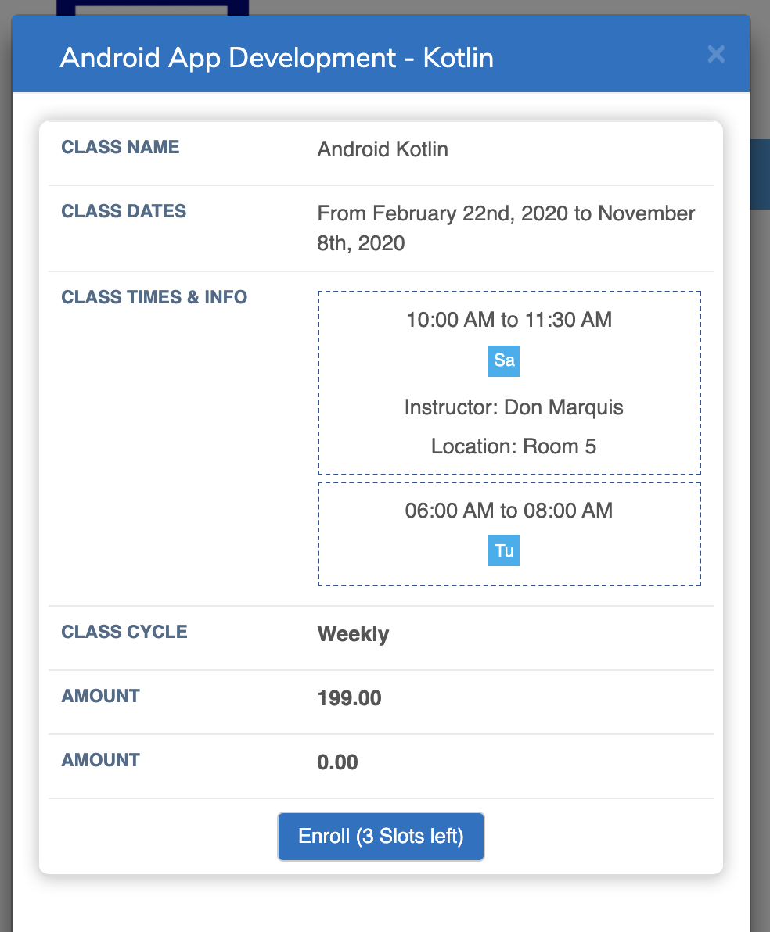

#### **General Coupons - Class Fee & Events Fee**

The General coupons logic has been modified to exclude the Class Fee from the discount and discount will be applied only to the Class amount.

Example - If the Class Amount is $100, Class Fee (like Registration Fee) is $100 and if a General coupon with 10% discount is applied in the registration then the total balance will be $190 instead of $180.

Previously, we had the logic in this way:

* 10% discount for the Class Amount $100
* 10% discount for the Class Fee (like Registration Fee) $100?

Going forward, it will be in this way:

* 10% discount will be applied for the Class Amount $100
* Class Fee (like Registration Fee) $100

#### **Revenue Generated Report - Added Totals**

Reports > Billing > Revenue Generated report provides a view to go through the revenue generated information for a specific duration or for a specific Type.

However, it was missing the totals. We have added the Totals now.

Total Amount Paid provides the total amount that has been paid for the selected duration and/or type.

Total Discount Given provides the total discount that has been given for the selected duration and/or type.

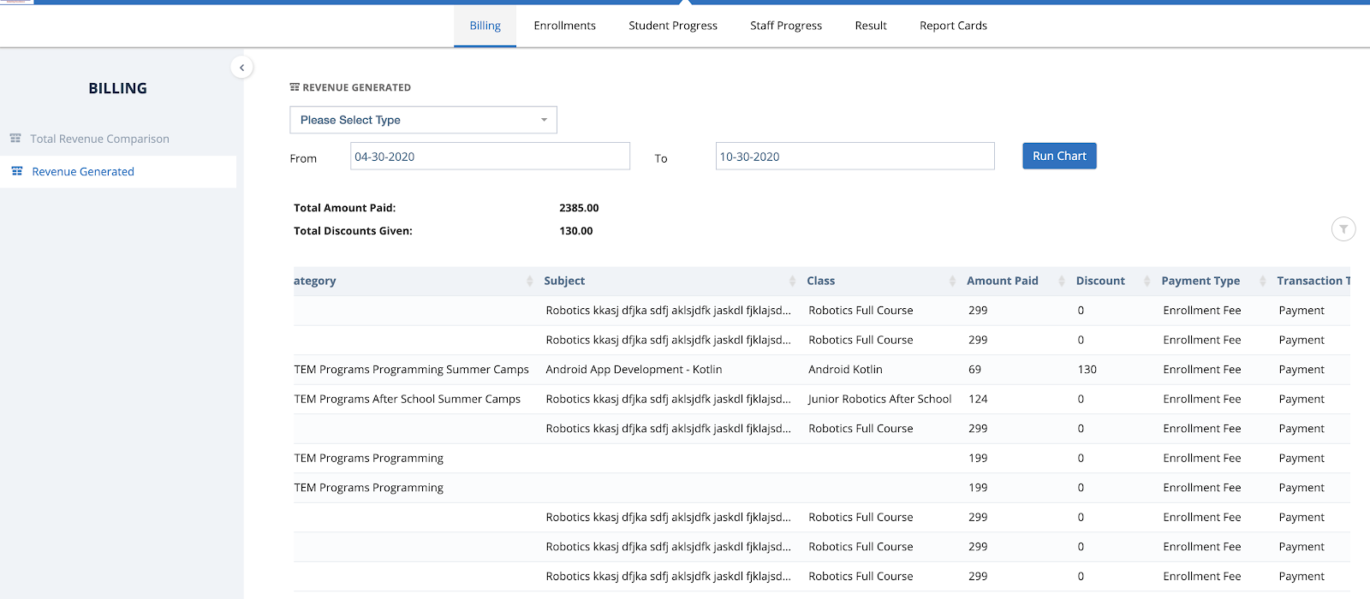

#### **Enrollment Forms Setup (Classes & Events) - Setting Active or In-Active**

In Courses > Enrollment Form Setup and Events > Enrollment Form Setup, when the user clicks on the edit icon, it provides the ability to set a form to Active or In-Active.

Only one form can be set to Active for a Type. If there is no form set to Active for a Type then the Enrollment page will use the Default form for corresponding Class or Event.

However, the Franchises were not able to set a form to Active or In-active if the form is added from the business account. In order to overcome this, we have provided the ability to set those forms to Active or In-Active by hovering them and clicking on the “Set to Active” link.

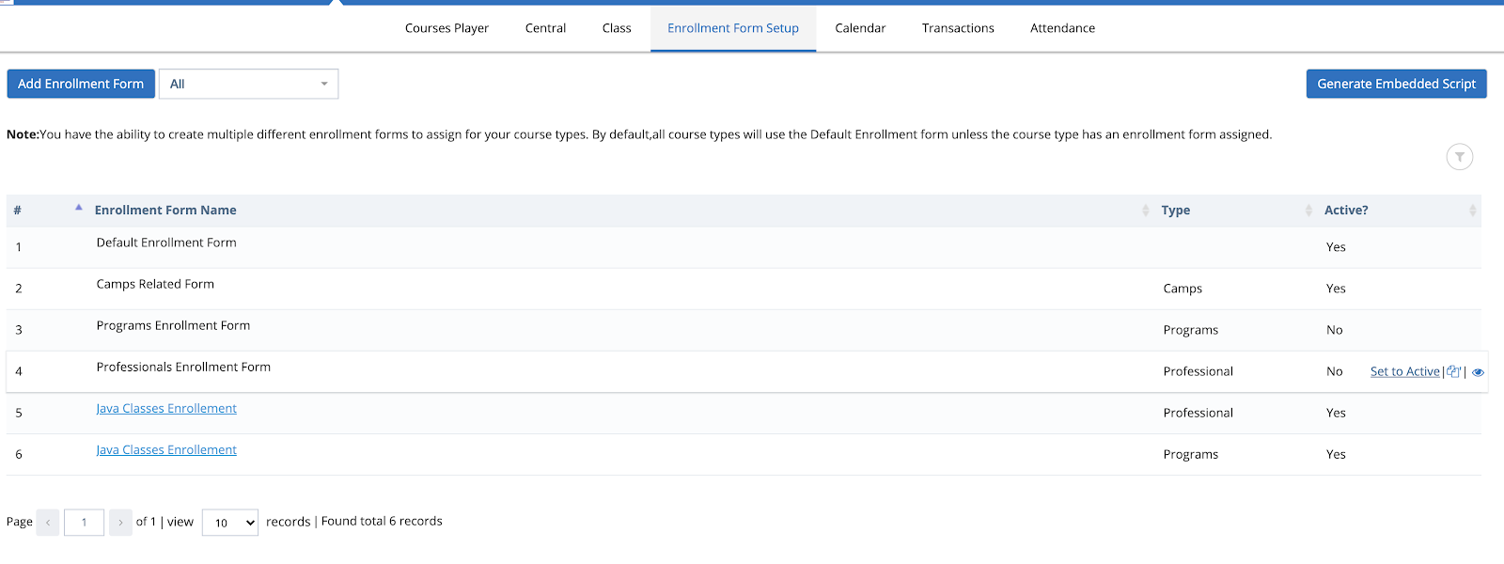

#### **Enrollment Page - Validation error for Profile Image**

In the enrollment page, we have the capability of uploading a profile image for the Student. Users are encountering an error to fix the validation errors on the page when they upload the Profile image and don’t click on the Crop button.

The validation error message was missing for the Crop button for Classes & Events Enrollment page with recent profile image capability. We have added the validate error message if the user forgets to click on the Crop button.

#### **Few Bugs fixes have been made**

Along with the Features, we also fixed bugs that were encountered by the customers and some previous pending bug fixes.

### **Oct 10th, 2020 Release - LMS Web Portal**

Oct 10th, 2020 Release Notes for Calimatic LMS web portal



Written By Scott Smith

Created one year ago

#### **Ability to view entire Enrollment data**

Enrollment Forms have both Standard and Custom fields to capture User's information. The current Families Info & Students Info popups (or profiles) were showing only Standard fields data. Going forward the custom fields & the entire enrollment form data are visible in the profiles in the “Enrollments” tab. The user & staff will be able to update the information as well based on the available permissions.

Navigation:

1. Families > Families Info > Open any existing Family or Add a New Family.
2. Students > Students Info > Open any existing Student or Add a New Student.

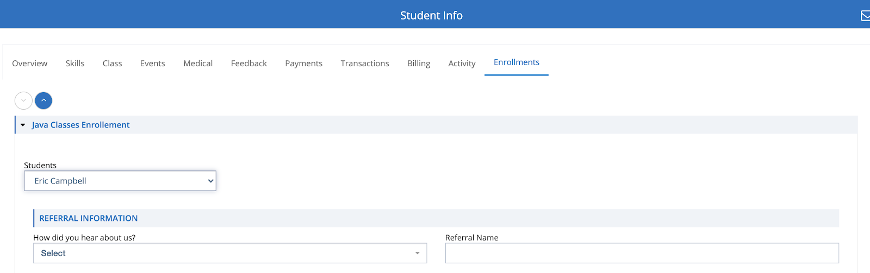

#### **Advanced Filters for Custom Fields in Enrollments or Contact Forms**

The system provides advanced filters to filter the custom fields data and view the information.

Navigation: Reports > Enrollments > Enrollment Details > Click on the “Advanced Filters”

In the popup, you have the ability to select an Enrollment Form (Class or Event), specify the criteria, and filter the data. Based on the filter, the Enrollment Details grid will be filtered.

You also have the ability to save the filter so that you can select the filter in the future.

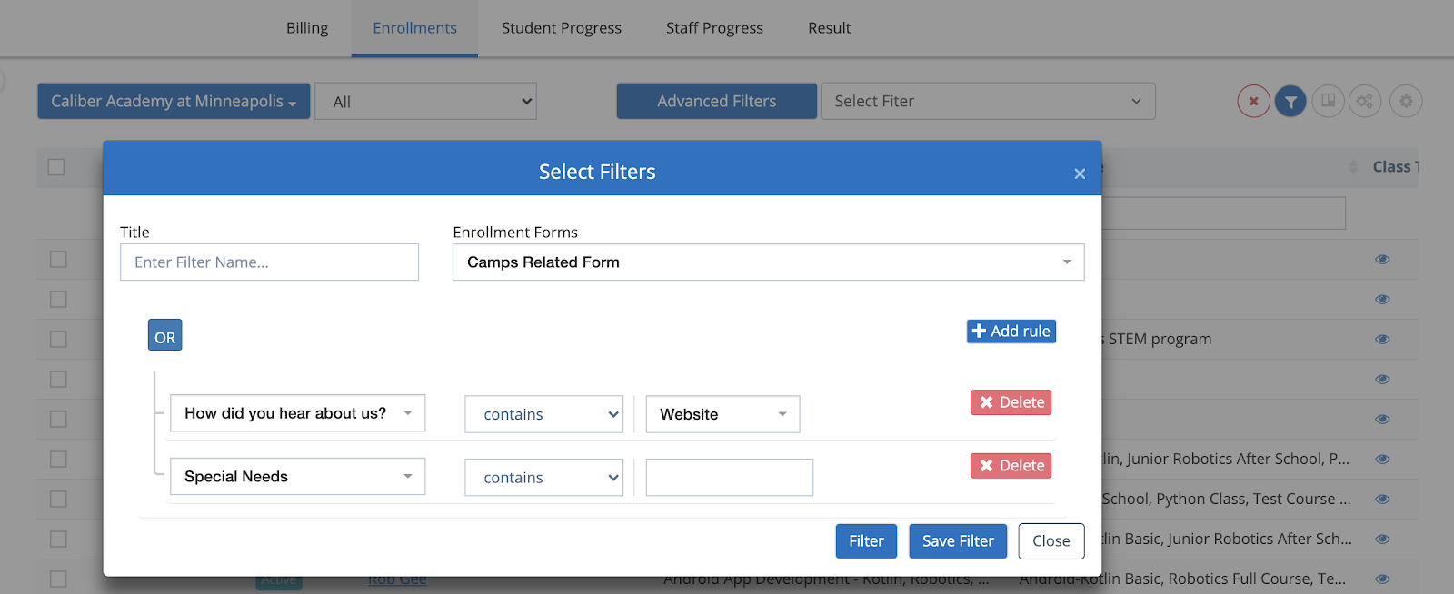

The same capability is available for Leads Management.

Navigation: CRM > Leads > Click on the “Advanced Filters”.

You have the ability to filter the custom fields for the Lead & Contact forms data.

#### **Providing Class Notes for the Students**

The system provides the ability for the Students & Parents to view the Class Notes (including Online recorded Classes if they are conducted using Calimatic built-in Online Classes).

Navigation: Boards

In the Student board, clicking on the Class Notes button will open all the class notes for all the classes that the student is enrolled in. All the Class Notes (Details, Attachments, Recordings, etc) are available to view.

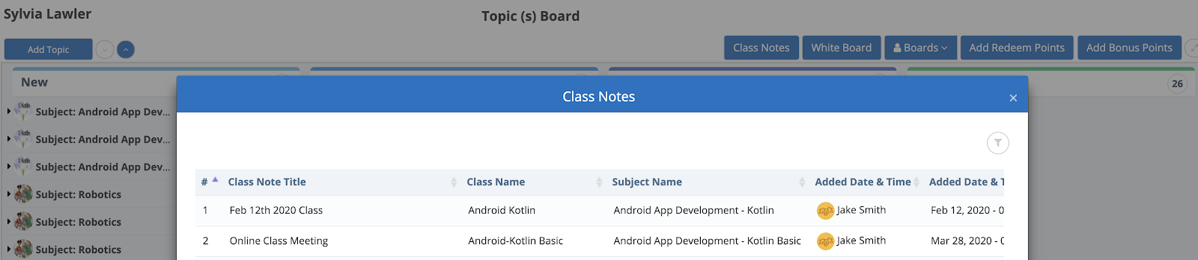

#### **Optimized Email Senders Selection**

In multiple places where we have the selection of Email Senders, the capability has been optimized.

Example - In Courses > Class > Classes Overview > Click on the Actions for any Class, Select Class Students > Send Email option.

In the Popup, for the “Send Email to” field, you can directly select the bulk selection option or select the “Choose the list of users” option to customize your selection.

Another example is in CRM > Emails > Send Emails page.

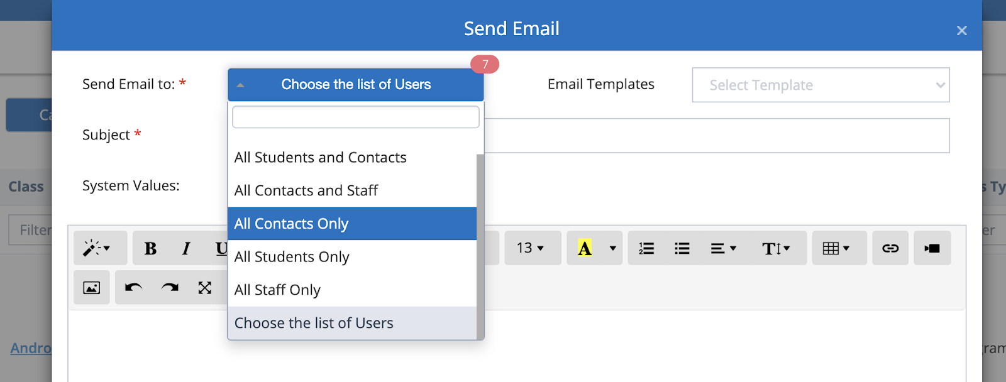

#### **Few Bugs fixes have been made**

Along with the Features, we also fixed bugs that were encountered by the customers and some previous pending bug fixes.

### **Sept 5th, 2020 Release - LMS Web Portal**

Sept 5th, 2020 Release Notes for Calimatic LMS web portal



Written By Scott Smith

Created one year ago

#### **Refund, Transfer, and Drop-Off Cases Payments via RazorPay - Indian Users**

The Refund, Transfer, and Drop-off cases can be used for the Indian users who are using RazorPay payments and fees.

The system provides the ability to connect with RazorPay and handle the transactions for the Refunds or Charging any balance. The Transfer and Drop-off cases are also handled for recurring payments.

#### **Copy Feature for Enrollment Forms (Classes and Events)**

Navigation:

1. Courses > Enrollment Form Setup
2. Events > Enrollment Form Setup

For both Classes and Events, you have the ability to make a copy of any existing enrollment form to re-use the form setup without the need to re-start over.

Please note that the copy is by default set to In-Active. You will need to change the name, any appropriate details and activate it before you can use it.

#### **Transactions Page - Date Range Filtering**

In order to provide the ability to easily filter the Transactions, the Date Range Filter fields have been added in the Transactions pages.

Navigation:

1. Students > Transactions
2. Families > Transactions

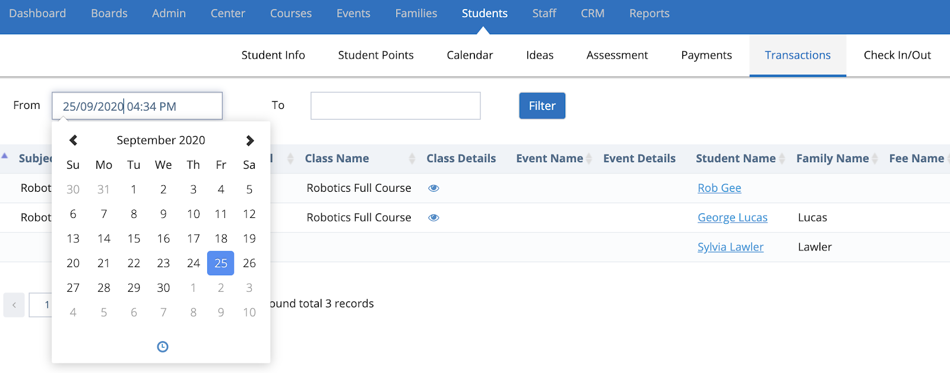

The From & To date will provide the ability to filter the Transactions grid for a given date range.

#### **Generate Passwords**

The system provides the ability to generate Passwords for all the Password fields through the application, in the enrollment forms and CRM forms.

Users will have the ability to generate strong passwords, view the passwords, copy the passwords and re-generate the passwords when creating the accounts, changing the passwords or setting up accounts. The system also provides the ability to see the password strong that you choose.

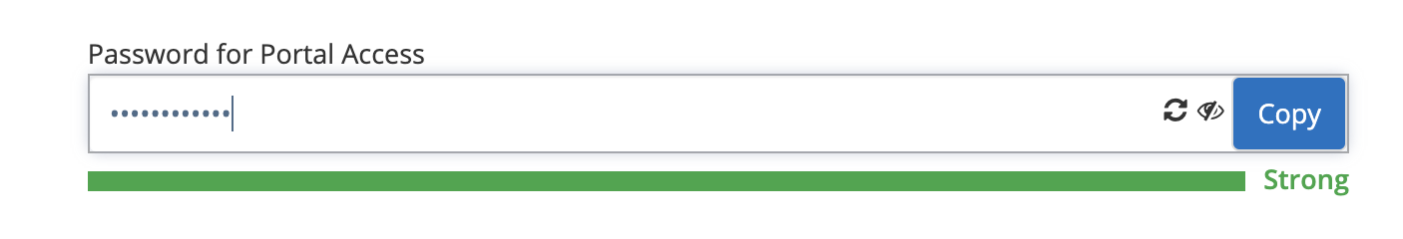

#### **Few Bugs fixes have been made**

Along with the Features, we also fixed bugs that were encountered by the customers and some previous pending bug fixes.

### **Aug 24th, 2020 Release - LMS Web Portal**

Aug 24th, 2020 Release Notes for Calimatic LMS web portal



Written By Scott Smith

Created one year ago

#### **“RazorPay” Payment Gateway for Indian Users**

“RazorPay” Payment Gateway has been introduced to collect Payments & Fees for Indian Users. All the Indian payment modes (like Credit, Debit, UPI, etc) that RazorPay supports are supported in the system.

Please contact us if you want “RazorPay” to be enabled for you. Admins will be able to set up the integration in Admin > System Config > Transactions Config.

Refer to [https://razorpay.com](https://razorpay.com/) for more information. You will need to signup before you can start using it. The signup is free.

#### **Rubric Scoring**

Rubric Scoring capability is introduced to the Assessments functionality. This capability explicitly represents the performance expectations for the Assessment. A rubric divides the assigned assessment component parts and provides clear descriptions of the characteristics of the assessments associated with each component, at varying levels of mastery.

Rubric Setup -

In Admin > System Config > Assessment Rubric Config page, you will have the ability to create different Rubric Configurations.

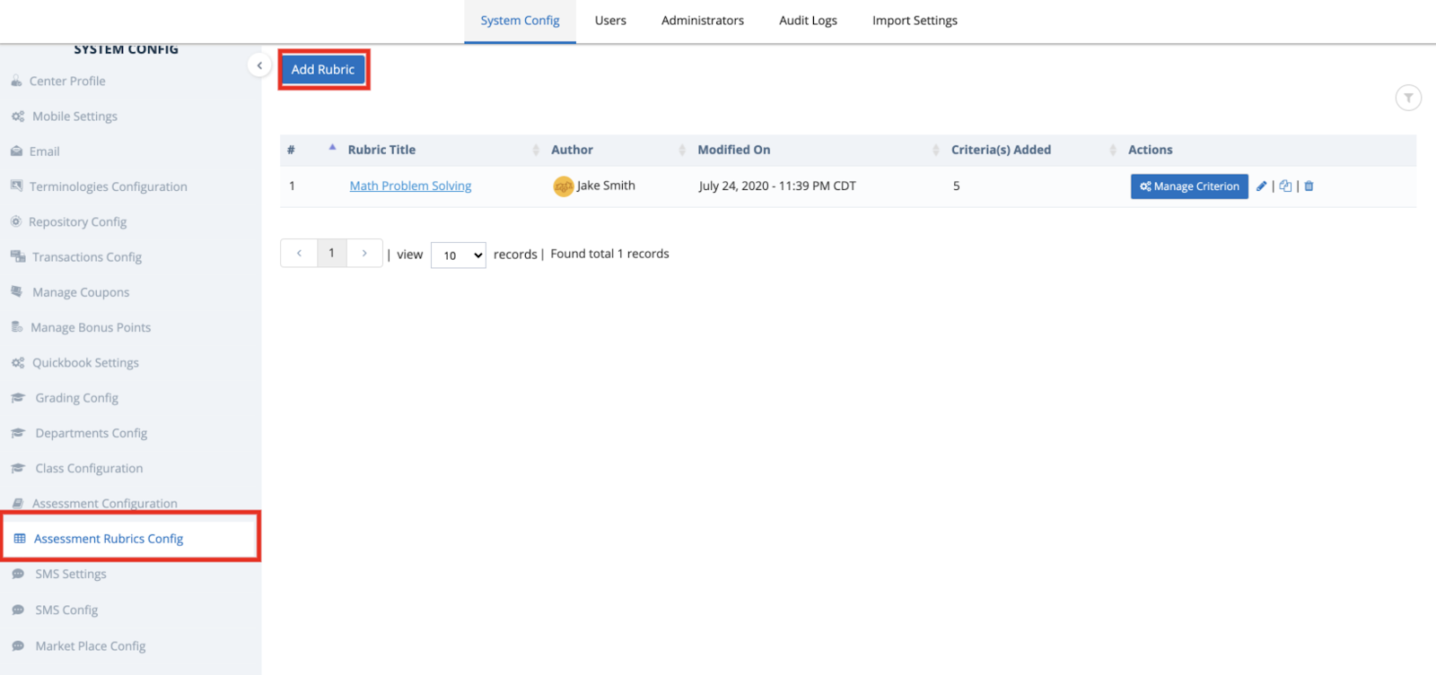

Clicking on Add Rubric will provide the ability to configure a Rubric. Clicking “Manage Criterion” will provide the ability to specify the Criterions for the Rubric.

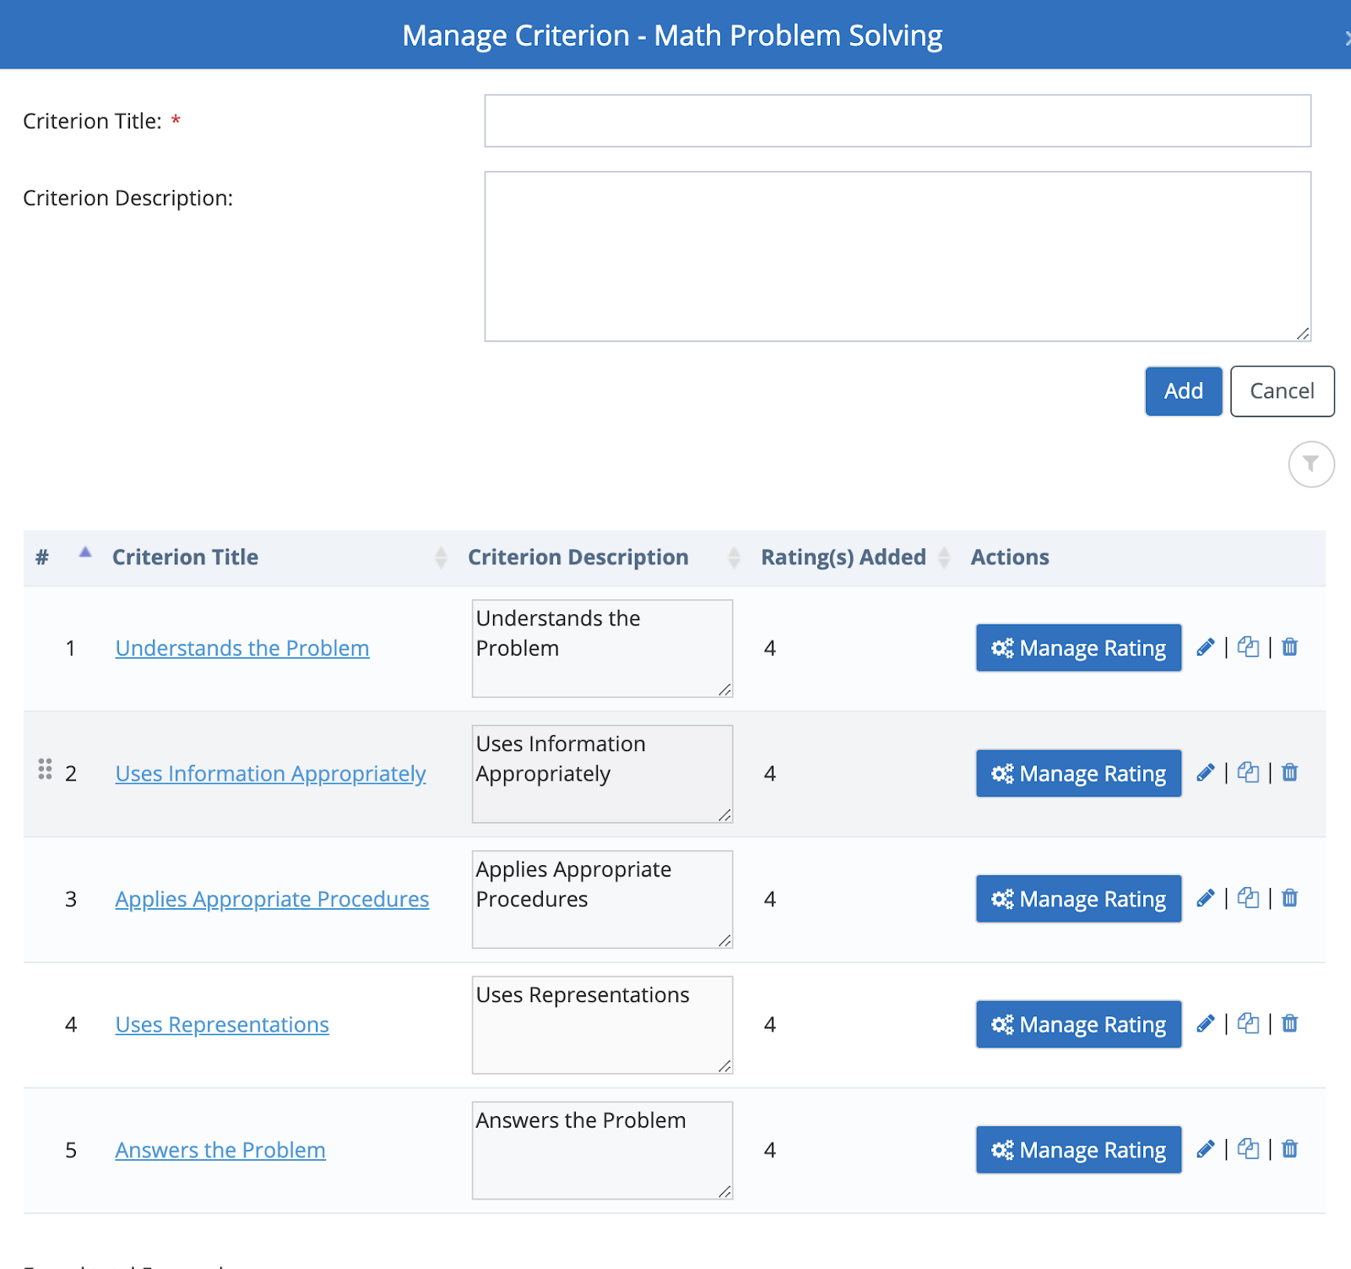

For each Criterion, clicking on the “Manage Rating” will provide the ability to define the details of the Ratings.

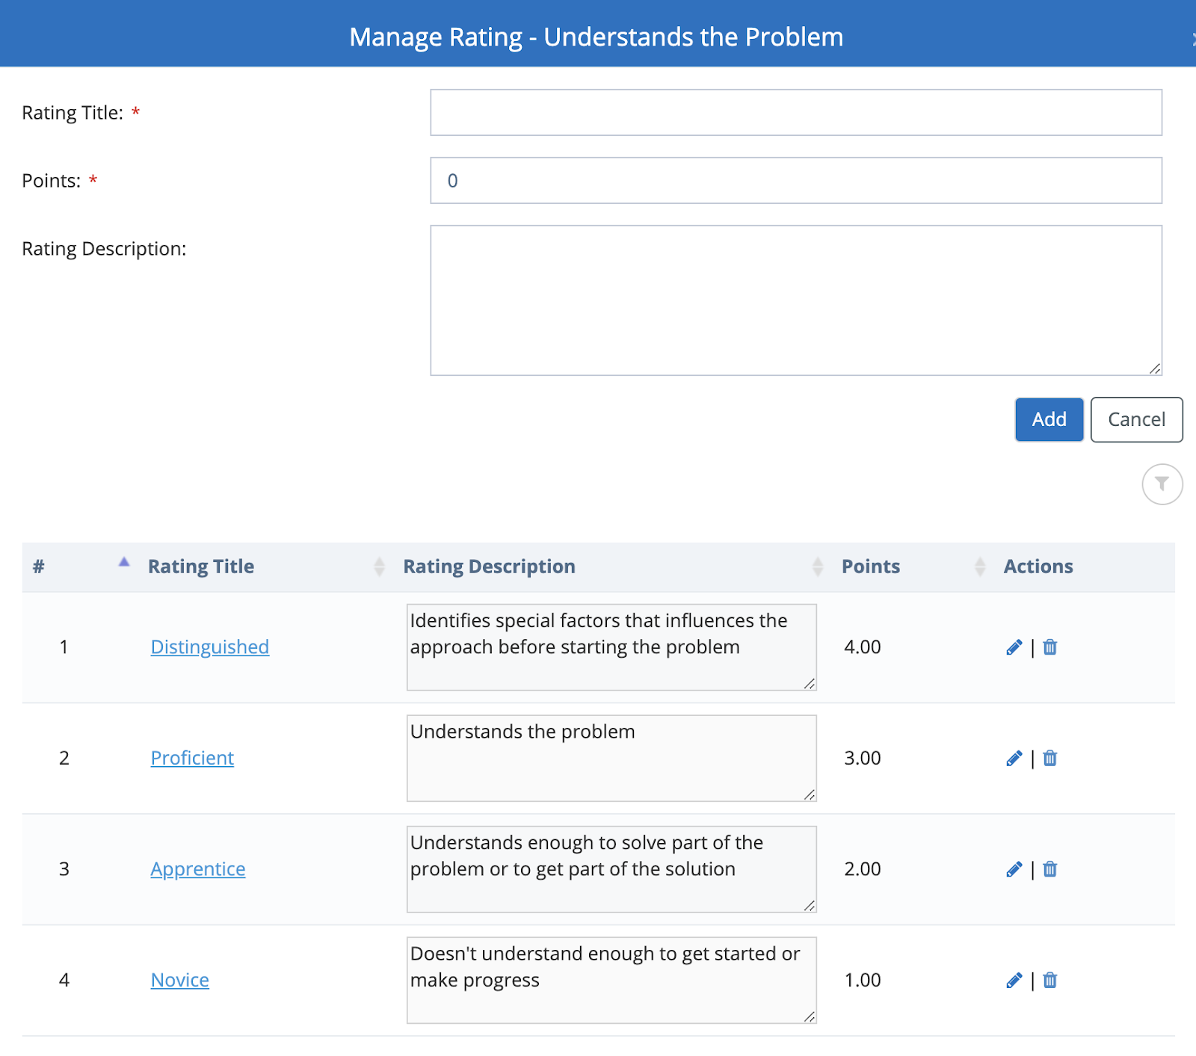

For each Rating, you will have the ability to specify the Points & Descriptions.

All the Rubric configurations can be used in the Assessments.

Navigation: Student > Assessment > Click on any existing online assessment or create a new online assessment. In the Assessment Configuration tab, you will have the ability to select a Rubric for the Assessment or for each Question.

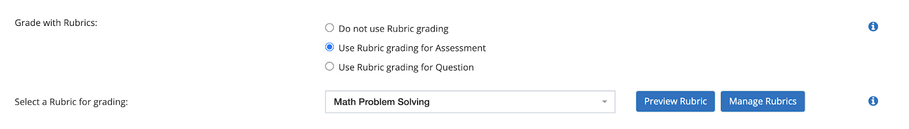

You will have the ability to preview the Rubric information by selecting the Rubric and clicking on the Preview Rubric button.

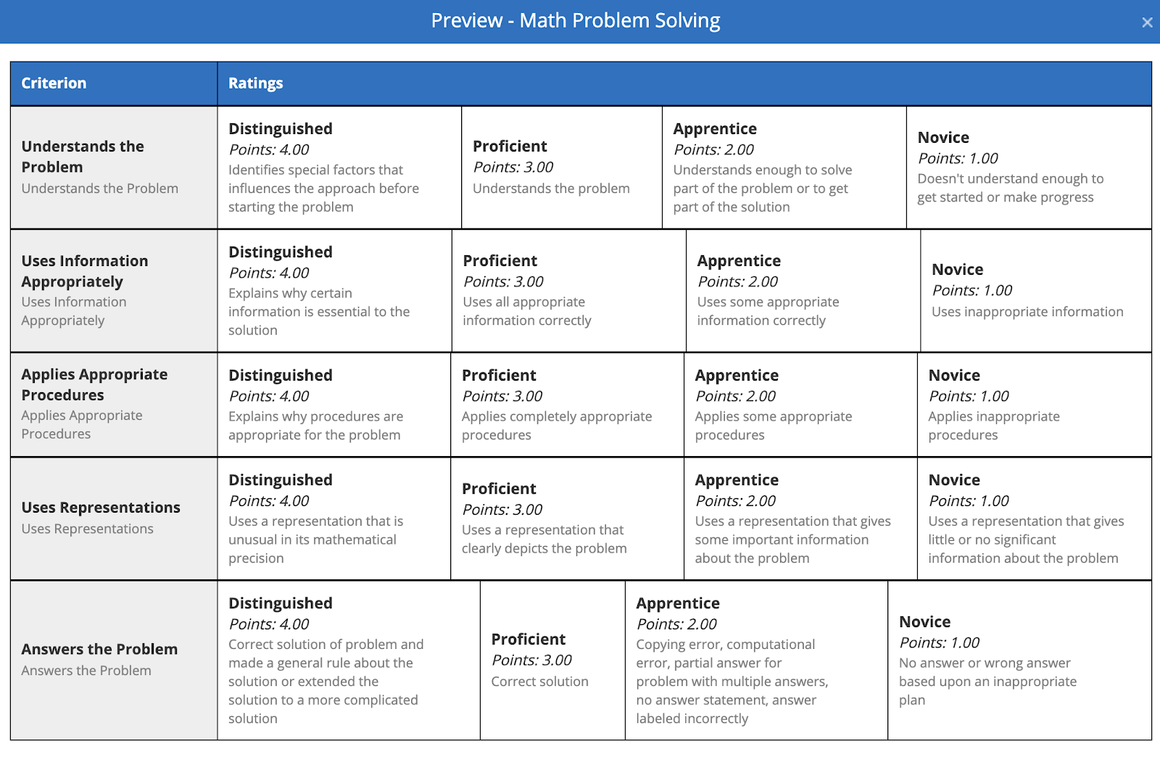

Staff will have the ability to select the Rubric for Auto-evaluated & Manual-evaluated Assessments to provide scoring to the Students.

#### **Additional Settings for Contact / Lead Generation Forms -**

Navigation: CRM > Contact Forms > Setup > Click on Edit icon for any existing Contact Form or Add New Contact Form. In the popup, click on the Settings button.

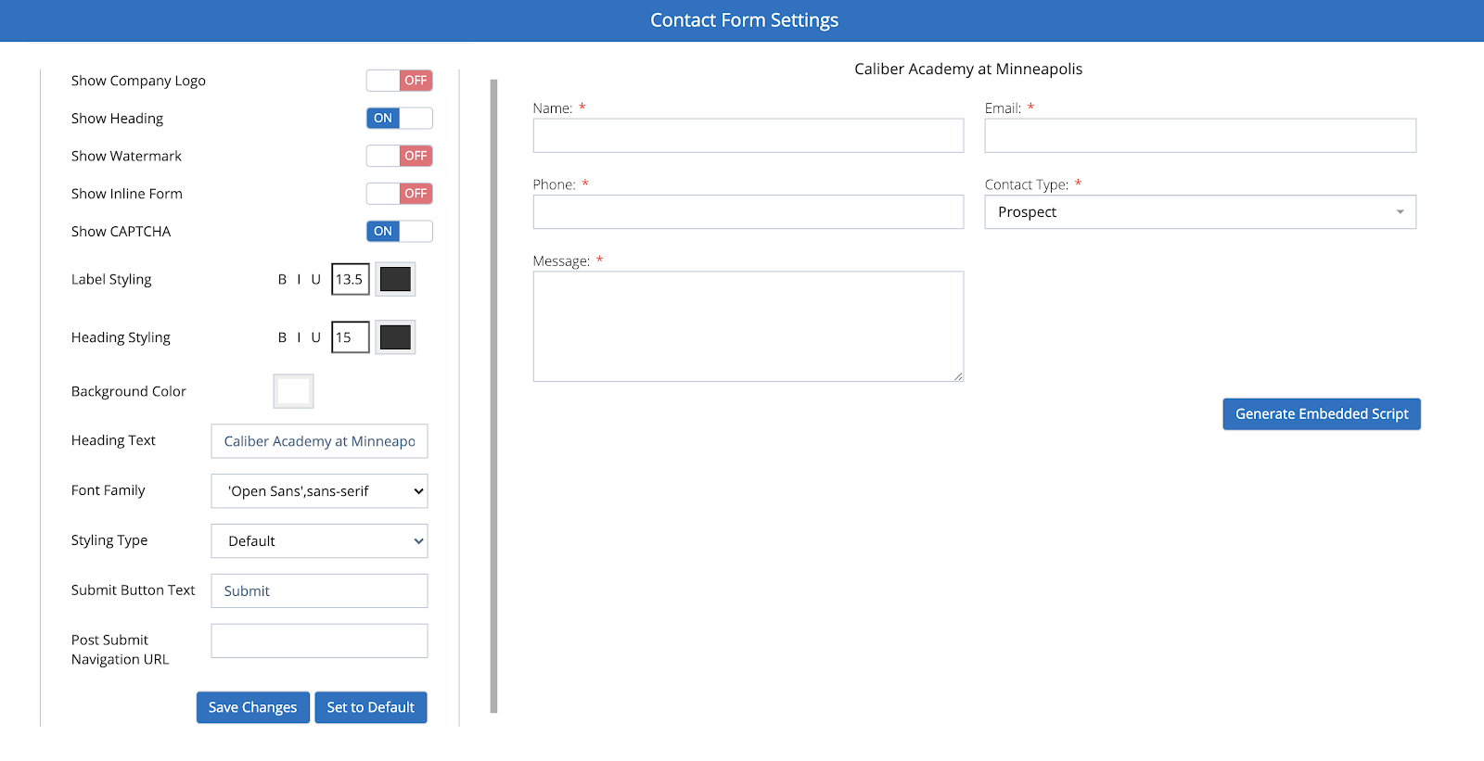

Several settings & options are added to ensure the forms display on your website cover the business needs you are looking for.

#### **Few Bugs fixes have been made**

Along with the Features, we also fixed bugs that were encountered by the customers and some previous pending bug fixes.

### **Aug 2nd & Aug 15th, 2020 Releases - LMS Web Portal**

Aug 2nd & Aug 15th, 2020 Release Notes for Calimatic LMS web portal



Written By Ivan Karmer

Updated 2 years ago

### **Aug 2nd, 2020 Release**

### 

#### **Calimatic Online Classes enhancements**

#### The Calimatic hosted online classes have been improved with several customizations, more server capacity and security features.

#### **Recap** of some of the high level features -

1. Secured Video conferencing capabilities
2. Default muted with videos Off providing the ability for the Instructor to control.
3. White Board (Multi-user White Board)
4. Public & Private Chat conversations
5. Emojis for participants to express (like raising hand)
6. Conducting Polls to engage students
7. Sharing Presentations
8. Sharing videos
9. Screen Sharing
10. Recording online classes
11. Share Notes
12. Breakout Rooms creation

#### 

#### All the recordings are automatically stored in the Class Notes. Depending on the size of the recording, the recordings will be added to the Class Notes after the processing is completed.

#### The recording will include the White board, Chats, Screen Sharing, Videos & Audio.

#### **“Unsubscribe” option in Emails for Users**

In order to follow the email authority rules to avoid emails going to spam, we have introduced the “Unsubscribe” option for the emails generated from the system. Previously, this option is available only for the Bulk emails but this is now expanded to other areas.

The “Unsubscribe” link will be displayed in the footer of the emails. User will be navigated to the Unsubscribe page to unsubscribe their email id from receiving that particular type of email.

Admins (and anyone that has access) will be able to see all the unsubscribe users in

CRM > Bulk Emails/SMS > Unsubscribed Users page.

The users can resubscribe by clicking on the Profile icon (on the left side corner) > My Profile > Email Subscriptions. They can also unsubscribe from here.

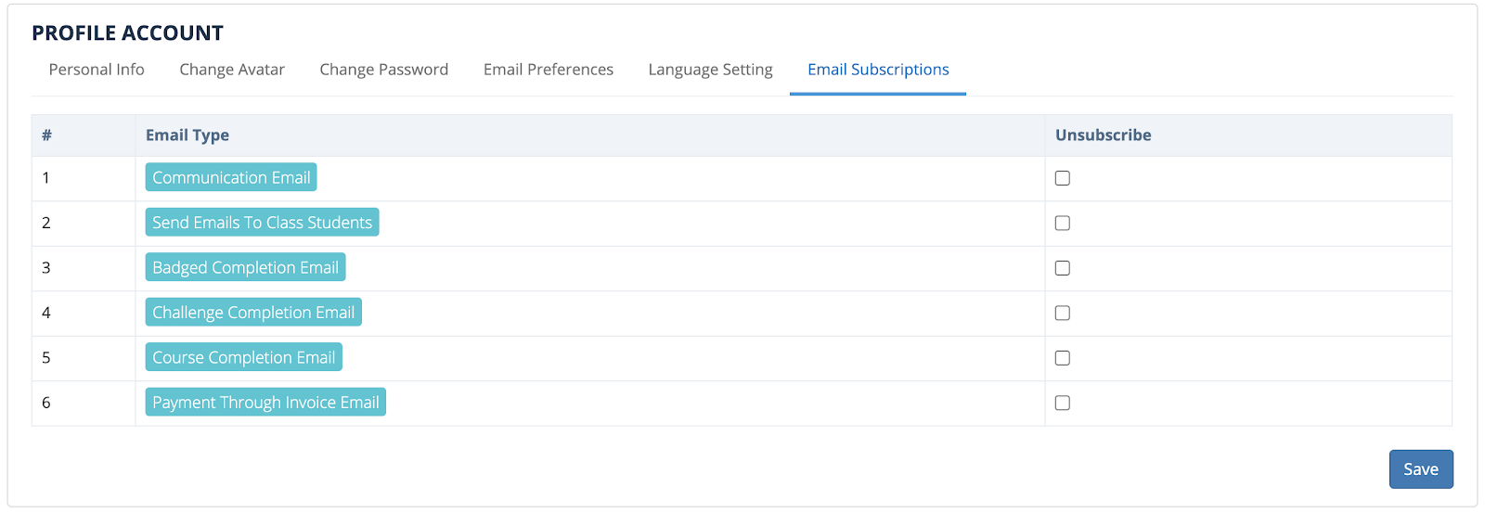

#### **“Add Students to a Class” button in Classes Overview**

“Add Students to a Class” button is now provided in the Classes Overview page. This provides the flexibility to add students to a Class directly avoiding multiple steps.

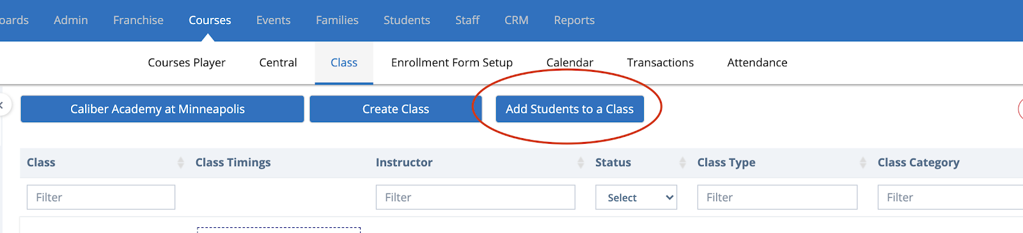

#### **“Generate Password” button for Password fields**

The system provides the “Generate Password” functionality for all the password fields throughout the application including the registration pages. This will help the user to generate a good or strong password by clicking on the Generate button.

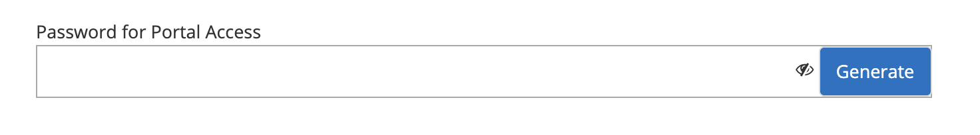

Clicking on the Re-generate icon will generate another password string. Clicking on the icon will show the password. Clicking on the Copy will copy the password.

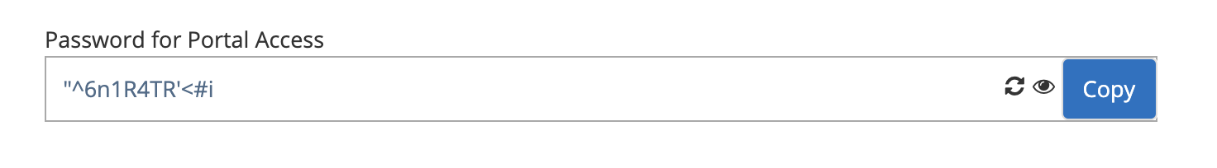

#### **Transaction Statement**

The system provides the ability to generate Transaction statements for a Family or Student and export it as PDF.

Navigation - In “Families > Families Info” or “Students > Students Info”, open the record and in the popup, click on the Transactions tab. In the “Transaction Statement” section, specify the date range and click on the Generate.

Based on the selected date range, the paid transaction information is displayed. Clicking on the “Export as PDF” button will download the transaction statement.

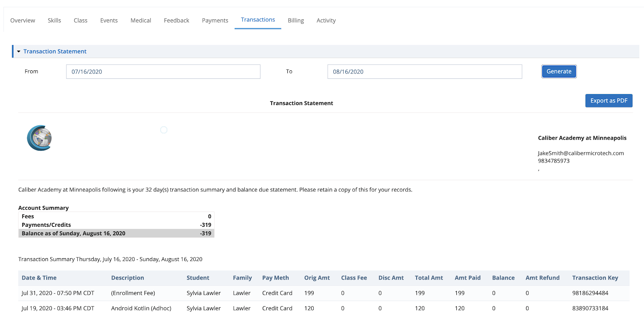

#### 

#### **Reports**

Following reports have been introduced by streaming/deprecating some unwanted reports -

1. Total Revenue Comparison - Displays the revenue generated across multiple years on a monthly basis. Navigation: Reports > Billing.
2. Revenue Generated - Displays revenue generated based on the selected criteria and date range. Navigation: Reports > Billing.

#### **Performance Improvements**

We have made some improvements to the following areas as part of our regular performance improvements to the platform -

1. Staff Info Page
2. Optimized Database CPU server impacted queries to handle heavy load activities.

#### **Few Bugs fixes have been made**

Along with the Features, we also fixed bugs that were encountered by the customers and some previous pending bug fixes.

#### 

#### ________________________________________

### **Aug 15th, 2020 Release**

#### 

#### **Auto-Attendance for Calimatic Hosted Online Classes**

#### 

#### To eliminate the need of manually taking the attendance for every Online class, we have introduced the auto attendance feature. This feature is only available for the Calimatic Hosted Online classes.

#### All the Students attendance is recorded for the online classes automatically and are displayed in Reports > Students Progress > Attendance > Attendance by Class.

#### The user also has the ability to export the attendance to a PDF.

#### 

#### **Introducing Secured Content Viewers & Video Players**

#### 

#### Protecting your curriculum or course content is very important to us and we have introduced couple of advanced features -

1. **Attachment Viewer:**

#### The attachments will open the file in a secured viewer where the user will not be able to download the file from the viewer. This will help you from the users downloading the file if you restrict the download from security permissions. This will thereby protect the users from sharing the content outside.

#### Supported File formats - DOC, DOCX, ODT, XLS, XLSX, ODS, CSV, PPT, PPTX, ODP, PDF, VSD, MPP, TIF, XPS, PSD, DWG, DXF, DGN, EML, MSG, TXT,RTF, XML, EPUB, SVG, JPG, JPEG, BMP, GIF, PNG, HTML, MHT, DICOM

1. **Video Player:**

#### The direct uploaded videos will be protected with DRM Encryption and will stream from the world class Microsoft Azure servers.

#### It protects the users from downloading the videos from the video player. The steaming of the videos are much faster and will play even with slower internet speeds.

#### Both the above mentioned features are not enabled by default. Please contact the Calimatic Support team to discuss the options to enable them.

#### 

#### **Class Board button have be restructured -**

#### 

#### In order to accommodate more features in the Class board, the buttons have been restructured. Adding items and the Class White Board button have been moved to the left.

#### Levels selection, Students selection, Online Class & Email Class related people are on the right side.

#### For the Online Class, the capabilities are moved as options for the button to streamline the features.

#### 

#### 

#### 

#### 

#### **Online Assessments/Exams Assignments -**

#### 

#### Centralized location to view the Online Assessments/Exams Assignments & their statuses have been added to the Assessments/Exams page.

#### Navigation: Students > Assessment. On the top right side of the page, the Assignments button is added. Clicking on it will open a popup where all the students are listed with the status and the counts of the Online Assessments/Exams assigned to the corresponding student.

#### Clicking on the “Not Started” link will open the popup with a list of items and ability to select them and unassign them.

#### 

#### 

#### 

#### **Performance Improvements**

#### 

#### We have made some improvements to the following areas as part of our regular performance improvements to the platform -

1. Students Board Page
2. Optimized Database CPU server impacted queries to handle heavy load activities.

#### 

#### 

#### **Few Bugs fixes have been made**

#### 

#### Along with the Features, we also fixed bugs that were encountered by the customers and some previous pending bug fixes.

### **July 18th, 2020 Release - LMS Web Portal**

July 18th, 2020 Release Notes for Calimatic LMS web portal



Written By Ivan Karmer

Updated 3 years ago

#### **New Dashboard or Home Page**

Introducing the new dashboard - Simplified and Fast Loading. The dashboard page has been updated to improve the performance of landing to the home page with simplified but required information in it. The page displays different information based on the user role.

Following sections provides the information about the page

1. Announcements - This section is not changed
2. Counters - Based on the role, the counters will display the information related to the user.
3. Activities - All the user specific activities are listed with the latest at the top.
4. Links - Important quick navigation links are provided here to quickly jump into the right area instead of searching around.
5. Links (Release Notes) - Release Notes link for the latest release will be displayed at the top right side of the section for Admins.

**Note:** The Counters and Activities functionalities coverage will be improved in the next releases. Example - For Students engagement counter, only some areas are covered but this will be enhanced in the future.

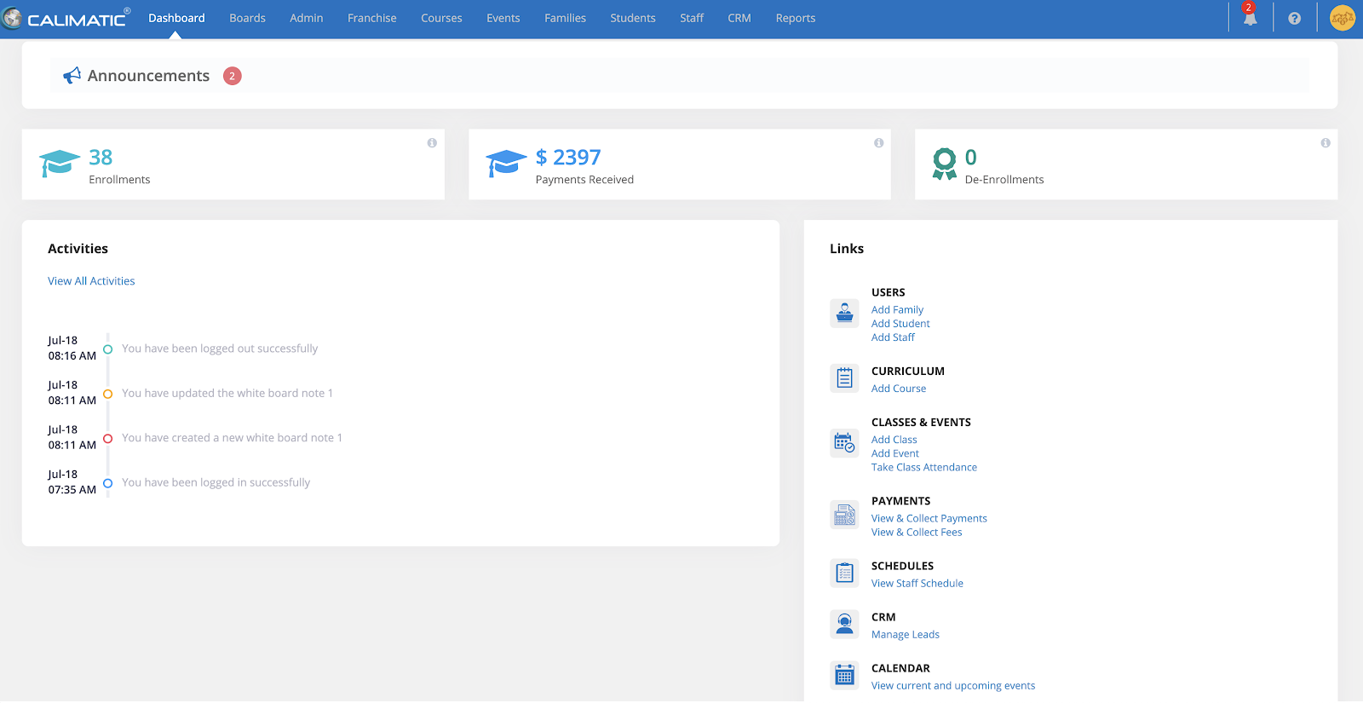

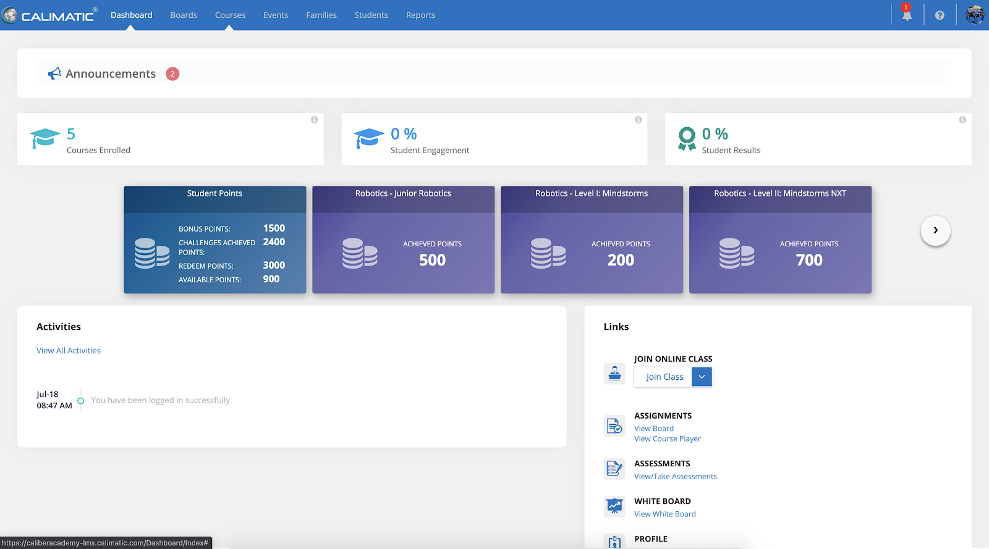

#### **Ability to Billing Details by the Admins**

The system now provides the ability to add Billing details for the Students by the Admins (Master & Franchise/Centers). The Admins can add the Billing Details for the Students to assist the Parents when they provide the information in center or on phone.

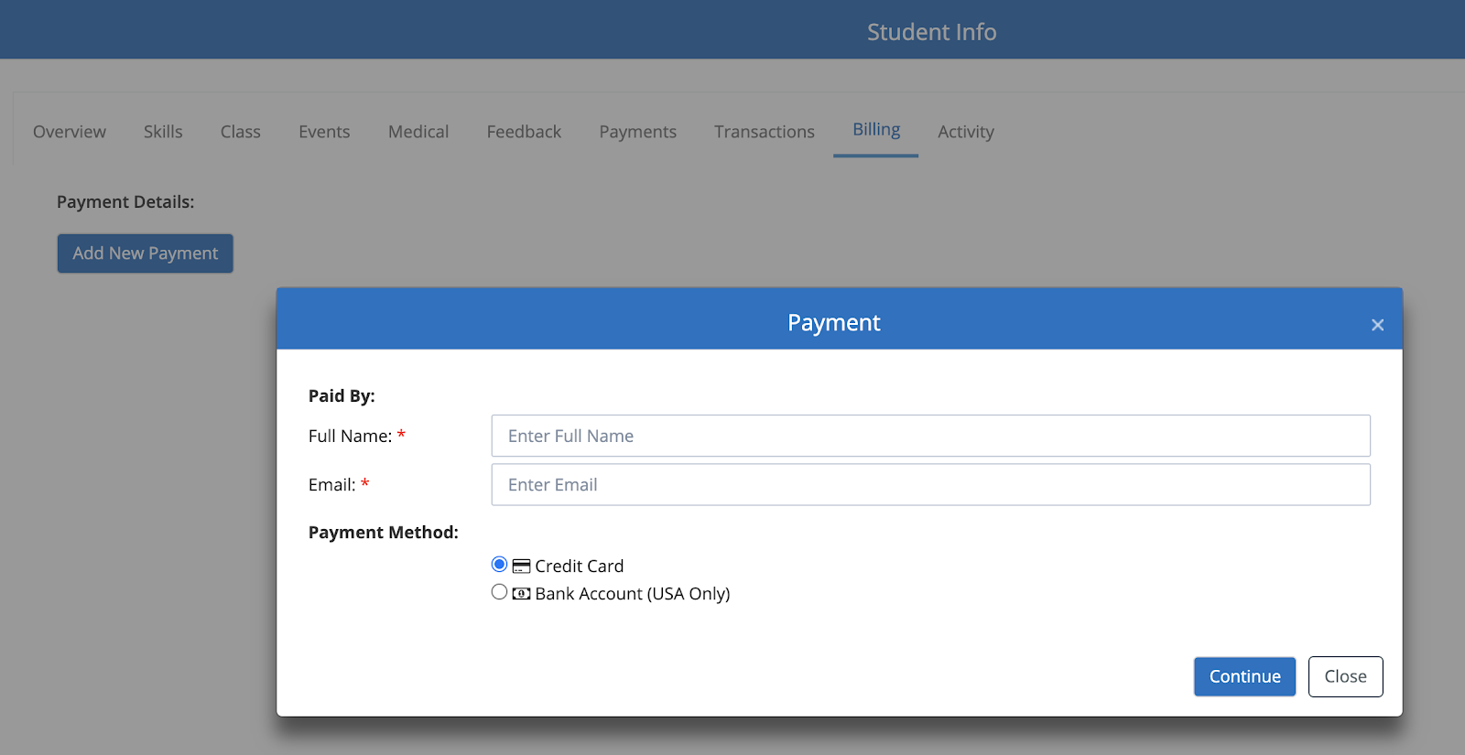

#### **Assessments - Ability to add the number of retakes**

The system provides the ability to specify the number of retakes that a Student can take when the “Allow retake” option is selected. By default, there is no limit. After the limit is reached, the Student can’t take the Assessment anymore.

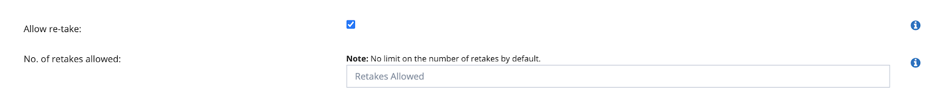

#### **Assessments - Ability to set Auto-Save at Question level or Data Point Level**

The system provides the ability to “Enable Auto Save” option at the Question level or at the Data Point Level. Note that the Data Point Level option will work only for the Assessments which have Data Points.

When these options are enabled, the Assessment will automatically save without the need for the Student to Save Session. The “Save Session” button will not display when this option is enabled.

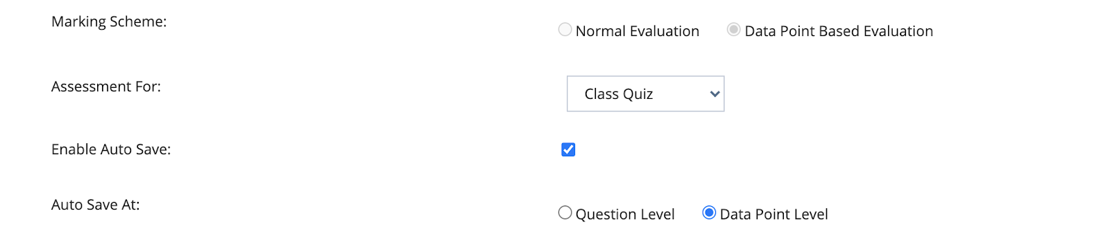

#### **Ability to add In-Active Students to the Class from Classes Overview page**

The system now provides the ability to add In-Active students to the Class from the Classes Overview page as well.

Navigation - Courses > Classes > Classes overview > Actions > Manage > Students > Add Student to a Class popup.

Active/Inactive filter provides the ability to filter and add students to the class as needed.

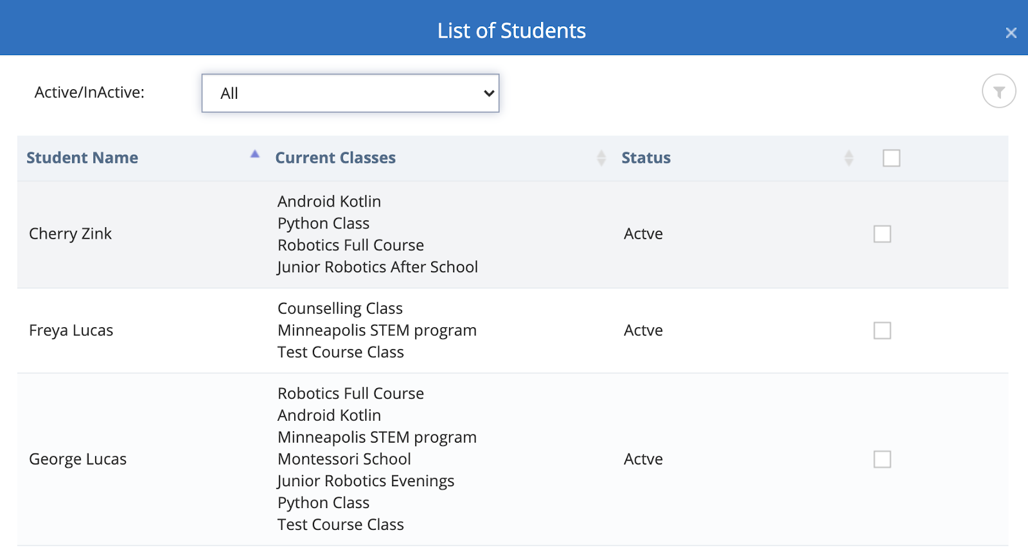

#### **Setting - Auto Assign all Courses to all Staff**

In the previous release we have introduced the security feature to restrict Courses & their content to Staff by default in the Central page. In this release a setting has been provided to remove restriction if it is not needed.

Navigation: Admin > System Config > Class Configuration -

Automatically Assign all Courses to all Staff

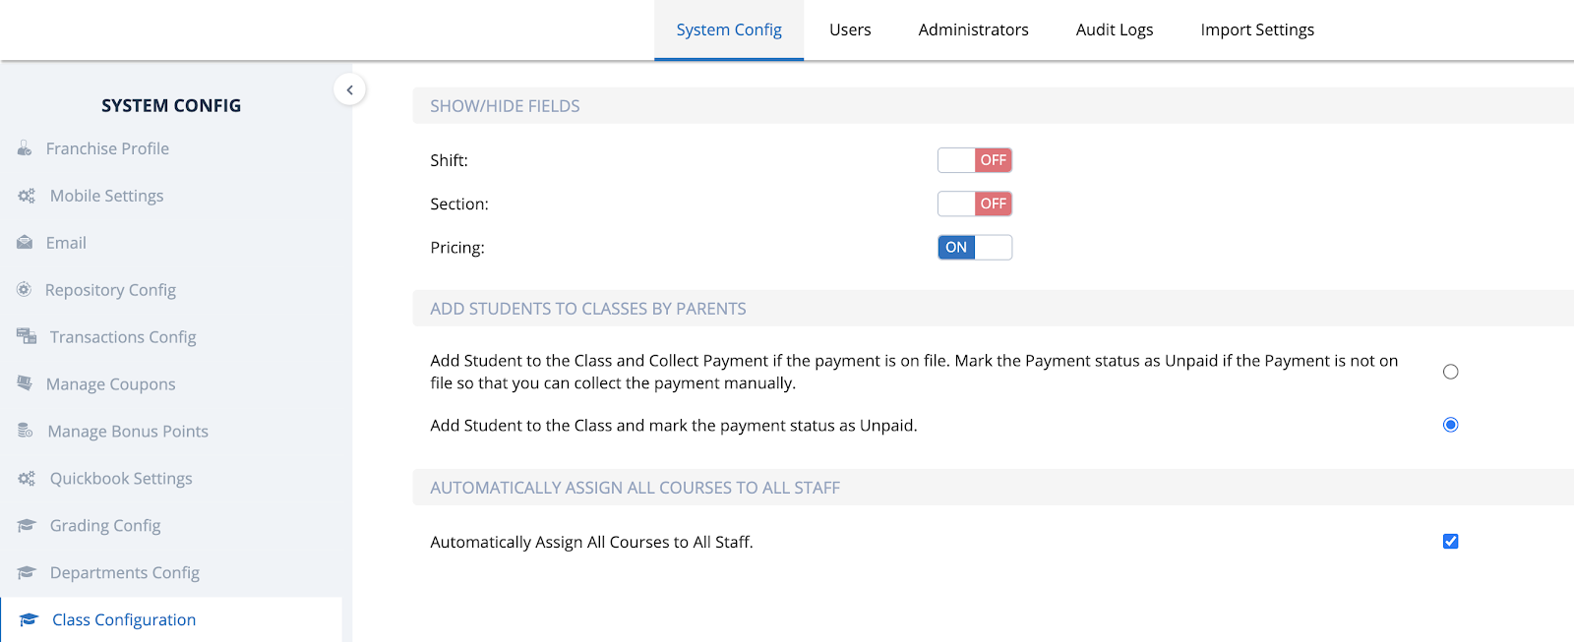

#### **Setting - Copy of all emails to specific email (added additional emails)**

The system provided a setting to set emails to receive the copy of any email sent from the system. Additional areas of the application have covered in this release.

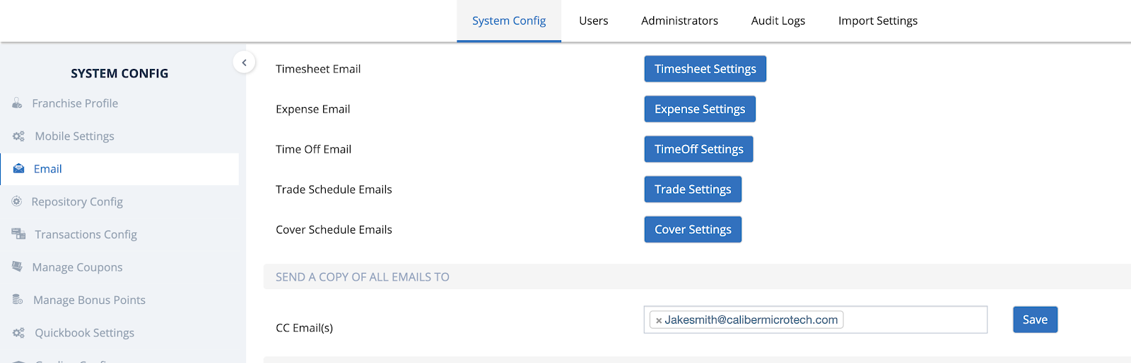

#### **Calendars**

The Calendars within the application have been modified to better display the scheduled Classes & Events based on the role.

Navigation:

1. Dashboard/Home Page - Clicking on the "View current and upcoming events" link in the Links section will navigate to the Calendar page.
2. Courses > Calendar
3. Families > Calendar
4. Students > Calendar

Clicking on the Class or Event in the Calendar will display the Class or Event Details along with the list of enrolled Students.

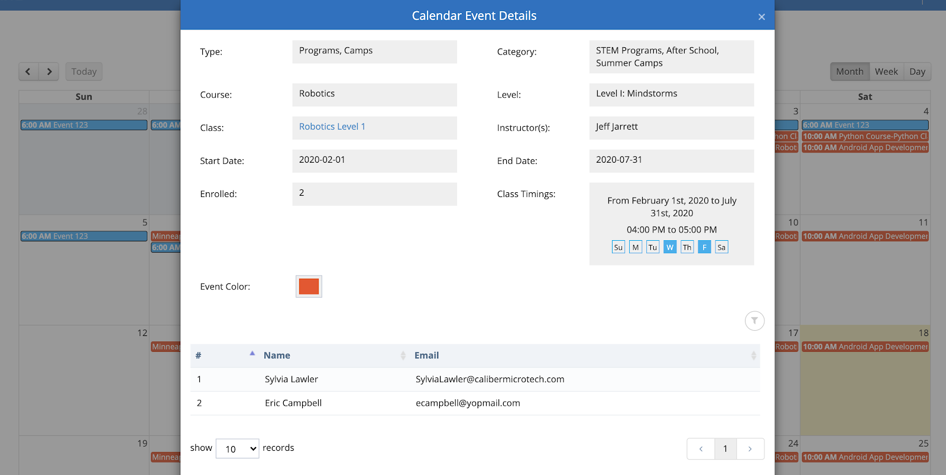

#### **Reports**

Following reports have been introduced by streaming/deprecating some unwanted reports -

1. Active Students Comparison - Displays the list of Students that are Active (Comparing between the years)
2. New Enrollments - New enrollments (Student became active) per each month
3. De-Enrollments - Students that have been moved from Active to In-active per each month.

#### **Performance Improvements**

We have made some improvements to the following areas as part of our regular performance improvements to the platform -

1. Course, Level, Challenge Popups
2. Dashboard

#### **Few Bugs fixes have been made**

Along with the Features, we also fixed bugs that were encountered by the customers and some previous pending bug fixes.

Contact us at lmscoach@calimatic.com for any questions.

### **July 7th, 2020 Release - LMS Web Portal**

July 7th, 2020 Release Notes for Calimatic LMS web portal



Written By Ivan Karmer

Updated 3 years ago

#### **Ability to enroll multiple Students into different classes one time**

The system now provides the ability for the users to enroll **multiple students** in **different classes** at **one time**. Example - In the Enrollment page, if the user adds 1 or more classes into the Cart and clicks on the Cart then all the added classes will be added to the Student by default. The user has the ability to

1. Modify the added classes
2. Add additional classes to the Student in the enrollment page
3. Add additional students in the enrollment page
4. Add classes to the newly added students in the enrollment page 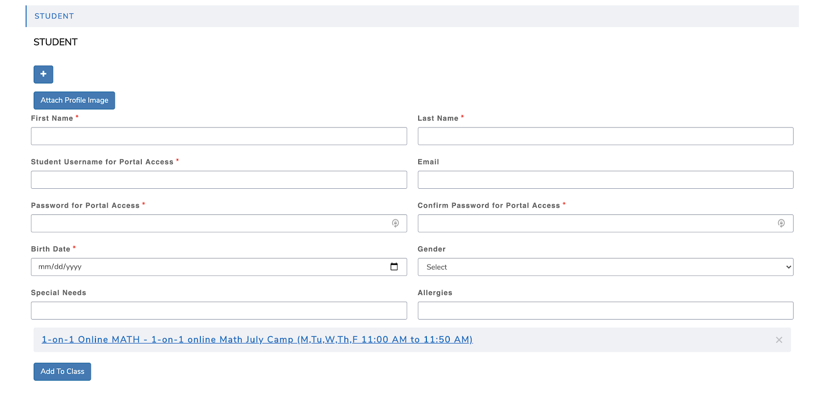

Once the enrollment process is completed then one enrollment email is sent for all the classes but the payments will be collected separately for each class and each student. There will be different entries (one per each class and each student) in the Portal (in Payments pages or Tabs) so that you can manage Payments, Drop-offs, Transfers, etc individually.

#### **Parents - Ability to add Students to Classes in Portal**

If the Parent permission to Add Student to the Class is enabled then the Parent can add Students to the Classes with or without Payment.

A new setting has been introduced to provide this flexibility - In Admin > System Config > Class Configuration, under “Add Students to Classes by Parents”.

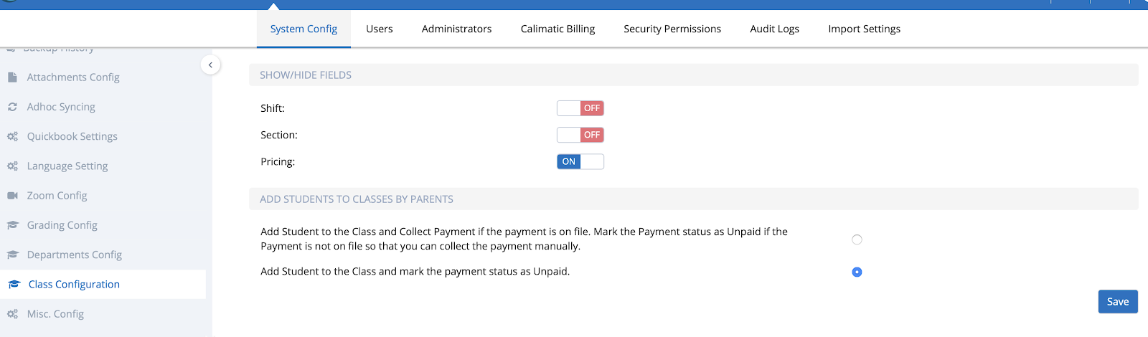

With “Add Student to the Class and Collect Payment if the payment is on file. Mark the Payment status as Unpaid if the Payment is not on file so that you can collect the payment manually.“ option, the Parents will be able to add the Student to the Class and the payments are collected automatically if there is a payment on file. Or else, it will add the Payment row with “Unpaid” status and requested information in the “Requested by” column in the Payments grid.

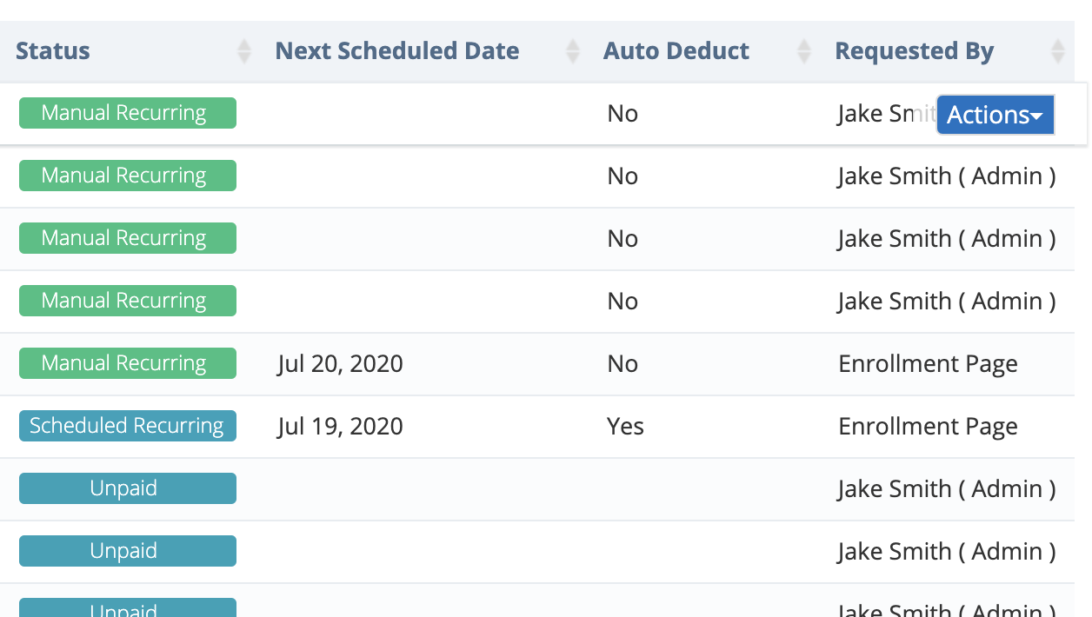

With “Add Student to the Class and mark the payment status as Unpaid.” option, the Parents will be able to add the Student to the Class and the payments will not be collected automatically and it will add the Payment row with “Unpaid” status and requested information in the “Requested by” column in the Payments grid.

#### **Class Details Report**

Class Details Report that provides the details of the Class and enrolled Students to the Class has been introduced. It is available in Reports > Enrollments > Class Details.

On this page, you can search for any Class or filter by Type, Category & Course.

It provides the details of the Class in the first section and displays the list of Students enrolled to the selected Class in the 2nd section.

It also provides the ability to “Export as PDF”.

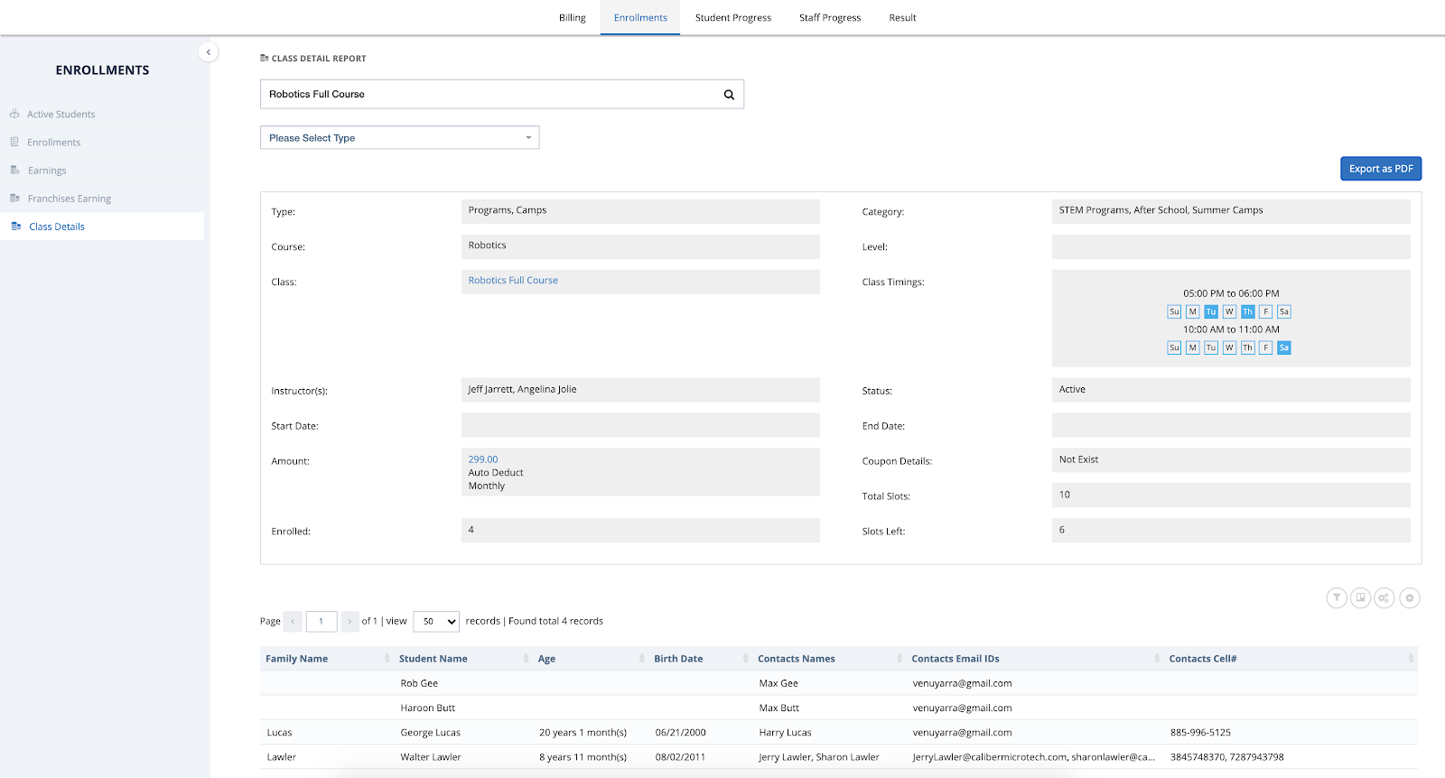

#### **Course Player - Discussions for Students are enabled**

In Course Player, the group discussions for Course, Level, and Challenges are enabled for the Students. This provides the ability for the students to post any questions to the Instructors and other students can learn from the discussions.

#### **Assessments - Due Date Capability**

Introducing the “Due Date” capability for Assessments. The system provides the ability to configure the Due Date for Assessments to ensure Students to complete the assessments before the Due Date. In the Assessments page and in the Challenges Assessment Step, the Due Date information is displayed.

Note that this field in the configuration is optional.

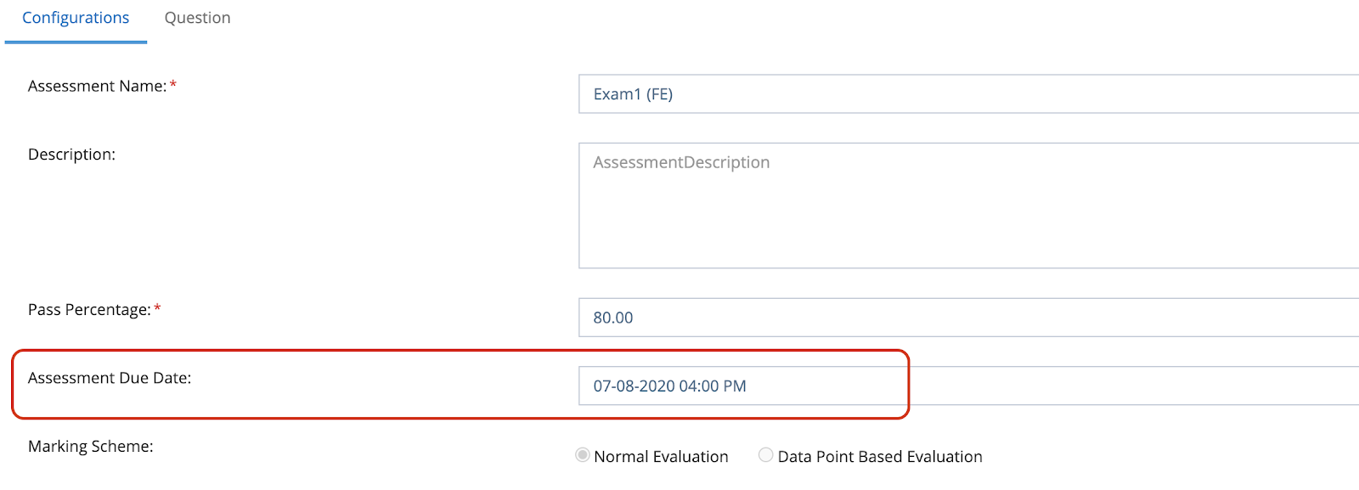

#### **Classes Overview - Retain Grid State**

Previously, the Classes Overview page grid has been refreshed and removing the filters when a new Class is added or Classes are updated. The Grid state retaining has now been added to the Classes Overview grid so that the applied filters are not lost until you refresh the page or navigate away from the page.

#### **Email Course Certificate**

When the Course status for a Student is marked as completed, then the Course completion email will also include the Certificate that is generated by the system.

#### **Few Bugs fixes have been made**

Along with the Features, we also fixed bugs that were encountered by the customers and some previous pending bug fixes.

Contact us at lmscoach@calimatic.com for any questions.

### **June 29th, 2020 Release - LMS Web Portal**

June 29th, 2020 Release Notes for Calimatic LMS web portal



Written By Ivan Karmer

Updated 3 years ago

#### **Challenge/Assignment - Ability to Add Attachment & HTML Project as a Step**

**Add Attachment (like PDF, PPT, Document, etc) as Step -** In the Challenge or Assignment popup, we are introducing the ability to add an attachment (like PDF, PowerPoint, Documents, etc) as Step under Students Instructions tab. This will allow the students to access the learning content documents along with other steps without the need to go to the Attachments.

**Add HTML Project as Step -** In the Challenge or Assignment popup, we are introducing the ability to upload an HTML Project to display an HTML page (or webpage) as a Step. This is mainly used for the animation project that is built in the HTML5 project.

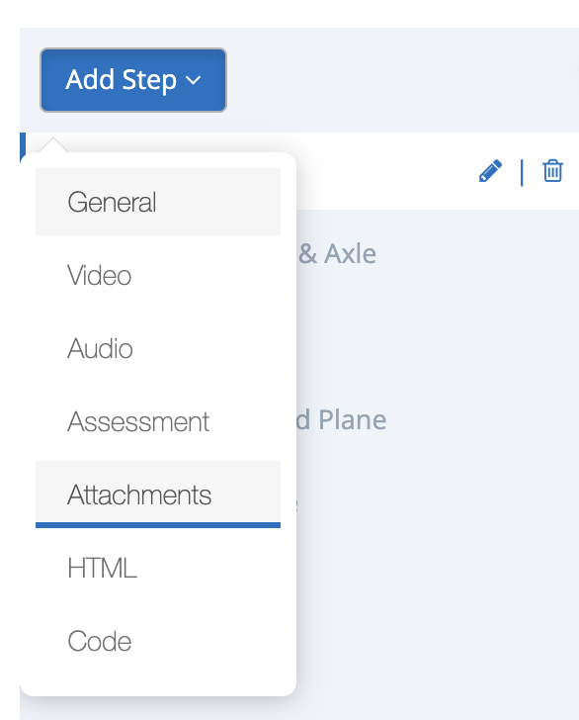

#### **Course Player - Delete Option for Courses, Levels & Challenges**

Educational institutions who are using Course Player for self-learning & instructor-led courses - Now you have the ability to delete the Courses, Level, and Challenges from the Course Player Course page view. This option will be available based on the assigned permissions.

#### **All emails will be sent from your preferred email id instead of Calimatic email id**

Currently, all the emails sent from the CRM module are using the “Account Sender” email id that is set in Admin > System Config > Emails. With this change, going forward all the emails generated from the system will be using the “Account Sender” email id if you have set one. If not, the emails will be sent from “do-not-replay@calimatic.com”.

This feature will enable your customers to reply back to you instead of Calimatic.

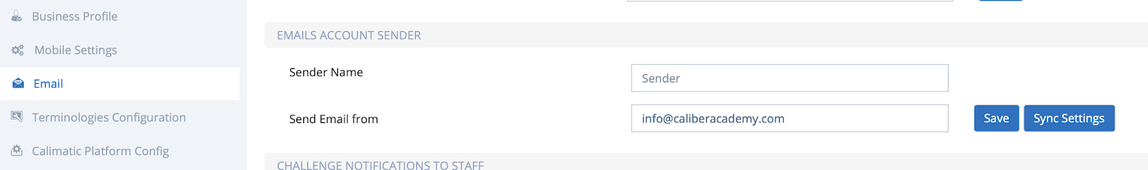

#### **Account Creation - Username can now be email id as well**

We had a restriction of not allowing the users to log in if they have created the username with email id. With this change, the users can create the email id as their username and it will allow them to log in.

#### **Assessments - AutoSave Questions Settings**

Currently, we have a “Save Session” capability which allows users to save their Assessment session and come back to proceed with their assessment. We are introducing an “Auto Save” feature which will allow the Assessment to AutoSave when the user clicks on Submit Question or Next button.

You will be able to set only one of these 2 settings - “Save Session” or “AutoSave”.

If the “AutoSave” setting is ON then the user will not see the “Save Session” button.

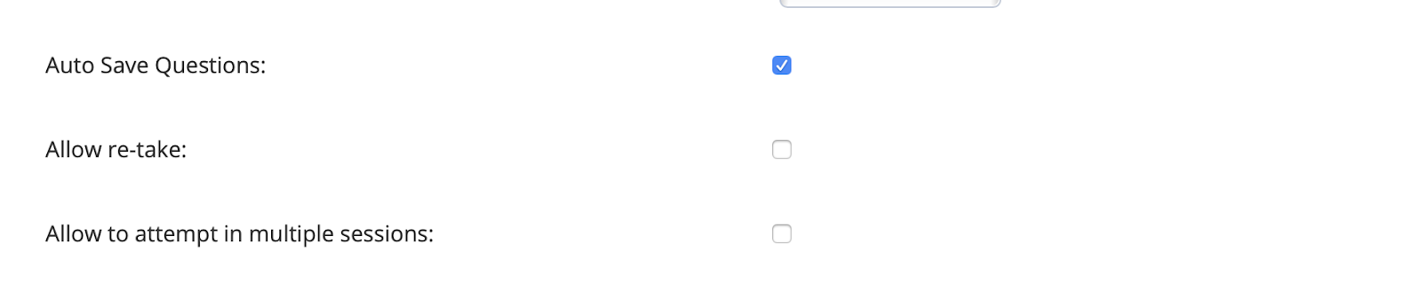

#### **Students & Contacts - Send Portal Access**

Previously, we had a restriction of not sending the Portal Access email to Students & Families in the Students Info popups more than once. We have now removed the restriction and you can send it multiple times.

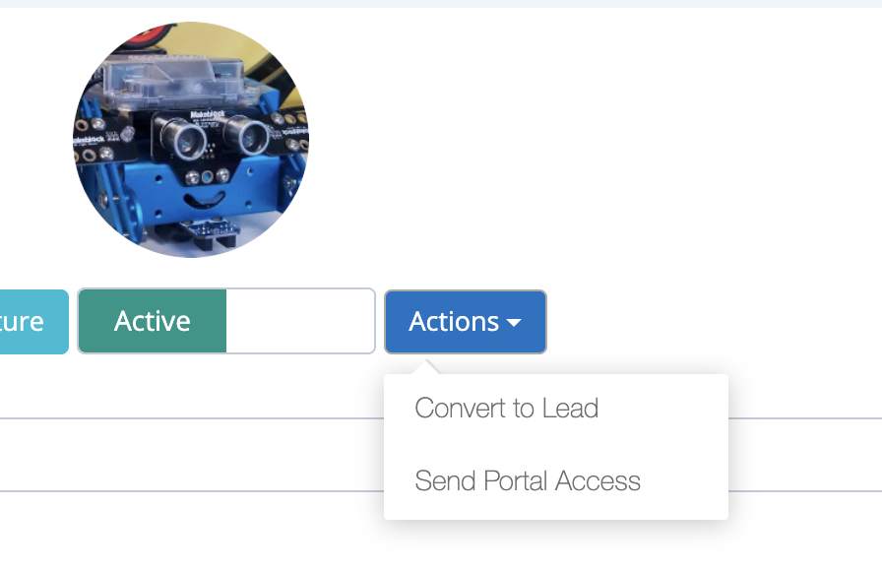

#### **CRM - Filling contact form in your website now sends an email to you**

We have now provided a setting in Admin > System Config > Emails to specify 1 or more email ids to receive emails when anyone fills and submits a contact form that you embedded in your website.

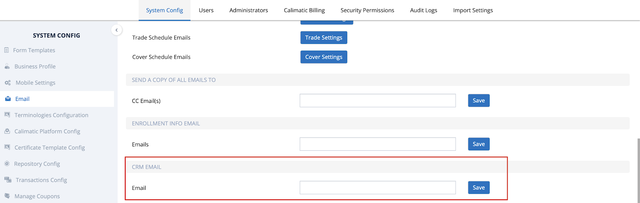

#### **CRM - Contact form leads are added to the Leads with Lead Source**

Any Lead that is added from the Contact forms from your website is added to the Leads page with the Lead Source as the Contact form name so that it can be easily filtered or sorted.

#### **Improved Performance**

We have made some improvements to the following areas as part of our regular performance improvements to the platform -

1. Course Player pages
2. Course, Level, Challenge/Subject/Assignment popups

#### **Few Bugs fixes have been made**

Along with the Features, we also fixed bugs that were encountered by the customers and some previous pending bug fixes.

Contact us at lmscoach@calimatic.com for any questions.

### **June 21st, 2020 Release - LMS Web Portal**

June 21st, 2020 Release Notes for Calimatic LMS web portal



Written By Ivan Karmer

Updated 3 years ago

#### Post Payment Feature

Introducing the “Post Payment” feature to post a fee (like Tuition Fee, Material Fee, etc) to the Family or Student and collect the payment.

You have the option to Collect the Fee or Save the Fee to collect later.

If there is payment on file then the Fee is collected when click on Collect Fee.

If there is no payment on file then the Fee is saved to collect later.

**Navigation:**

1. Families > Payments > Fee Payments section > Post Fee button
2. Families > Families Info > Select a Family > Payments > Fee Payments section > Post Fee button
3. Students > Payments > Fee Payments section > Post Fee button
4. Students > Students Info > Select a Student > Payments > Fee Payments section > Post Fee button

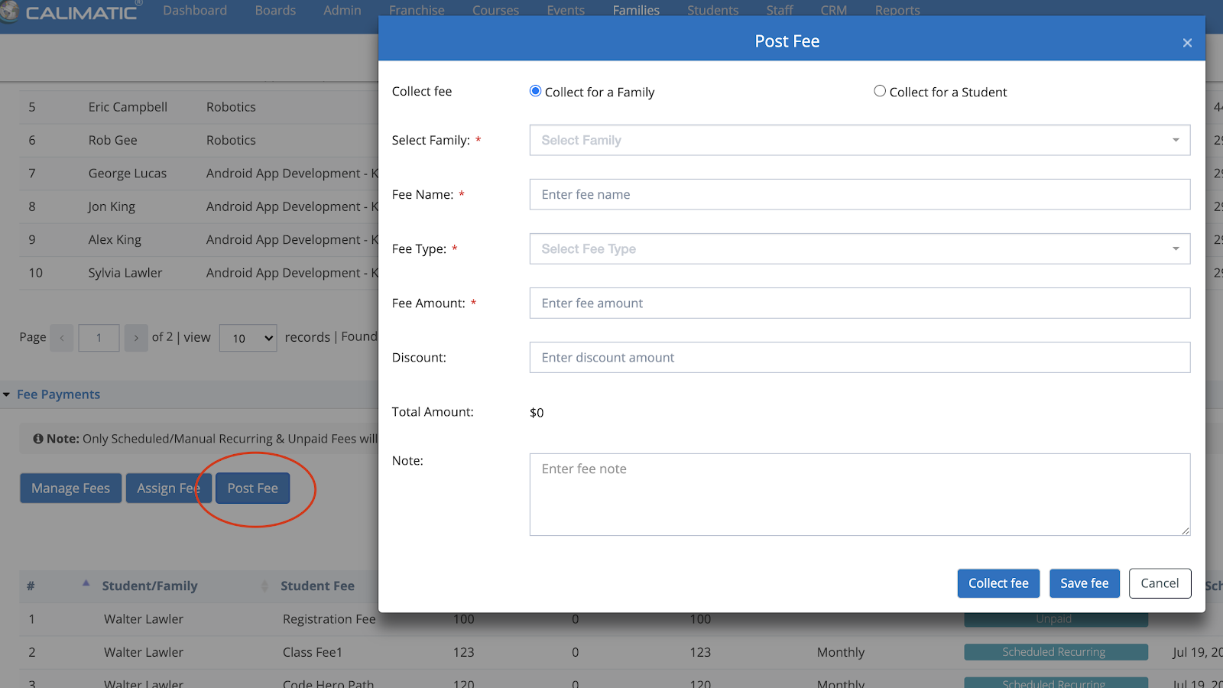

**Pending items related to Post Fee -**

1. In the Transactions pages & grids, including the Fee Name and Notes columns are pending.
2. In the Post Fee email, including the Notes information is pending.

#### Payment Status moved from Web-hooks to API

Web-hooks were used to get the Status from the Stripe for Bank Payments. In some cases, Stripe web-hooks are not working generating errors. This implementation has been moved to a more reliable API approach.

#### Central - Staff or Faculty Permissions for only assigned Courses

In order to provide more security & control for the learning content, now you have the ability to assign Courses only to the Staff or Faculty in the Course Popup that needs access.

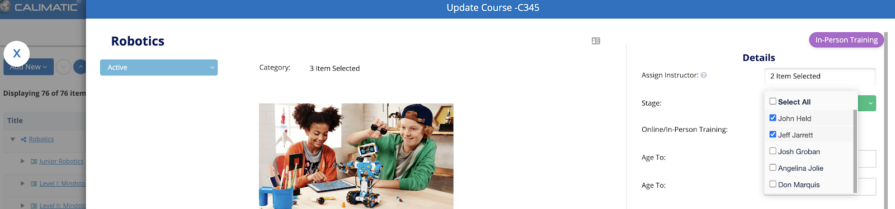

Going forward, this assignment is needed when a course is created or when the course is needed to be assigned to a new staff member.

Along with this, you also have the ability to control the list of classes that should be shown in the Boards header dropdown list. The setting is found in the Admin > System Config > Misc Config. This setting is available only for the Business/Master Admin.

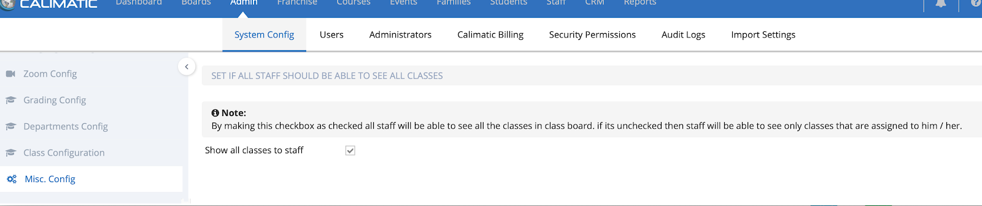

#### Transfer Student to another Class - Without Payment

In a few places within the application, we have the ability to Transfer the Student from one class to another.

Now, we have provided the ability to transfer the Student to a Class without the Payment when there is Amount Due. In the Transfer popup, the “Transfer without Payment” button provides this ability.

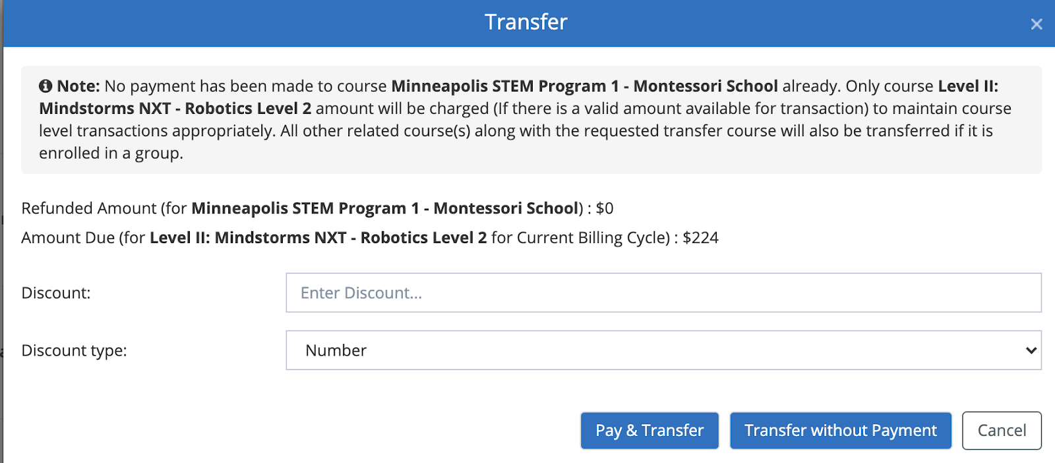

#### Removed the Franchise Payment notification on the Dashboard

We have removed the Franchise Payment details missing notification on the dashboard.

#### Enrollment page - “Already a Customer? Click here to login” text is made obvious now

In the Enrollment Page, “Already a Customer? Click here to login” text is made obvious for the customers to make sure they log in if they already have an account. Clicking on the link we navigate them to the Portal login. From the Portal, they will have the ability to add new Students or add students to the Class (if they have permissions to add and the permissions are set at the Master admin level).

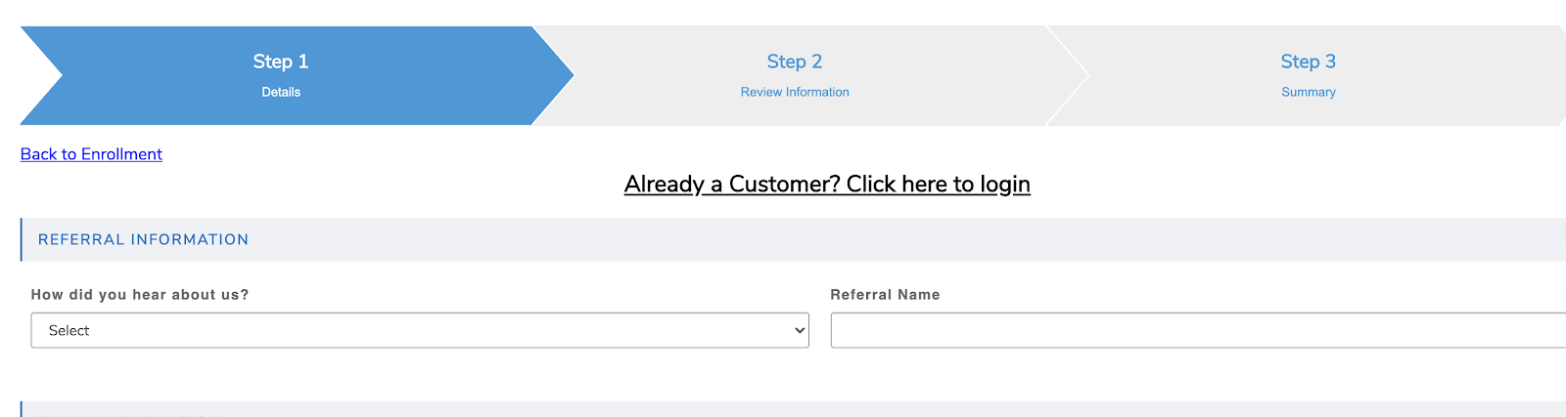

In the enrollment page, the ability to add new Students is temporarily disabled.

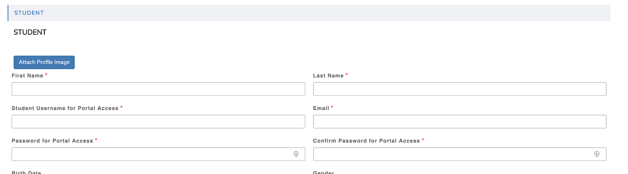

**Pending Changes for enrollments -**

1. The ability to add multiple students to different classes in the enrollment form is currently being worked as a priority.
2. In Portal, when the permissions are set for the Parents to add Students to the Classes, we will add the Students to the Classes and will show the Payment status as Requested instead of directly collecting the Payments. You will then have the ability to collect manually.

#### Improved performance for the Courses, Levels & Challenges Popups -

We have made some improvements to the Courses, Levels & Challenges popups. We are continuously working on improving performance on a regular basis.

#### Few Bugs fixes have been made

Along with the Features, we also fixed bugs that were encountered by the customers and some pending bug fixes.

Contact us at lmscoach@calimatic.com for any questions.